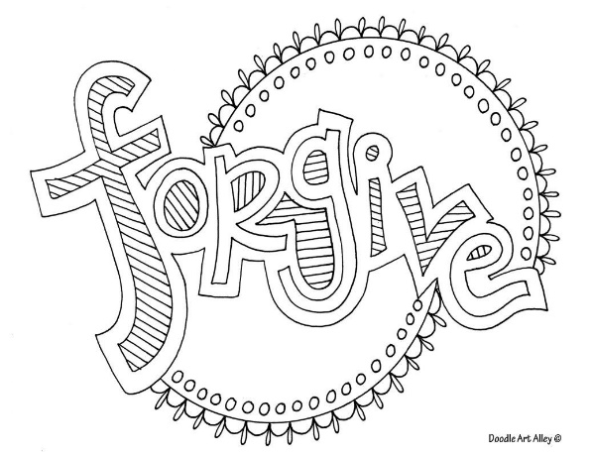
Children’s Bulletin
First Parish Congregational Church
July 19, 2020

Please gather the following (optional) items to help you worship today:
- Crayons, markers, or colored pencils
- Scissors
- You’ll find a special activities to the sermon and scripture message on the final pages of this Children’s Bulletin

Words of Welcome

Go around the room and greet each person (and pet!) and wave to everyone else worshiping out there with you today

Sing along! HYMN # 303 Rejoice, Give Thanks and Sing (vs. 1, 4)
Rejoice, give thanks and sing: your Sovereign God adore!
For Christ has robbed death's sting and triumphs evermore.
Lift up your heart, lift up your voice! Rejoice, again I say, rejoice.

Rejoice in glorious hope, for Christ the Judge shall come,
And take the faithful up to their eternal home.
We soon shall hear a heavenly voice above the trumpet's sound, "Rejoice!"

Call to Worship & Invocation
Read out loud the words in bold if you can.

CALL TO WORSHIP:
One: Open your arms and your souls to receive the covenant.
Many: We are here to in response to God's steadfast love.
One: God welcomes you and offers renewal.
Many: God is merciful and gracious, and allows us 'to lie down in safety.
One: As followers of Jesus, God calls us to use our gifts for the sake of justice.
Many: For justice’s sake, God equips us as stewards of the new covenant.

INVOCATION (unison):
Living God, we read your Word in the lives of people who lived long ago. And we read your Word today in the lives of people who embody your Spirit. All of us have the potential to become your letters to the world. This is, after all, why we gather: to find integration of faith and deed, trust and discipleship. If we are to be authentic witnesses to your steadfast love, make yourself known to us so that your presence can be seen in the world. Amen.
Song of Praise
Discordant humankind, in this your concord find,
may Jesus Christ be praised!
Let all the earth around ring joyous with the sound;
may Jesus Christ be praised!

Time Especially for Children
Let’s sing “Jesus loves me”
Come in close and bring your listening ears

Let’s learn the Lord’s Prayer in Sign Language! https://youtu.be/EVcYGOWJuns

I challenge you to practice at home, I will, too!

THE LORD’S PRAYER:
Our Father, who art in heaven, hallowed be Thy name. Thy kingdom come; Thy will be done; on earth as it is in heaven. Give us this day our daily bread and forgive us our debts as we forgive our debtors. Lead us not into temptation but deliver us from evil; for Thine is the Kingdom, and the Power, and the Glory forever. Amen.

Scripture Reading
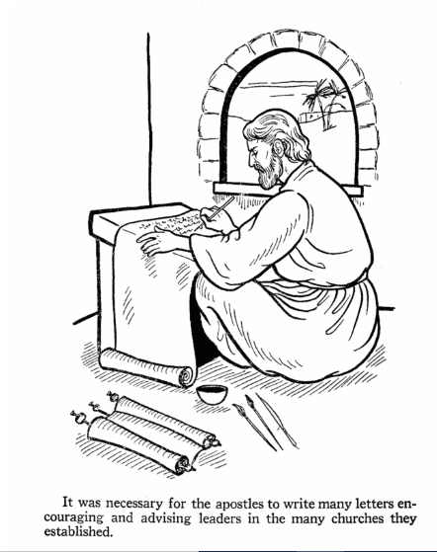
NEW TESTAMENT:

2 Corinthians 2:1-10
Matthew 18:21-22

Can you count how many times the word forgive, or a form of the word forgive is said in the scripture reading this week?

Sermon
During this time, as you listen to the sermon, please enjoy the activities found on the last pages of the Children’s Bulletin

HYMN #553 (vs.1, 2) There’s a Balm in Gilead
There is a balm in Gilead, to make the wounded whole, there is a balm in
Gilead, to heal the sinsick soul.
Sometimes I feel discouraged, and think my work's in vain. But then the
Holy Spirit revives my soul again.
There is a balm in Gilead, to make the wounded whole, there is a balm in
Gilead, to heal the sinsick soul.
Don't ever feel discouraged, for Jesus is your friend, who, if you ask for
knowledge, will never fail to lend.
There is a balm in Gilead, to make the wounded whole, there is a balm in
Gilead, to heal the sinsick soul.

Invitation to Generosity
Prayer of Dedication
As ministers of your new covenant, O God, we bring these offerings. May they impart new life to the sisters and brothers we know and to many we will never meet. Bless the work of our hands as we reach out in your name. May all your people feast at the banquet table of your love. Amen.

Sharing Joys and Concerns:
Do you have a joy or concern you’d like to share with the congregation?
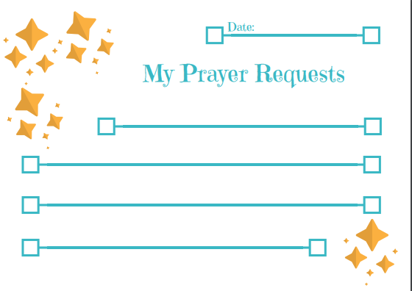

HYMN # 551 1, 4 “Pass Me Not
Pass me not, O gentle Savior, ear my humble cry;
While on others you are calling, do not pass me by.
Savior, Savior, hear my humble cry;
While on others you are calling, do not pass me by.

Let me at your throne of mercy find a sweet relief;
Kneeling there in deep contrition, help my unbelief.
Savior, Savior, hear my humble cry;
While on others you are calling, do not pass me by.

Benediction

Postlude “Go now in peace. Go now in peace. May the love of God surround you everywhere, everywhere you may go.”
Words & Music: Natalie Sleeth, © 1976 Hinshaw Music, Inc.; All rights reserved. Reprinted under ONE LICENSE #A-708716.

Virtual Coffee Hour
Share your artwork with everyone!

MINISTERS OF THE CHURCH - Members of the Congregation SENIOR PASTOR AND TEACHER - The Rev. Dr. Deborah Roof
LAY READER – Brian Williams
DEACON/GREETER- Rachel Cobban, Jack Martin
CHOIR DIRECTOR/ ORGANIST - Joan Virga
CHRISTIAN EDUCATION DIRECTOR - Christine Lehoullier
ADMINISTRATIVE ASSISTANT - Michelle Guerrin
Visit our Facebook page or our website for recent videos of services and moments of Christian Faith Formation and inspiration.

This week, Paul teaches the members of the church in Corinth about the importance of forgiveness. This wordsearch focuses on a quote from the Book of Matthew in which God tells us how many times we should forgive our brothers and sisters. The answer? God says….ALOT! Listen more to our discussion of forgiveness in our Summer Storytime Series posted on Facebook this week and every weekend this summer!
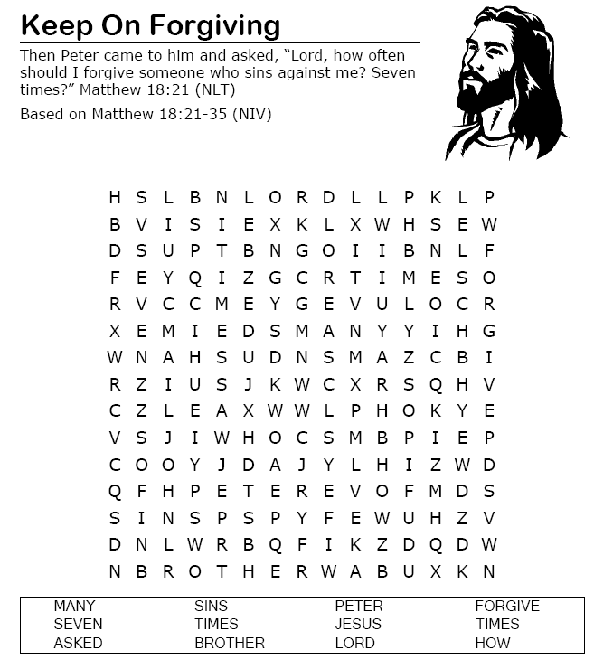

Jesus Taught About Forgiveness Bible Craft
Supplies List:
Contact paper
Tissue paper
Black construction paper
Craft brads
.
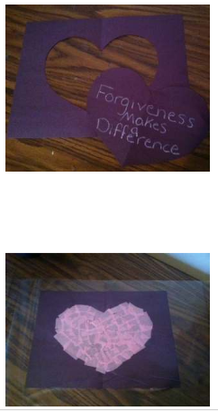
Instructions:
Step 1. Fold the black construction paper in half and cut out a large heart shape along the fold. In white crayon write the word “Forgiveness Makes a Difference” onto the black heart and set aside. Unfold the rest of the paper to reveal an empty heart shape in the center of the page (see image).

Step 2.
Take a sheet of contact paper and carefully lay the unfolded paper onto the sticky
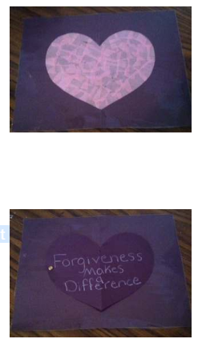
side of the contact paper. Take several pieces of colored tissue paper squares and stick the papers carefully onto the contact paper inside the heart. Lay another sheet of contact paper, sticky side down on top of the page (see image). This will seal the tissue paper squares inside.
.
Step 3.Trim the edges of contact paper. Turn the craft over to reveal a colorful heart center (see image).

Step 4.
Using a craft brad and attach the black heart you cut out and set aside earlier
(see image).

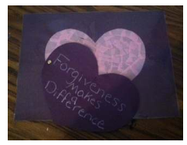
Step 5.
Now the black heart can be moved back and forth to illustrate what happens to our hearts when we open our hearts to forgive. The forgiving heart is beautiful and the light of God can shine through it (see image.)

If a king forgives, then the one forgiven should forgive as well. Moreover, if God forgives, the ones God’s forgiven also should forgive. Have fun coloring this crown fit for royalty rich in forgiveness and love (that’s you!)

