Children’s Bulletin
First Parish Congregational Church
August 16, 2020
Today is National Joe Miller’s Joke Day. Tell a funny Joke today !

Please gather the following (optional) items to help you worship today:
- Drawing paper
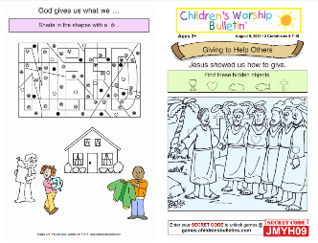
- Crayons, markers, or colored pencils
- You’ll also find an additional activity pages for ages 7+ and 3+ for use during the sermon on the final pages of this Children’s Bulletin
Words of Welcome

Go around the room and greet each person (and pet!) in American Sign Language!

Sing, dance or shake along! HYMN # #13 O My Soul, Bless Your Creator vs. 1, 2, 4
O my soul, bless your creator; all within me bless God’s name;
Bless your Maker, and forget not all God’s mercies to proclaim.
God forgives all your transgressions, all who suffer, gently heals;
God redeems you from destruction, and with you so kindly deals.
As it was without beginning, so it lasts without an end;
To their children’s children ever shall God’s righteousness extend.

Call to Worship & Invocation
Read out loud the words in bold if you can
(God loves when we gather and pray together)

CALL TO WORSHIP:
One: We come to meet our Holy God who welcomes us wholeheartedly.
Many: We gather to experience God's steadfast love and grace.
One: Listen: for God will speak to those who have ears to hear.
Many: Let us open our hearts to the Source of all wisdom.
One: God is ready to restore us to right relationship.

Many: Let us be ready to accept the blessing and cost of discipleship

INVOCATION (unison):
Living, Loving God, we come as your children to be reclaimed and blessed. We
need the inner strength that comes to us through worship and prayer and hearing
your Holy Word. All week long we wrestle with the heaviness of our world’s
conflicts. Dim that noise if but for a short time, so that we my turn toward your
Presence and your will for our lives. Amen.
SONG OF PRAISE Gloria Patri (Traditional)
Glory be to the Father and to the Son and to the Holy Ghost. As it was in the beginning, is now and ever shall be, World without end, Amen, Amen

Time Especially for Children
Let’s sing “Jesus loves me”
Come in close and bring your listening ears

CHILDREN’S MESSAGE: A conversation with Miss Katie!

THE LORD’S PRAYER:
Our Father, who art in heaven, hallowed be Thy name. Thy kingdom come; Thy will be done; on earth as it is in heaven. Give us this day our daily bread and forgive us our debts as we forgive our debtors. Lead us not into temptation, but deliver us from evil; for Thine is the Kingdom, and the Power, and the Glory forever. Amen.

Scripture Reading
Luke 11:2-4
2
(Jesus) said to them, “When you pray, say: Father, hallowed be your name.
Your kingdom come. 3 Give us each day our daily bread.
4 And forgive us our sins, for we ourselves forgive everyone indebted to us.
And do not bring us to the time of trial.”

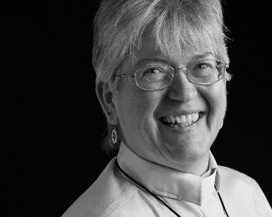
Sermon
During this time, as you listen to the sermon, please enjoy the activities found on the last page of the Children’s Bulletin

HYMN # 26 We Worship You, God vs. 1,5
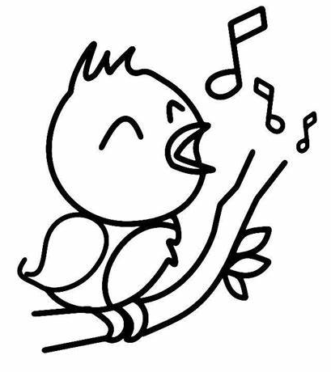
We worship you, God; your power and your love
are blazoned abroad, Around, and above;
Our shield and Defender, the Ancient of Days,
Pavilioned in splendor and girded with praise.
Frail children of dust, and feeble as frail,
in you do we trust, nor find you to fail.
Your mercies how tender, how firm to the end,
our Maker, Defender, Redeemer and Friend!

Invitation to Generosity
(What is something kind or a funny joke you can share with others?)

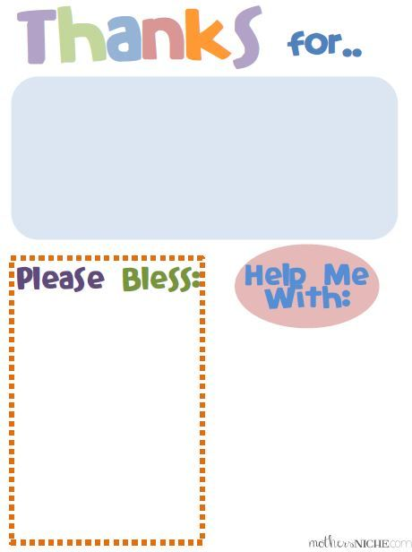
Sharing Joys and Concerns: Do you have a Joy or Concern you’d like to share with the congregation?

WE GO OUT TO LOVE AND SERVE A LOVING, SERVING GOD

HYMN #24 The God of Abraham Praise vs. 1, 3
The God of Abraham praise, all praises to God’s name,
who was and is and is to be, Fore’er the same!
The one eternal God, before what now appears; the First the
Last: beyond all thought through timeless years!
God has eternal life implanted in the soul;
God’s love shall be our strength and stay, while ages roll.
All praise the living God! Extol that hallowed name,
who was and is, and ever shall be still the same!
BENEDICTION (The benediction is a blessing that the Pastor gives over God’s people before they go)

POSTLUDE “Go now in peace. Go now in peace. May the love of God surround
you everywhere, everywhere you may go.”
Words & Music: Natalie Sleeth, © 1976 Hinshaw Music, Inc.; All rights reserved.
Reprinted under ONE LICENSE #A-708716.
MINISTERS OF THE CHURCH - Members of the Congregation Members of the Congregation
SENIOR PASTOR AND TEACHER - The Rev. Dr. Deborah Roof
LAY READER – Sue Brown
ZOOM/FACEBOOK GREETERS- Jack Martin, Debbie Gline Allen, Beth McFarlane
(our guest from Pilgrim UCC)
CHOIR DIRECTOR/ ORGANIST - Joan Virga
CHRISTIAN EDUCATION DIRECTOR - Christine Lehoullier
ADMINISTRATIVE ASSISTANT - Michelle Guerrin

