Children’s Bulletin
First Parish Congregational Church
August 2, 2020

AUGUST IS NATIONAL CRAYON COLLECTION MONTH
READ MORE ABOUT THIS AWESOME KINDNESS MOVEMENT HERE: https://crayoncollection.org/
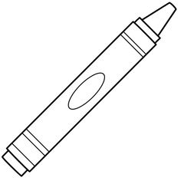

Please gather the following (optional) items to help you worship today:
- Drawing paper
- Crayons, markers, or colored pencils
- You’ll also find an additional coloring page and activity for use during the sermon on the final page of this Children’s Bulletin

Words of Welcome

Go around the room and greet each person (and pet!)

Sing along! HYMN #403 “My Hope Is Built on Nothing Less” (vs 1, 2)
My hope is built on nothing less than Jesus’ love and righteousness;
I dare not trust this earthly frame, but wholly lean on Jesus’ name.
On Christ, the solid Rock I stand,
all other ground is sinking sand, all other ground is sinking sand.
When shadows veil my Savior’s face, I rest upon unchanging grace;
In every high and stormy gale, my anchor holds within the veil.
On Christ, the solid Rock I stand,
all other ground is sinking sand, all other ground is sinking sand.

Call to Worship & Invocation
Read out loud the words in bold or color in the footprints.

CALL TO WORSHIP
One: It is good to give thanks to God!
Many: God knows our troubles and remembers our need.
One: Seek God's help in the sanctuary.
Many: Our petitions are answered and our hearts' desires fulfilled.
One: Listen for the voice of God, speaking to us again.
Many: God responds when we call – and we will bear fruit for God!

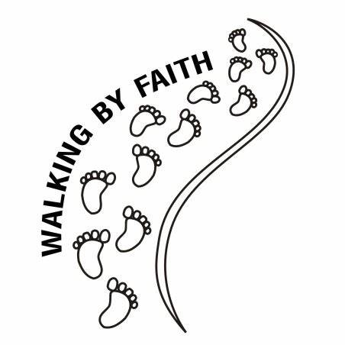
INVOCATION (unison)
We turn to you, God of all worlds, knowing we can depend on you when earthly rulers stumble and fall, when other relationships are strained and broken, when we are faced with difficult challenges. It is good to sing your praises; it is good to declare your faithfulness; it is good to give thanks. It is when we do these things that we are reminded of the multitude of blessings you have blessed us with. Lead us in this time of worship. Amen

CALL TO CONFESSION:
Each of us has a mandate from God to give our best and bear fruit for God's realm. We who gather in God's house are called to be a faithful community in which all followers of Christ may be motivated by the love of Christ. Let us examine ourselves before our Creator.

PRAYER OF CONFESSION:
God of all truth and justice, you examine our hearts, we pray. We see what is on the surface, but you discern beauty deep within. We measure importance by paychecks, but you find value among those we deem lowly and insignificant. You offer us the deep and profound joy of your realm. We forget your promises and turn to pursuits that separate us and destroy community. We seek forgiveness as we seek a fuller expression of You in our lives. Amen

SONG OF PRAISE Gloria Patri (Traditional)
Glory be to the Father and to the Son and to the Holy Ghost. As it was in the beginning, is now and ever shall be, World without end, Amen, Amen

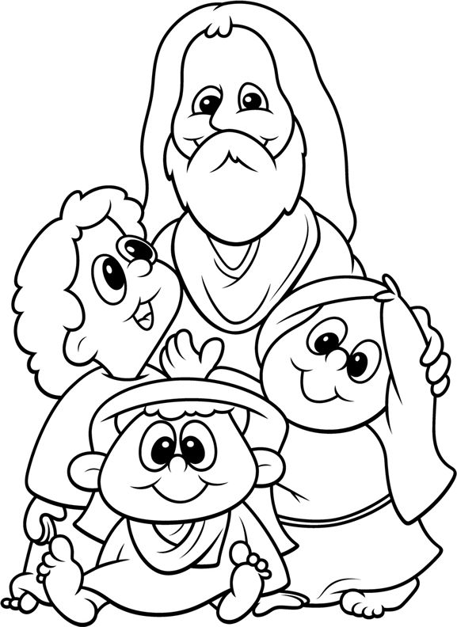
Time Especially for Children
Let’s sing “Jesus loves me”
Come in close and bring your listening ears

Let’s learn the Lord’s Prayer in Sign Language! https://youtu.be/EVcYGOWJuns
I challenge you to practice at home, I will, too!

THE SACRAMENT OF HOLY COMMUNION

The Sacrament of Holy Communion

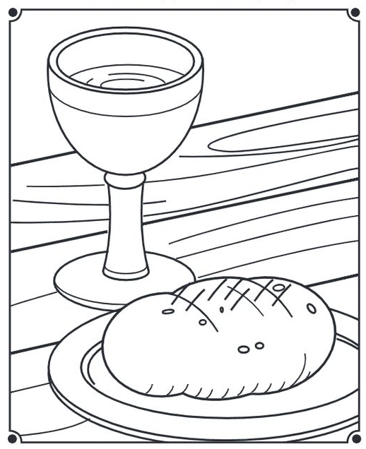
As we take communion together, we think about how much Jesus loves us and we know this by the sacrifices he made. We remember how to stay close to God and Jesus by praying everyday.

INVITATION TO THE TABLE

COMMUNION HYMN # 330 Let Us Break Bread Together (vs 1, 3) Let us break bread together on our knees; Let us break bread together on our knees. When I fall on my knees, with my face to the rising sun, My God, have mercy on me. Let us praise God together on our knees; Let us praise God together on our knees. When I fall on my knees, with my face to the rising sun, My God, have mercy on me.

SHARING THE PEACE OF CHRIST

Go around the room and say or sign, “Peace be with you” to everyone near and far away!

PEACE HYMN: Let there Be Peace on Earth Let there be peace on earth and let it begin with me. Let there be peace on earth, the peace that was meant to be. With God our Creator, we are family, let me walk with my neighbor, in perfect harmony. Let peace begin with me, let this be the moment now. With every step I take, let this be my solemn vow; To take each moment and live each moment in peace eternally. Let there be peace on earth and let it begin with me.

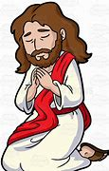
PRAYER OF CONSECRATION followed by
THE LORD’S PRAYER:
Our Father, who art in heaven, hallowed be Thy name. Thy kingdom come; Thy will be done; on earth as it is in heaven. Give us this day our daily bread and forgive us our debts as we forgive our debtors. Lead us not into temptation, but deliver us from evil; for Thine is the Kingdom, and the Power, and the Glory forever. Amen.

Scripture Reading
Draw a picture of what you hear in the Bible passages.
2 Corinthians 5:1-7; 16-19 “Walk by Faith not Sight”

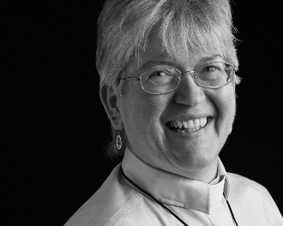
Sermon
During this time, as you listen to the sermon, please enjoy the activities found on the last page of the Children’s Bulletin

Sing along! HYMN: “We Walk by Faith” (vs 1, 3)
We walk by faith, and not by sight; No gracious words we hear Of him who spoke as none e’er spoke, but we believe him near. We may not touch his hands and side, Nor follow where he trod. Yet in his promise we rejoice and cry “My Lord and God!”
Invitation to Generosity

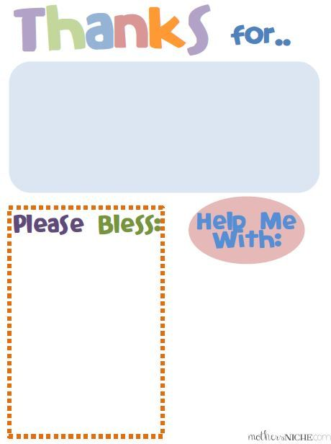
Sharing Joys and Concerns: Do you have a Joy or Concern you’d like to share with the congregation?

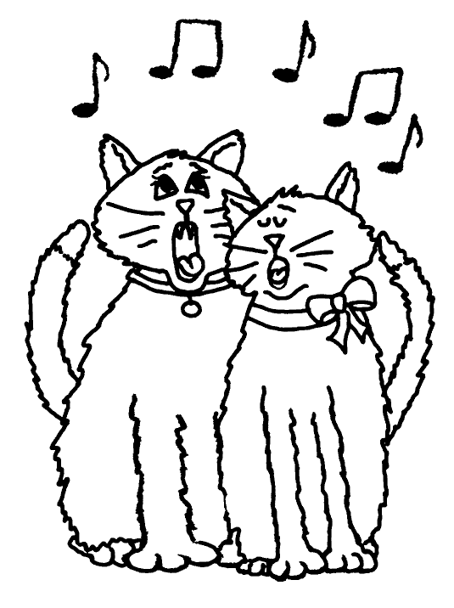

WE GO OUT TO LOVE AND SERVE A LOVING, SERVING GOD

Sing along! HYMN #407 How Firm a Foundation (vs. 1, 2) How firm a foundation for you has been laid, By God in the Word, in the sacrifice paid! What more can God say than to you has been said, To you, who for refuge to Jesus have fled! “Fear not, I am with you, oh, be not dismayed, For I am your God, I will still give you aid. I’ll strengthen you, help you, and cause you to stand Upheld by my gracious, omnipotent hand.”

BENEDICTION

POSTLUDE

MINISTERS OF THE CHURCH - Members of the Congregation Members of the Congregation SENIOR PASTOR AND TEACHER - The Rev. Dr. Deborah Roof LAY READER – Liz Greenberg GREETERS – Rachel Cobban, Sue Brown GUEST MUSICIAN – Katlyn Leahy CHOIR DIRECTOR/ ORGANIST - Joan Virga CHRISTIAN EDUCATION DIRECTOR - Christine Lehoullier ADMINISTRATIVE ASSISTANT - Michelle Guerrin

Visit our Facebook page or our website for recent videos of services and moments of Christian Faith Formation and inspiration.

