Children’s Bulletin
First Parish Congregational Church
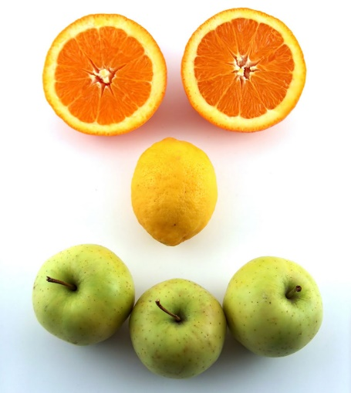
SEPTEMBER 13, 2020
SEPTEMBER IS NATIONAL
FRUITS AND VEGETABLES MONTH!
Top 5 Farm Stands Voted in NH:

1. LaValley Farms in Hooksett

2. Trombly Gardens in Milford

3. J&F Farms in Derry

4. Sunnycrest Farm in Londonderry

5. Johnson Golden Harvest in Hooksett

Please gather the following (optional) items to help you worship today:
- Drawing paper
- Crayons, markers, or colored pencils
- You’ll also find an additional activity pages for use during the sermon on the final pages of this Children’s Bulletin

Words of Welcome

Go around the room and greet each person (and pet!)
Sing along! HYMN #28 For the Beauty of the Earth vs. 1,3, 4
For the beauty of the earth, for the splendor of the skies.
For the love which from our birth over and around lies.
God of all, to you we raise this our hymn of grateful praise.

For the joy of human love, brother, sister, parent, child.
Friends on earth, and friends above, for all gentle thoughts and mild.
God of all, to you we raise this our hymn of grateful praise.

For the good that love inspires, for the world where no exclude,
For a faith that never tires, and for every heart renewed.
God of all, to you we raise this our hymn of grateful praise.

Call to Worship & Invocation
Read out loud the words in bold or color in the footprints.

CALL TO WORSHIP
One: We gather to give thanks with our whole hearts.
Many: Let us rejoice in God's love and faithfulness.
One: Our Creator increases our strength of soul.
Many: We pour out our thanks in songs of praise.

INVOCATION (unison)
Our souls wait for you, O God. Our ears are attentive to your Word. We hope for a clear understanding of your will for us. Let this time of meeting draw us together in unity, with a sense of direction and purpose for our church and our individual lives. Amen.

CALL TO CONFESSION:
Each of us has a mandate from God to give our best and bear fruit for God's realm. We who gather in God's house are called to be a faithful community in which all followers of Christ may be motivated by the love of Christ. Let us examine ourselves before our Creator.

PRAYER OF CONFESSION:
We confess, O God, that we make decisions without considering your larger purposes. Our own convenience and desires are more important to us than your commands. We go our own way and then blame others for our mistakes. We hide from you rather than admitting our needs. O God, we want to face our misdirection and find forgiveness. Help us! Amen.

SONG OF PRAISE Gloria
Gloria, Gloria, in excelsis Deo!
Gloria, Gloria, alleluia, alleluia

Time Especially for Children
Let’s sing “Jesus loves me”
Come in close and bring your listening ears

CHILDREN’S MESSAGE - Christine Lehoullier

Back to School Blessing

Elementary Students: Bless my paper and my pen.
Guide my spirit deep within.
Help me think and help me play
This whole school year, day by day.
All: Of whom much is given, much is required.
May learning be your greatest desire!
Middle School (Jr. High) students:
As I move from class to class
Guide my footsteps; clear my path.
Keep my tongue to speak your words.
Let your will for me be heard.
All: Of whom much is given, much is required.
May learning be your greatest desire!
High School Students: In every subject high or low,
May God's excellence be shown!
Keep me strong to reach the prize
To grow in grace, becoming wise.
All: Of whom much is given, much is required.
May learning be your greatest desire!
College Students: Whether far from home or near
May I hold God's precepts dear.
To do my best at every task;
For this blessing, I do ask.
All: Of whom much is given, much is required.
May learning be your greatest desire!
Non-Traditional and Graduate Adult Students:
Help my family be a part
As I lift my mind and heart.
As I study, work, and pray,
Be with them throughout the day.
All: Of whom much is given, much is required.
May learning be your greatest desire!
About the Author: The Rev. Marilyn E. Thornton is Lead Editor of African American Resources for Abingdon Press and Director of the Wesley Foundation on the campus of Fisk University.
"Back to School Blessing" Copyright © 2007 Marilyn E. Thornton. All Rights Reserved. Posted with permission.

THE SACRAMENT OF HOLY COMMUNION

As we take communion together, we think about how much Jesus loves us and we know this by the sacrifices he made. We remember how to stay close to God and Jesus by praying everyday.

INVITATION TO THE TABLE

COMMUNION HYMN #330
Let Us Break Bread
Let us break bread together on our knees,
Let us break bread together on our knees.
When I fall on my knees with my face to the rising sun, My God, have mercy on me.

Let us praise God together on our knees;
Let us praise God together on our knees. When I fall on my knees, with my face to the rising sun, My God, have mercy on me.
SHARING THE PEACE OF CHRIST
Go around the room and say or sign, “Peace be with you” to everyone near and far away!

PEACE HYMN: Let there Be Peace on Earth
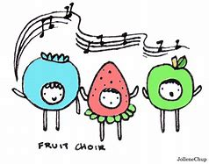
Let there be peace on earth and let it begin with me.
Let there be peace on earth, the peace that was meant to be.
With God our Creator, we are family,
let me walk with my neighbor, in perfect harmony.

Let peace begin with me, let this be the moment now.
With every step I take, let this be my solemn vow;
To take each moment and live each moment in peace eternally.
Let there be peace on earth and let it begin with me.

PRAYER OF CONSECRATION followed by
THE LORD’S PRAYER:
Our Father, who art in heaven, hallowed be Thy name. Thy kingdom come; Thy will be done; on earth as it is in heaven. Give us this day our daily bread and forgive us our debts as we forgive our debtors. Lead us not into temptation, but deliver us from evil; for Thine is the Kingdom, and the Power, and the Glory forever. Amen.

Scripture Reading
Draw a picture of what you hear in the Bible passages.
Genesis 2:15 - 23

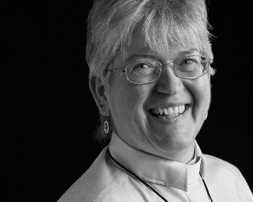
Sermon
During this time, as you listen to the sermon, please enjoy the activities found on the last page of the Children’s Bulletin

Sing along! HYMN #12 I Sing the Mighty Power of God vs. 1, 3
I sing the mighty power of God that made the mountains rise,
That spread the flowing seas abroad and built the lofty skies.
I sing the wisdom that ordained the sun to rule the day;
The moon shines full at God's command, and all the stars obey.

On earth there's not a plant or flower but makes your glory known.
The clouds arise and spread their showers by order from your throne.
All life is but a gift from you and ever in your care;
Wherever people gather you, O God, are present there.
Invitation to Generosity

*DOXOLOGY
Masithi, Amen, siyakudumisa, Masithi
Amen, siyakudumisa, Masithi;
Amen, Bawo, Amen, Bawo, Amen, siyakudumisa.

Sing amen, Amen, we praise your name, O God, Sing Amen
Amen, we praise your name, O God. Sing Amen
Amen, Amen, Amen, Amen, Amen, we praise your name, O God.

PRAYER OF DEDICATION
We bring ourselves and some of what we have accumulated to praise you and do the work you call us to do. Thank you, God, for your faithfulness. Fulfill your purpose for this church as you enlist our offerings and our lives. Help us to do your will. Amen.

Sharing Joys and Concerns: Do you have a Joy or Concern you’d like to share with the congregation?

WE GO OUT TO LOVE AND SERVE A LOVING, SERVING GOD
Sing along! HYMN #407 How Firm a Foundation (vs. 1, 2) How firm a foundation for you has been laid, By God in the Word, in the sacrifice paid! What more can God say than to you has been said, To you, who for refuge to Jesus have fled! “Fear not, I am with you, oh, be not dismayed, For I am your God, I will still give you aid. I’ll strengthen you, help you, and cause you to stand Upheld by my gracious, omnipotent hand.”

BENEDICTION: The Pastor often will give a benediction at the end of service. This is like a special prayer asking for God’s help, guidance and blessing over everyone before the end of service.

POSTLUDE “Go now in peace. Go now in peace. May the love of God surround you everywhere, everywhere you may go.” Words & Music: Natalie Sleeth, © 1976 Hinshaw Music, Inc.; All rights reserved. Reprinted under ONE LICENSE #A-708716.
MINISTERS OF THE CHURCH - Members of the Congregation Members of the Congregation SENIOR PASTOR AND TEACHER - The Rev. Dr. Deborah Roof LAY READER – Liz Greenberg GREETERS – Rachel Cobban, Sue Brown GUEST MUSICIAN – Katlyn Leahy CHOIR DIRECTOR/ ORGANIST - Joan Virga CHRISTIAN EDUCATION DIRECTOR - Christine Lehoullier ADMINISTRATIVE ASSISTANT - Michelle Guerrin
Visit our Facebook page or our website for recent videos of services and moments of Christian Faith Formation and inspiration.

