Children’s Bulletin
First Parish Congregational Church
August 30, 2020

september is international speak out month

Not sure how to speak out against bullies when it’s happening? Maybe there’s a cause in the world that is really important to you….recycling, saving animals, helping other children or the homeless? Here are some websites that can get you started to getting your voice heard:
1. https://kidsspeakout.org/
2. https://cumberlink.com/news/local/family/kids_speak_out/kids-speak-out-if-i-ruled-the-world-i-would-get-rid-of/article_f4f5dc14-9d05-11e4-aba8-0f1ed36d062b.html
3. https://www.pacerkidsagainstbullying.org/how-can-you-help/if-you-see-bullying/

Please gather the following (optional) items to help you worship today:
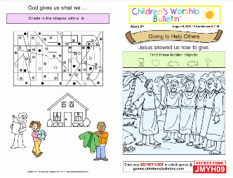
- Crayons, markers, or colored pencils
- You’ll also find an additional activity pages for ages 7+ and 3+ for use during the sermon on the final pages of this Children’s Bulletin
Words of Welcome
Go around the room and greet each person (and pet!) as they traditionally would in India. This greeting is carried out by placing your hands together in a praying position with your fingers pointed upwards and bowing slightly when you say “Namaste.”

Sing, dance or shake along! HYMN #24 The God of Abraham Praise (vs. 1, 4)
The God of Abraham praise, all praises to God’s name
Who was and is and is to be, fore’er the same.
The one eternal God, before what now appears;
The First, the Last: beyond all though through timeless years!
The God of Sarah praise, all praises to God’s name
Who was and is and is to be, fore’er the same
The one eternal God, before what now appears.
The First the Last: beyond all thought through timeless years!
Call to Worship & Invocation
Read out loud the words in bold if you can
(God loves when we gather and pray together)

CALL TO WORSHIP:
One: The storms of life do not have the last word. Our faith is our buoy.
Many: Our doubts lead to greater faith. Our losses allow possibilities.
One: Let the hearts of all who seek God rejoice and call on God's name.
Many: We will sing of God's wonderful works and share God's love.
INVOCATION:
We seek your presence, holy God. Break through all our pretenses that we might sense the vibrant energy embracing the whole universe. How amazing are the miracles of life that surround us! We praise you. We thank you. In this hour, we pray that our faith may be enlivened, our trust deepened, our commitment
expanded to meet the challenges of our times. Amen.

SONG OF PRAISE Gloria: Gloria, Gloria, in excelsis Deo! Gloria, Gloria, alleluia, alleluia

Time Especially for Children
Let’s sing “Jesus loves me”

Come in close and bring your listening ears

CHILDREN’S MESSAGE

THE LORD’S PRAYER:
Our Father, who art in heaven, hallowed be Thy name. Thy kingdom come; Thy will be done; on earth as it is in heaven. Give us this day our daily bread and forgive us our debts as we forgive our debtors. Lead us not into temptation, but deliver us from evil; for Thine is the Kingdom, and the Power, and the Glory forever. Amen.

Scripture Reading
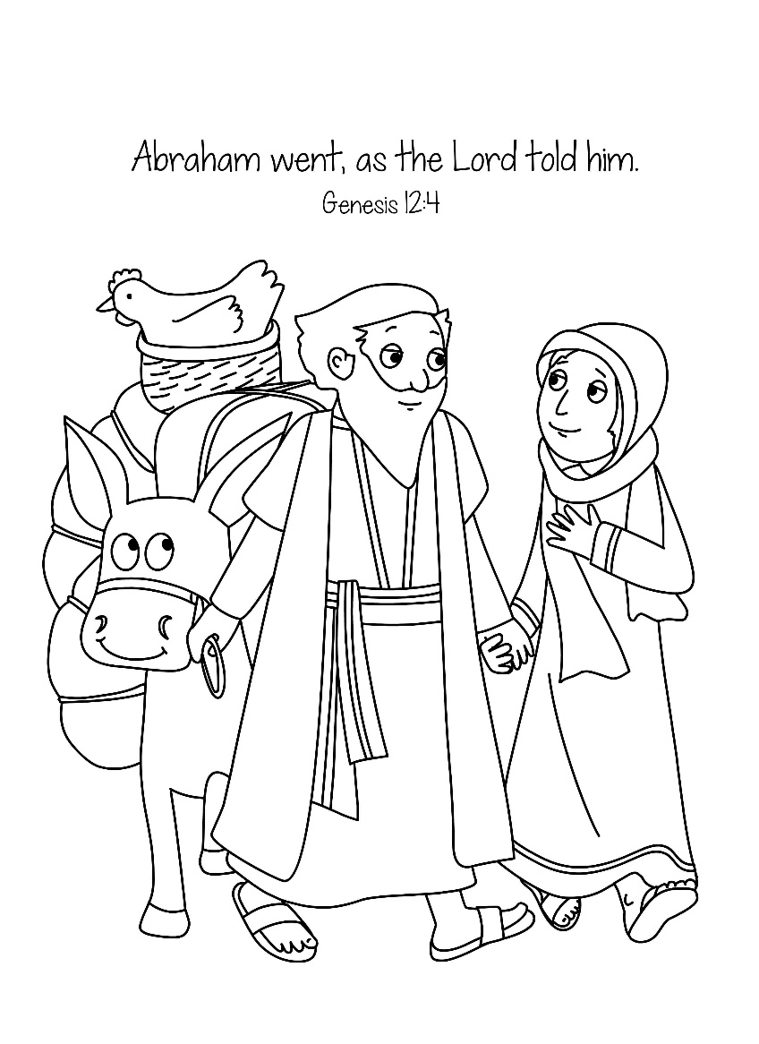
OLD TESTAMENT: Genesis 15:1-6
1After these things the word of the LORD came to Abram in a vision, “Do not be
afraid, Abram, I am your shield; your reward shall be very great.” 2 But Abram said,
“O Lord GOD, what will you give me, for I continue childless, and the heir of my
house is Eliezer of Damascus?” 3 And Abram said, “You have given me no
offspring, and so a slave born in my house is to be my heir.” 4 But the word of the
LORD came to him, “This man shall not be your heir; no one but your very own
issue shall be your heir.” 5 He brought him outside and said, “Look toward heaven
and count the stars, if you are able to count them.” Then he said to him, “So shall
your descendants be.” 6 And he believed the LORD; and the LORD reckoned it to
him as righteousness.
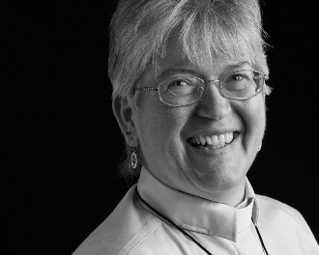
Sermon “When the Word of the Lord Contradicts What We See”

During this time, as you listen to the sermon, please enjoy the activities found on the last page of the Children’s Bulletin.

HYMN #20 God of Abraham and Sarah
God of Abraham and Sarah, God of Moses, Miriam’s Guide
God of David and the prophets, God in Jesus glorified
Up from the dust you raise a people, breathe in the breath of life, of soul;
Down through the years the people praise you till alleluias make them whole!
God who dances in creation, spinning stars above our heads;
God whose face is scribed in music, by whose hand the earth is fed.
Up from the ground you raise the mountains, raise our spirits, lift our eyes;
Down through the years your people praise you till alleluias flood the skies!
Invitation to Generosity
Is there a way you can speak out for something or someone else? Is there a good cause you’d like to learn more about and think of a way the Congregation can get involved in helping you support this cause? Let us know!

*DOXOLOGY
Masithi, Amen, siyakudumisa, Masithi; Amen, siyakudumisa, Masithi;
Amen, Bawo, Amen, Bawo, Amen, siyakudumisa.
Sing amen, Amen, we praise your name, O God, Sing Amen
Amen, we praise your name, O God. Sing Amen
Amen, Amen, Amen, Amen, Amen, we praise your name, O God.
Sharing Joys and Concerns: Do you have a Joy or Concern you’d like to share with the congregation?

WE GO OUT TO LOVE AND SERVE A LOVING, SERVING GOD
HYMN #1 Immortal, Invisible, God only Wise
Immortal, invisible, God only wise,
In light inaccessible hid from our eyes.
Most blessed, most glorious, the Ancient of Days,
Almighty, victorious, your great name we praise.
Unresting, unhasting, and silent as light,
Not wanting, not wasting, but ruling in might;
Your justice like mountains high soaring above,
Your clouds which are fountains of goodness and love.
BENEDICTION (The benediction is a blessing that the Pastor gives over God’s people before they leave service)

POSTLUDE “Go now in peace. Go now in peace. May the love of God surround
you everywhere, everywhere you may go.”
Words & Music: Natalie Sleeth, © 1976 Hinshaw Music, Inc.; All rights reserved.
Reprinted under ONE LICENSE #A-708716.
MINISTERS OF THE CHURCH - Members of the Congregation Members of the Congregation
SENIOR PASTOR AND TEACHER - The Rev. Dr. Deborah Roof
ZOOM/FACEBOOK GREETERS- Anne-Marie Merrill, Sue Lindemann
CHOIR DIRECTOR/ ORGANIST - Joan Virga
CHRISTIAN EDUCATION DIRECTOR - Christine Lehoullier
ADMINISTRATIVE ASSISTANT - Michelle Guerrin
AV/ TECHNICAL – Paul Lindemann

