Children’s Bulletin
First Parish Congregational Church
September 27, 2020

This Last week in september is national fall foliage week

NATIONAL FALL FOLIAGE WEEK HISTORY
In 2014, the Yankee Chef Jim Bailey created National Fall Foliage Week to bring families together as nature changes her coat of many colors for the next season. The day starts each year on the last Sunday in September when the temperatures begin to cool, and harvests begin in earnest. On his website, he reminds us that the time was not only “when families came together for the harvest of the winter crop, but starting on the allocated day of rest, frolic and beauty that was and is, Sunday.”

Please gather the following (optional) items to help you worship today:
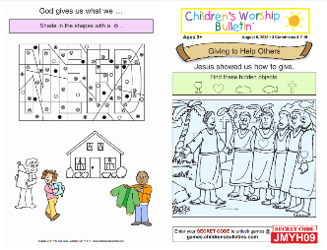
- Crayons, markers, or colored pencils
- You’ll also find an additional activity pages for ages 7+ and 3+ for use during the sermon on the final pages of this Children’s Bulletin

Words of Welcome
Go around the room and greet each person (and pet!) as they traditionally would in India. This greeting is carried out by placing your hands together in a praying position with your fingers pointed upwards and bowing slightly when you say “Namaste.

Sing, dance or shake along! HYMN # 23 There’s a Wideness is God’s Mercy
There’s a wideness in God’s mercy, like the wideness of the sea,
There’s a kindness in God’s justice, which is more than liberty.
There’s no place where earthly sorrows are more felt than in God ‘s heaven;
There’s no place where earthly failings have such kindly judgment given.
For the love of God is broader than the measures of our minds;
And the heart of the Eternal is most wonderfully kind.
If our love were but more faithful, we would gladly trust God’s word;
And our lives would show thanksgiving for the good ness of our God.
Call to Worship & Invocation
Read out loud the words in bold if you can
(God loves when we gather and pray together)

CALL TO WORSHIP:
One: It is time; it is time to set aside our fear -
Many: and praise the God of our ancestors and the God of our children.
One: The God who reaches out to us in the pit of our despair –
Many: God, calls to us in the depths of our dreams.
One: Do not be afraid – for the world that you see
Many: is merely the undercoat of God’s spectacular vision;
One: Do not have fear – for the world around you
Many: Contains more moments of wonder than you can even imagine..
INVOCATION:
Saving God, our eyes see danger all around us. We see the treachery of our
brothers and the uninformed views of people in power but You say “fear not”. We
hear the bitter voices of angry protestors and misguided policemen but You say
“have no fear”. God, deliver us from the surface noise and remind us once again
that Your intention for us is one of ultimate goodness in You. As we worship You
today, calm our hearts and replace any fears with rays of faith in Your will for us.
SONG OF PRAISE Gloria: Gloria, Gloria, in excelsis Deo! Gloria, Gloria, alleluia, alleluia
Time Especially for Children
Let’s sing “Jesus loves me”

CHILDREN’S MESSAGE: Come in close and bring your listening ears

THE LORD’S PRAYER:
Our Father, who art in heaven, hallowed be Thy name. Thy kingdom come; Thy will be done; on earth as it is in heaven. Give us this day our daily bread and forgive us our debts as we forgive our debtors. Lead us not into temptation, but deliver us from evil; for Thine is the Kingdom, and the Power, and the Glory forever. Amen.

Scripture Reading
OLD TESTAMENT: Genesis 37:3-8 (some highlights); 50:15-21
3 Now Israel (Jacob) loved Joseph more than any other of his children, because he was the son of his old age; and he had made him a long robe with sleeves. 4 But when his brothers saw that their father loved him more than all his brothers, they
hated him and could not speak peaceably to him.

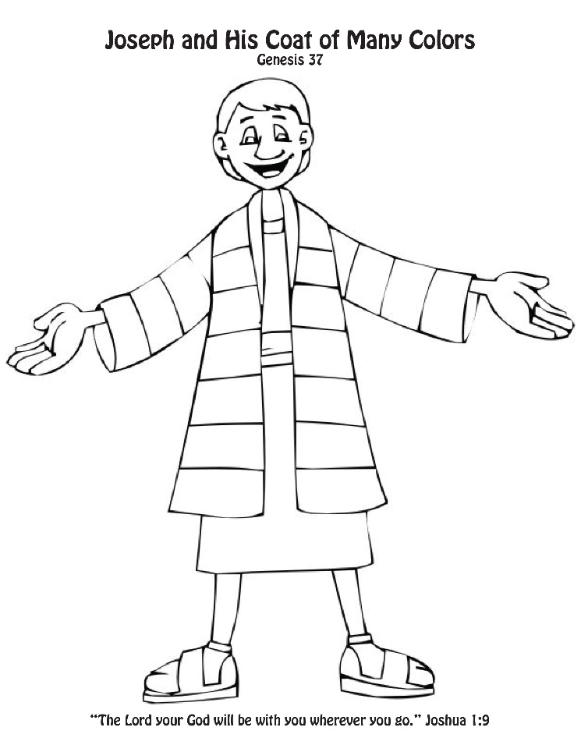
5 Once Joseph had a dream, and when he told it to his brothers, they hated him
even more. 6 He said to them, “Listen to this dream that I dreamed. 7 There we
were, binding sheaves in the field. Suddenly my sheaf rose and stood upright; then
your sheaves gathered around it and bowed down to my sheaf.” 8 His brothers said
to him, “Are you indeed to reign over us? Are you indeed to have dominion over
us?” So they hated him even more because of his dreams and his words.
(Some highlights…)

50:15-21
15 Realizing that their father was dead, Joseph’s brothers said, “What if Joseph still
bears a grudge against us and pays us back in full for all the wrong that we did to
him?” 16 So they approached Joseph, saying, “Your father gave this instruction
before he died, 17 ‘Say to Joseph: I beg you, forgive the crime of your brothers and
the wrong they did in harming you.’ Now therefore please forgive the crime of the
servants of the God of your father.” Joseph wept when they spoke to him. 18 Then
his brothers also wept, fell down before him, and said, “We are here as your
slaves.” 19 But Joseph said to them, “Do not be afraid! Am I in the place of God?
20 Even though you intended to do harm to me, God intended it for good, in order to
preserve a numerous people, as he is doing today. 21 So have no fear; I myself will
provide for you and your little ones.” In this way he reassured them, speaking kindly
to them.

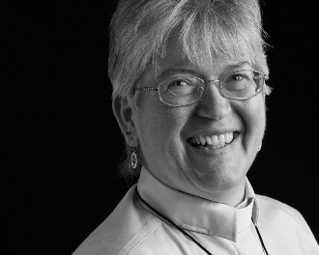
Sermon “The Second Agreement: And Taking it Seriously”

During this time, as you listen to the sermon, please enjoy the activities found on the last page of the Children’s Bulletin.

HYMN # 46 Hope of the World 1, 3
Hope of the world, O Christ of great compassion,
Speak to our fearful hearts by conflict torn.
Save us your people from consuming passion.
From false pursuits through which our lives are worn.
Hope of the world, who by the cross did save us
From death and sad despair, from sin and guilt.
We render back the love your mercy gave us;
Take back our lives and use them as our will.

Invitation to Generosity
There are lots of ways to be generous that don’t involve money!
1. Give your time: read a book to a younger sibling or friend (or even a grandparent)
2. If you want to help a friend with a disability or someone in need, don’t be afraid to ask people to join together to help you in your cause!
3. Give Thanks. You can never be too grateful. Send a thank you note or make a phone call to thank someone for simply being an awesome teacher or person! You’ll be amazed what a difference you can make in someone’s day or even life!

*DOXOLOGY
Masithi, Amen, siyakudumisa, Masithi; Amen, siyakudumisa, Masithi;
Amen, Bawo, Amen, Bawo, Amen, siyakudumisa.
Sing amen, Amen, we praise your name, O God, Sing Amen
Amen, we praise your name, O God. Sing Amen
Amen, Amen, Amen, Amen, Amen, we praise your name, O God.
Sharing Joys and Concerns: Do you have a Joy or Concern you’d like to share with the congregation?

WE GO OUT TO LOVE AND SERVE A LOVING, SERVING GOD

HYMN #547 Amazing Grace 1,3,4
Amazing grace how sweet the sound that saved a wretch like me
I once was lost but now am found was blind but now I see.
Through many dangers, toils, and snares, I have already come;
‘Tis grace has brought me safe thus far, and grace will lead me home.
My God has promised good to me, whose word my hope secures;
God will my shield and portion be as long as life endures.
BENEDICTION (The benediction is a blessing that the Pastor gives over God’s people before they leave service)

POSTLUDE “Go now in peace. Go now in peace. May the love of God surround
you everywhere, everywhere you may go.”
Words & Music: Natalie Sleeth, © 1976 Hinshaw Music, Inc.; All rights reserved.
Reprinted under ONE LICENSE #A-708716.
MINISTERS OF THE CHURCH - Members of the Congregation Members of the Congregation
SENIOR PASTOR AND TEACHER - The Rev. Dr. Deborah Roof
LAY READER – Joanne Worthen
ZOOM/FACEBOOK GREETERS- Jack Martin, Sue Brown.
Atkinson Congregational Church Greeter Darlene Graczyk.
CHOIR DIRECTOR/ ORGANIST - Joan Virga
CHRISTIAN EDUCATION DIRECTOR - Christine Lehoullier
ADMINISTRATIVE ASSISTANT - Michelle Guerrin
AV/ TECHNICAL – Paul Lindemann

