Children’s Bulletin
First Parish Congregational Church
NOVEMBER 1ST, 2020
ALL SAINT’S DAY & COMMUNION SUNDAY

Please gather the following items to help you worship today:
- Bread and juice for communion
- Drawing paper
- Crayons, markers, or colored pencils
- You’ll also find an additional activity pages for use during the sermon on the final pages of this Children’s Bulletin

Words of Welcome

Go around the room and greet each person (and pet!)

HYMN:FOR ALL THE SAINTS
For all the saints who from their labors rest,
Who to the world their steadfast faith confessed,
Your name, O Jesus, be forever blessed - Alleluia! Alleluia!

Still may your people, faithful, true, and bold,
Live as the saints who nobly fought of old,
And share with them a glorious crown of gold. Alleluia! Alleluia!
Call to Worship & Invocation
Read out loud the words in bold or color in the footprints.
CALL TO WORSHIP
One: Come, all who are anxious or burdened
Many: We are brought together in the family of God.
One: Come with expectancy and anticipation.
Many: God is present to greet us and guide your life.
One: We are here to remember the ministry of Jesus.
Many: We have come to be equipped for our ministry.
INVOCATION
Wonderful God, we are here, seeking an extra measure of reassurance, the restoration of our best selves and the clarification of our responsibilities. You are the builder in whose hands the church can become a community of joy and fulfillment. You keep watch over us, strengthening us to be the church wherever we live and serve. Be known to us now in these sacred moments of worship. Amen
CALL TO CONFESSION
At our best, we long to be whole people whose words and deeds are a reflection of the truth within us. We want to be free of pretense and alive to the wonders. God is ready to heal us as we confess our sin.

PRAYER OF CONFESSION (Led by Pastor Deborah)
All wise God, you are aware of the shortcuts we take for our own advantage. You see the ways we pretend to be more than we are. You observe not only our actions but our motives as well. We need your help to put away all that is false and to discover our true identity as your children. Life us up in your forgiving love, we pray. Amen

ASSURANCE OF FORGIVNESS
Those who truly repent and renew their relations with God are welcomed as next of kin by Jesus Christ. The witness of a life lived for the common good inspires us to rise up to the best we can be. We are forgiven. Thanks be to God.

SONG OF PRAISE
Praise our God together singing alleluia, alleluia, alleluia!
Praise our God together singing alleluia, alleluia, alleluia!
Time Especially for Children
Let’s sing “Jesus loves me”
Come in close and bring your listening ears
CHILDREN’S MESSAGE
Write four words that stuck out while you listened to Pastor Deborah’s message:
1.

2.

3.

4.

THE SACRAMENT OF HOLY COMMUNION

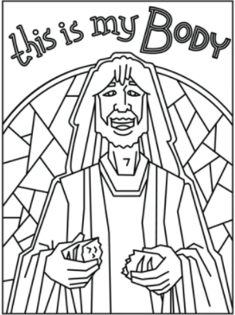
As we take communion together, we think about how much Jesus loves us and we know this by the sacrifices he made. We remember how to stay close to God and Jesus by praying everyday.

INVITATION TO THE TABLE

COMMUNION HYMN: LET US BREAK BREAD TOGETHER
Let us break bread together on our knees;
Let us break bread together on our knees.
When I fall on my knees, with my face to the rising sun,
My God, have mercy on me.
Let us praise God together on our knees;
Let us praise God together on our knees;
When I fall on my knees, with my face to the rising sun,
My God, have mercy on me.

OUR SACRED STORY

SHARING THE PEACE OF CHRIST
Go around the room and say or sign, “Peace be with you” to everyone near and far away!

PEACE HYMN: LET THERE BE PEACE ON EARTH
Let there be peace on earth and let it begin with me.
Let there be peace on earth, the peace that was meant to be.
With God our Creator, we are family,
Let me walk with my neighbor, in perfect harmony.

Let peace begin with me, let this be the moment now.
With every step I take, let this be my solemn vow;
To take each moment and live each moment in peace eternally.
Let there be peace on earth and let it begin with me.

PRAYER OF CONSECRATION followed by

THE LORD’S PRAYER:
Our Father, who art in heaven, hallowed be Thy name. Thy kingdom come; Thy will be done; on earth as it is in heaven. Give us this day our daily bread and forgive us our debts as we forgive our debtors. Lead us not into temptation, but deliver us from evil; for Thine is the Kingdom, and the Power, and the Glory forever. Amen.

SCRIPTURE READING
Draw a picture of what you hear in the Bible passages while you listen to the story.
OLD TESTAMENT: 1 Kings 17:1-16
1 Now Elijah the Tishbite, of Tishbe in Gilead, said to Ahab, "As the Lord the God of Israel lives, before whom I stand, there shall be neither dew nor rain these years, except by my word."
2 The word of the Lord came to him, saying,
3 "Go from here and turn eastward, and hide yourself by the Wadi Cherith, which is east of the Jordan. 4 You shall drink from the wadi, and I have commanded the ravens to feed you there."
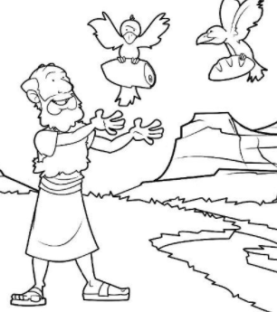
5 So he went and did according to the word of the Lord; he went and lived by the Wadi Cherith, which is east of the Jordan. 6 The ravens brought him bread and meat in the morning, and bread and meat in the evening; and he drank from the wadi. 7 But after a while the wadi dried up, because there was no rain in the land. 8 Then the word of the Lord came to him, saying,
9 "Go now to Zarephath, which belongs to Sidon, and live there; for I have commanded a widow there to feed you."
10 So he set out and went to Zarephath. When he came to the gate of the town, a widow was there gathering sticks; he called to her and said, "Bring me a little water in a vessel, so that I may drink."
11 As she was going to bring it, he called to her and said, "Bring me a morsel of bread in your hand."
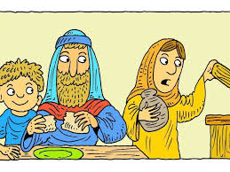
12 But she said, "As the Lord your God lives, I have nothing baked, only a handful of meal in a jar, and a little oil in a jug; I am now gathering a couple of sticks, so that I may go home and prepare it for myself and my son, that we may eat it, and die."
13 Elijah said to her, "Do not be afraid; go and do as you have said; but first make me a little cake of it and bring it to me, and afterwards make something for yourself and your son. 14 For thus says the Lord the God of Israel: The jar of meal will not be emptied and the jug of oil will not fail until the day that the Lord sends rain on the earth."
15 She went and did as Elijah said, so that she as well as he and her household ate for many days. 16 The jar of meal was not emptied, neither did the jug of oil fail, according to the word of the Lord that he spoke by Elijah.

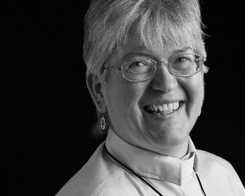
Sermon
During this time, as you listen to the sermon, please enjoy the activities found on the last pages of the Children’s Bulletin

HYMN:THERE’S A WIDENESS IN GOD’S MERCY
There’s a wideness in God’s mercy, like the wideness of the sea;
There’s a kindness in God’s justice, which is more than liberty.
There’s no place where earthly sorrows are more felt than in God’s heaven;
There’s no place where earthly failings have such kindly judgment given
For the love of God is broader than the measures of our minds;
And the heart of the Eternal is most wonderfully kind.
If our love were but more faithful, we would gladly trust God’s word;
And our lives would show thanksgiving for the goodness of our God.

Invitation to Generosity

*DOXOLOGY
Rejoice, give thanks and sing; your Sovereign God adore!
For Christ has robbed death’s sting and triumphs evermore.
Lift up your heart, lift up your voice! Rejoice, again I say, rejoice.

PRAYER OF DEDICATION
We give in the spirit of Jesus, whose whole life was committed to proclaiming your love, gracious God. Our offerings today are a token of the gifts we now invest in the work of your realm that is forever, with beginnings among us now. Amen

Sharing Joys and Concerns: Do you have a Joy or Concern you’d like to share with the congregation?

WE GO OUT TO LOVE AND SERVE A LOVING, SERVING GOD

HYMN #448 Take My Life and Let it Be
Take my life, God, let it be consecrated faithfully.
Take my moments and my days, let them flow in ceaseless praise.
Take my love and help it grow; let my loving overflow.
Take me now, and help me be part of Christ’s community.

BENEDICTION: The Pastor often will give a benediction at the end of service. This is like a special prayer asking for God’s help, guidance and blessing over everyone before the end of service.

POSTLUDE “Go now in peace. Go now in peace. May the love of God surround you everywhere, everywhere you may go.” Words & Music: Natalie Sleeth, © 1976 Hinshaw Music, Inc.; All rights reserved. Reprinted under ONE LICENSE #A-708716.

A Collection of Expressions of Gratitude – put to music!
What are you grateful for? Show us! Tell us! The CE Board invites EVERYONE to participate in this amazing expression of our congregation’s sentiments of gratitude! We need from you a short voice recording of what you are grateful for. Or send along photos or drawings!
We need these by November 14th. More details can be found in the November newsletter. E-mail Christine Lehoullier at cedirector@fpc-ucc.org/ 603-264-9261 with any questions.
Here are some gratitude ideas that help if you ever get stuck (these are really helpful sometimes!) :

