Children’s Bulletin
First Parish Congregational Church
OCTOBER 11, 2020

Please gather the following (optional) items to help you worship today:
- Drawing paper
- Crayons, markers, or colored pencils
- You’ll also find an additional activity pages for use during the sermon on the final pages of this Children’s Bulletin (AND SOME SPECIAL PAGES FOR PASTOR APPRECIATION SUNDAY THIS WEEK!)

Words of Welcome

Go around the room and greet each person (and pet!)
Sing along! HYMN #383 Come, Let Us Join with Faithful Souls
Come, let us join with faithful souls our song of faith to raise;
One family in heart are we, and one the God we praise.

Faithful are all who love the truth and perfect truth proclaim,
Who steadfast stand at God’s right hand and glorify God’s name.

O God of hosts, our faith renew and grant us, in your grace,
To join the songs sung by the saints in every time and place.

Call to Worship & Invocation
Read out loud the words in bold or color the picture.

CALL TO WORSHIP
One: Come away from the valleys of misplaced loyalty
Many: So many things in the world would lure us from God.
One: Come with open hearts, seeking God’s Presence.
Many: God’s steadfast love and enduring compassion endure.
One: We can rejoice that ours is a God of hope, of trust and of truth.
Many: Let us embrace the welcome of God.
INVOCATION (unison) Gracious God, you have invited and welcomed us to this time of worship. When we come together in Spirit, we sense the Peace that you intend. All of the mysteries of life are in Your mind and we but catch glimpses when we seek You. We want to meet with You again and be reminded that You created us, You loved us into being and You support us on this journey of life. Amen.
SONG OF PRAISE #236
Halle, halle, hallelujah. Halle, halle, hallelujah
Halle, halle, hallelujah. Halleluja, hallelujah.

Time Especially for Children
Let’s sing “Jesus loves me”
Come in close and bring your listening ears

CHILDREN’S MESSAGE

PRAYER OF CONSECRATION followed by
THE LORD’S PRAYER:
Our Father, who art in heaven, hallowed be Thy name. Thy kingdom come; Thy will be done; on earth as it is in heaven. Give us this day our daily bread and forgive us our debts as we forgive our debtors. Lead us not into temptation, but deliver us from evil; for Thine is the Kingdom, and the Power, and the Glory forever. Amen.

Scripture Reading
Draw a picture of what you hear in the Bible passages.
OLD TESTAMENT: Exodus 32:1-14

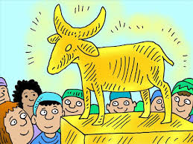
1 When the people saw that Moses delayed to come down from the mountain, the people gathered around Aaron, and said to him, “Come, make gods for us, who shall go before us; as for this Moses, the man who brought us up out of the land of Egypt, we do not know what has become of him.” 2 Aaron said to them, “Take off the gold rings that are on the ears of your wives, your sons, and your daughters, and bring them to me.” 3 So all the people took off the gold rings from their ears, and brought them to Aaron. 4 He took the gold from them, formed it in a mold, and cast an image of a calf; and they said, “These are your gods, O Israel, who brought you up out of the land of Egypt!” 5 When Aaron saw this, he built an altar before it; and Aaron made proclamation and said, “Tomorrow shall be a festival to the LORD.” 6 They rose early the next day, and offered burnt offerings and brought sacrifices of well-being; and the people sat down to eat and drink, and rose up to revel.

7 The LORD said to Moses, “Go down at once! Your people, whom you brought up out of the land of Egypt, have acted perversely; 8 they have been quick to turn aside from the way that I commanded them; they have cast for themselves an image of a calf, and have worshiped it and sacrificed to it, and said, ‘These are your gods, O Israel, who brought you up out of the land of Egypt!’” 9 The LORD said to Moses, “I have seen this people, how stiff-necked they are. 10 Now let me alone, so that my wrath may burn hot against them and I may consume them; and of you I will make a great nation.”

11 But Moses implored the LORD his God, and said, “O LORD, why does your wrath burn hot against your people, whom you brought out of the land of Egypt with great power and with a mighty hand? 12 Why should the Egyptians say, ‘It was with evil intent that he brought them out to kill them in the mountains, and to consume them from the face of the earth’? Turn from your fierce wrath; change your mind and do not bring disaster on your people. 13 Remember Abraham, Isaac, and Israel, your servants, how you swore to them by your own self, saying to them, ‘I will multiply your descendants like the stars of heaven, and all this land that I have promised I will give to your descendants, and they shall inherit it forever.’” 14 And the LORD changed his mind about the disaster that he planned to bring on his people.

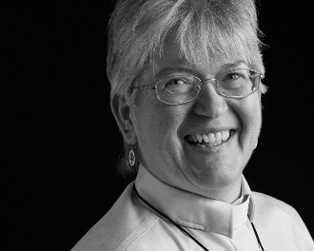
Sermon
During this time, as you listen to the sermon, please enjoy the activities found on the last page of the Children’s Bulletin

Sing along! HYMN #222 My Song Is Love Unknown
My son is love unknown, my Savior’s love to me,
Love to the loveless shown, that they might lovely be.
O who am I, that for my sake my God should take frail
flesh and die? My God should take frail flesh and die?

I sing my plain belief, one song my heart outpours;
Never was pain nor grief, never was love like yours.
This is my Friend, in whose sweet praise I all my days could
Gladly spend; I all my days could gladly spend.
Invitation to Generosity

*DOXOLOGY #780
Praise God from whom all blessings flow;
Praise God all creatures here below;
Praise God above you heavenly host;
Creator, Christ, and Holy Ghost. Amen

PRAYER OF DEDICATION
Holy God of all Creation, bless these gifts, we pray. May our offerings help to
provide food to the hungry and clothing to the naked; may strangers be welcomed
and prisoners be comforted; may the thirsty drink the water of eternal life and may
the sick and infirmed know God’s healing touch. All of this, through the gifts that we
dedicate here today and beyond. Amen.

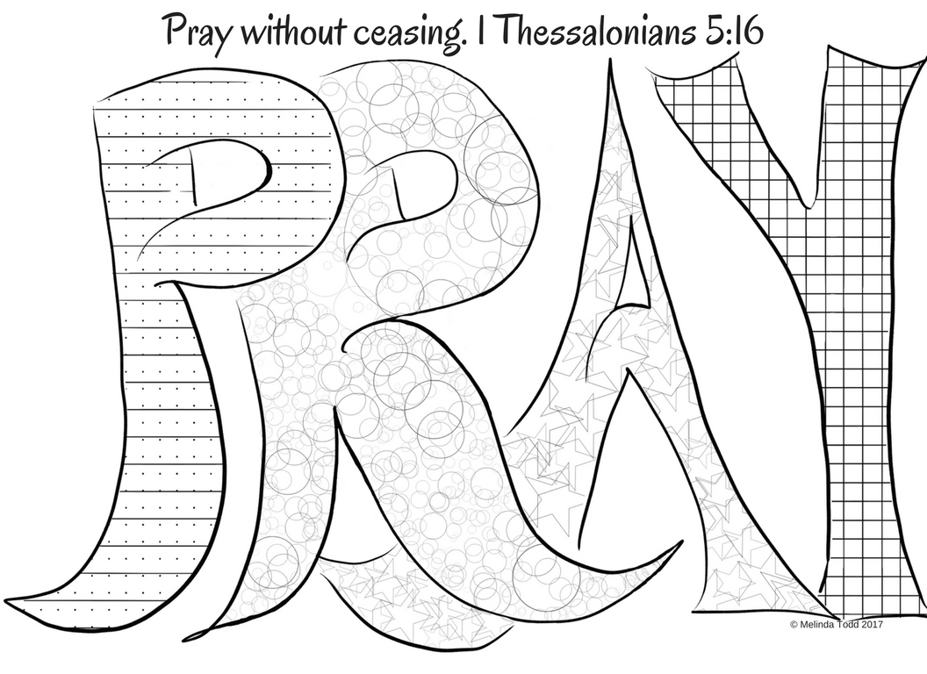
Sharing Joys and Concerns: Do you have a Joy or Concern you’d like to share with the congregation?

WE GO OUT TO LOVE AND SERVE A LOVING, SERVING GOD

Sing along! HYMN #377 Forward Through the Ages
Forward through the ages, in unbroken line,
Move the faithful spirits at the call divine;
Gifts in differing measure, hearts of one accord,
Manifold in service, one the sure reward.
Forward through the ages, in unbroken line,
Move the faithful spirits at the call divine.

Not alone we conquer, not alone we fall;
In each loss or triumph, lose or triumph all.
Bound by God’s far purpose in one living whole,
Move we on together to the shining goal
Forward through the ages, in unbroken line,
Move the faithful spirits at the call divine.

BENEDICTION: The Pastor often will give a benediction at the end of service. This is like a special prayer asking for God’s help, guidance and blessing over everyone before the end of service.

POSTLUDE “Go now in peace. Go now in peace. May the love of God surround you everywhere, everywhere you may go.” Words & Music: Natalie Sleeth, © 1976 Hinshaw Music, Inc.; All rights reserved. Reprinted under ONE LICENSE #A-708716.

MINISTERS OF THE CHURCH - Members of the Congregation Members of the Congregation
SENIOR PASTOR AND TEACHER - The Rev. Dr. Deborah Roof
LAY READER – Sue Brown
GREETERS – Rachel Cobban, Brian Williams
CHOIR DIRECTOR/ ORGANIST - Joan Virga
CHRISTIAN EDUCATION DIRECTOR - Christine Lehoullier
ADMINISTRATIVE ASSISTANT - Michelle Guerrin
Visit our Facebook page or our website for recent videos of services and moments of
Christian Faith Formation and inspiration.
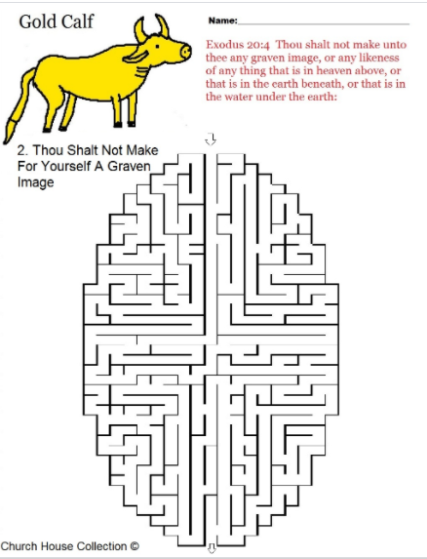

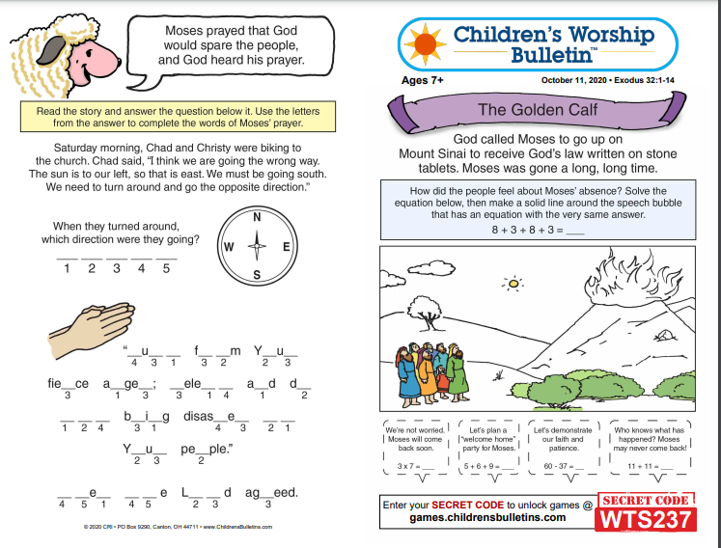
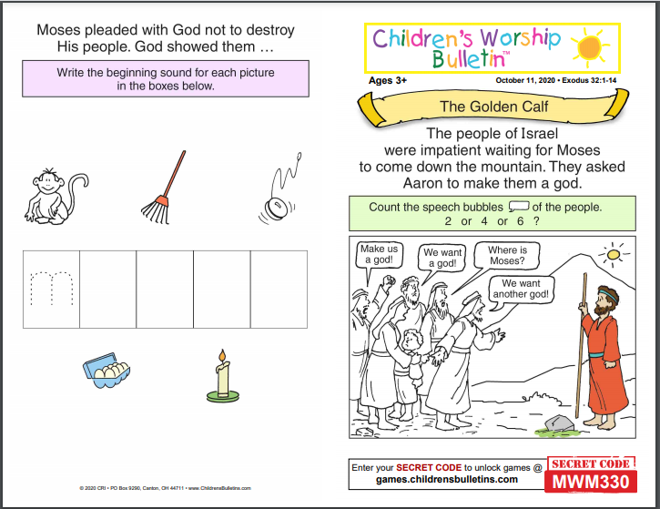
“Thank EWE for being the best pastor! Love, Your FLOCK.”
Try drawing a picture of a sheep and send a picture of it either with you or with you and your family in it! I’d love to print them out and give them to Pastor Deborah or you can send them to her yourself! If you’d like to text them to me, my #603-264-9261 or e-mail me @ cedirector@fpc-ucc.org. You could also simply send the picture of the sheep without you in it if you’re shy ; ) Just don’t forget to tell me who it’s from!

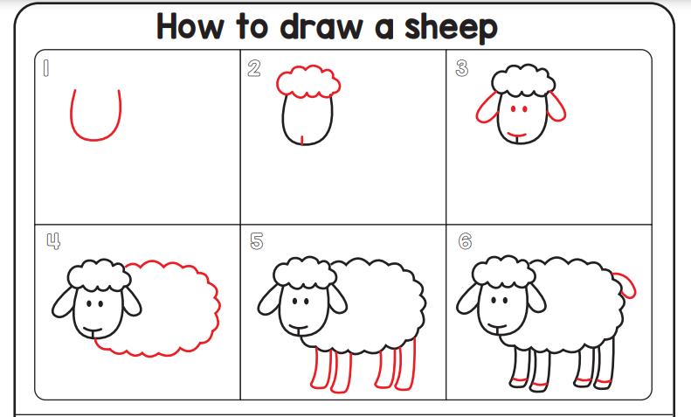

To: Pastor Deborah From: _________________________________________

