Children’s Bulletin
First Parish Congregational Church
OCTOBER 25, 2020
THIS WEEK IN OCTOBER:
World Origami Days: 24-11/11
Kids Care Week: 25-31 (Always Includes 10/27 Make A Difference Day)
Let’s combine Kids Care Week and World Origami Days by joining the Peace Crane Project ! Just click on the picture of the Peace Crane Project Icon to the left to learn what it’s all about. Here are some easy origami instructions you can follow to make your own “Peace Doves”:
Please gather the following (optional) items to help you worship today:
- Drawing paper
- Crayons, markers, or colored pencils
- You’ll also find an additional activity pages for use during the sermon on the final pages of this Children’s Bulletin (AND SOME SPECIAL PAGES FOR PASTOR APPRECIATION MONTH FOR THE MONTH OF OCTOBER! PLEASE TAKE A PICTURE AND SEND THEM TO ME IF YOU COMPLETE THEM SO I CAN GATHER AND SEND THEM TO PASTOR DEBORAH IN ONE PRETTY PACKAGE – THANKS!)
Words of Welcome

Go around the room and greet each person (and pet and pumpkin! )

Sing along! HYMN ##122 Come Thou Long Expected Jesus
Come, Thou long expected Jesus, born to set all people free;
From our fears and sins release us; grant us your true liberty.
Israel’s strength and consolation, hope to all the earth impart;
Dear desire of every nation, enter every longing heart.
By your own eternal Spirit, come to claim us as your own;
By your all sufficient merit, let us share your cross and crown.

Call to Worship & Invocation
Read out loud the words in bold or color the picture.

CALL TO WORSHIP
One: Come! Come to praise our Holy and timeless God!
Many: Come! Come to worship our God of past, present and future!
One: Come! Come to hear the wisdom, embrace the glory and bask in the light of God!
Many: We come to listen to the holy Word of God and to hear God’s will for our lives.
One: We come to feel the encompassing compassion of God and breathe in God’s peace.
Many: We come to unite under God’s loving countenance.

INVOCATION (unison) God of shepherds and kings, God of past and future, remind us of the promises of old and remind us that to you those promises are as present to us and they were to David. May we be transformed from our noble shepherd mindset to the very heart of beneficent royalty. May our Spirits be ignited once again with divine passion for a new Calling – one of courage and truth in these chaotic times. Amen.

SONG OF PRAISE #236
Halle, halle, hallelujah. Halle, halle, hallelujah
Halle, halle, hallelujah. Halleluja, hallelujah.
Time Especially for Children
Let’s sing “Jesus loves me”
Come in close and bring your listening ears

CHILDREN’S MESSAGE

PRAYER OF CONSECRATION followed by
THE LORD’S PRAYER:
Our Father, who art in heaven, hallowed be Thy name. Thy kingdom come; Thy will be done; on earth as it is in heaven. Give us this day our daily bread and forgive us our debts as we forgive our debtors. Lead us not into temptation, but deliver us from evil; for Thine is the Kingdom, and the Power, and the Glory forever. Amen.

Scripture Reading
Draw a picture of what you hear in the Bible passages.
OLD TESTAMENT: 2 Samuel 7:1-17

1 Now when the king was settled in his house, and the Lord had given him rest from all his enemies around him, 2 the king said to the prophet Nathan, "See now, I am living in a house of cedar, but the ark of God stays in a tent." 3 Nathan said to the king, "Go, do all that you have in mind; for the Lord is with you."
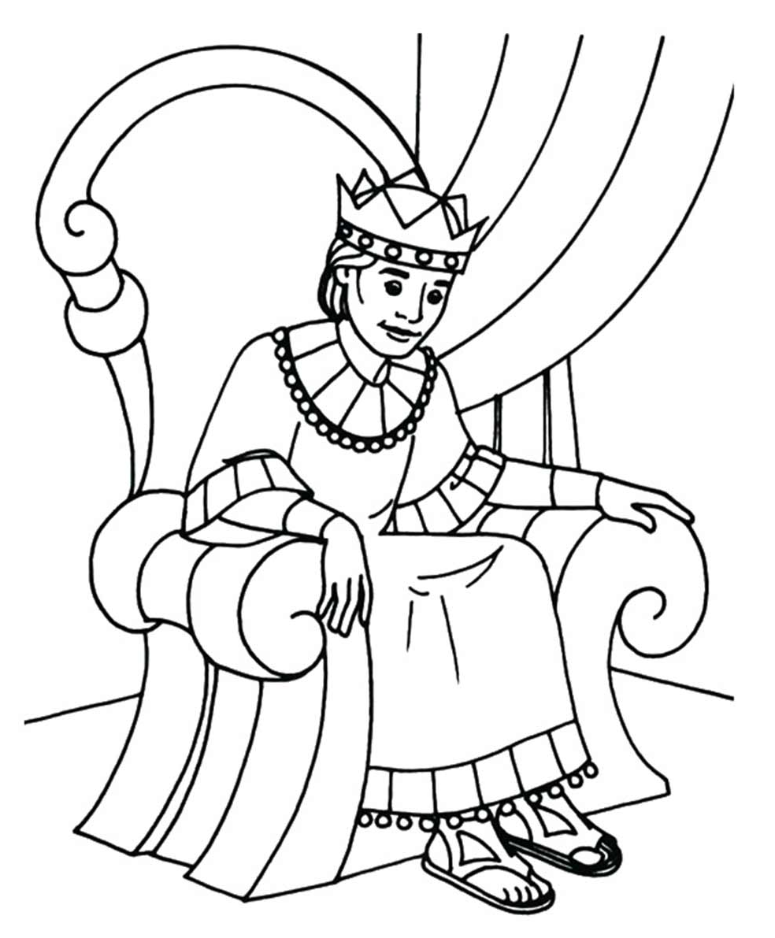
4 But that same night the word of the Lord came to Nathan: 5 Go and tell my servant David: Thus says the Lord: Are you the one to build me a house to live in? 6 I have not lived in a house since the day I brought up the people of Israel from Egypt to this day, but I have been moving about in a tent and a tabernacle. 7 Wherever I have moved about among all the people of Israel, did I ever speak a word with any of the tribal leaders of Israel, whom I commanded to shepherd my people Israel, saying, "Why have you not built me a house of cedar?" 8 Now therefore thus you shall say to my servant David: Thus says the Lord of hosts: I took you from the pasture, from following the sheep to be prince over my people Israel; 9 and I have been with you wherever you went, and have cut off all your enemies from before you; and I will make for you a great name, like the name of the great ones of the earth. 10 And I will appoint a place for my people Israel and will plant them, so that they may live in their own place, and be disturbed no more; and evildoers shall afflict them no more, as formerly, 11 from the time that I appointed judges over my people Israel; and I will give you rest from all your enemies. Moreover the Lord declares to you that the Lord will make you a house. 12 When your days are fulfilled and you lie down with your ancestors, I will raise up your offspring after you, who shall come forth from your body, and I will establish his kingdom. 13 He shall build a house for my name, and I will establish the throne of his kingdom forever. 14 I will be a father to him, and he shall be a son to me. When he commits iniquity, I will punish him with a rod such as mortals use, with blows inflicted by human beings. 15 But I will not take my steadfast love from him, as I took it from Saul, whom I put away from before you. 16 Your house and your kingdom shall be made sure forever before me; your throne shall be established forever.
17 In accordance with all these words and with all this vision, Nathan spoke to David.

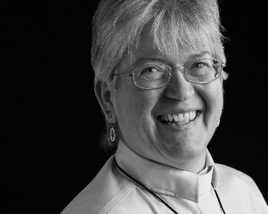
Sermon
During this time, as you listen to the sermon, please enjoy the activities found on the last pages of the Children’s Bulletin

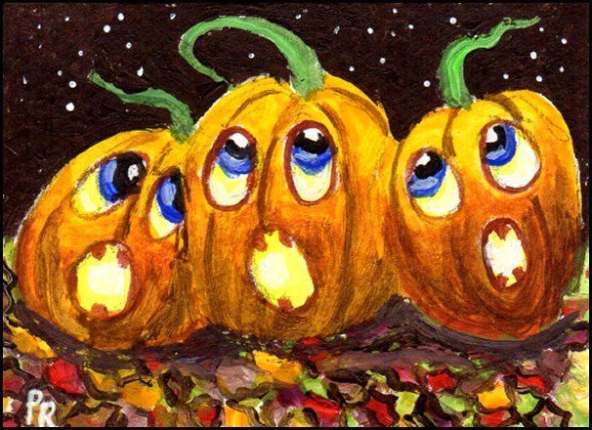
HYMN #350 Now in the Days of Youth
Now in the days of youth when life is filled with choice,
When hope and doubt touch every hour, when all thoughts find a voice,
We turn, O God, to you for guidance and for grace.
In all our days, in all our ways, help us to seek your face.

Teach us to use our lives with purpose and with power
For visions of a better world and for decision’s hour;
To choose the way of life, reject the way of death,
Until the radiant force of God fills mind and strength and breath.

Teach us to love in truth, to give and to receive
With joyful and with open hearts, with all that we believe;
To seek another’s good, to honor what is right,
To let our will and our desire be held in holy light.

Teacher, Creator, God, enfold us in your arms;
Be with us as we try our wings, and keep us safe from harm.
All good and perfect gifts come to us from your hand.
O help us use them carefully and live by love’s command.

Invitation to Generosity: Think about how you would like to give to others, yourself and your family this week to show how you love yourself and others just like God loves us

*DOXOLOGY #780
Praise God from whom all blessings flow;
Praise God all creatures here below;
Praise God above you heavenly host;
Creator, Christ, and Holy Ghost. Amen

PRAYER OF DEDICATION
Generous God of all good gifts, we give not because we must. We give because we want to acknowledge in some small way the generosity that we receive from you. We ask your blessing upon these gifts that through them your children in our neighborhoods and around the world may know you that much more. With humble gratitude we pray. Amen.

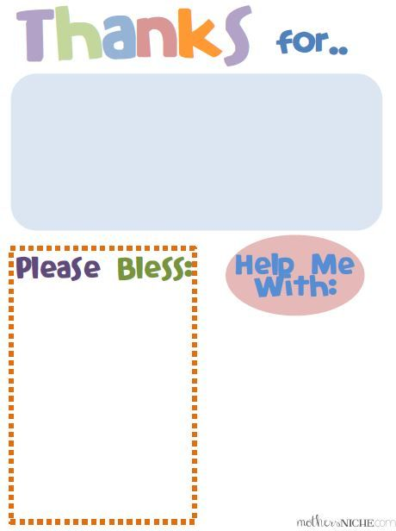
Sharing Joys and Concerns: Do you have a Joy or Concern you’d like to share with the congregation?

WE GO OUT TO LOVE AND SERVE A LOVING, SERVING GOD
HYMN #257 Alleluia, Gracious Jesus
Alleluia! Not as orphans are we left in sorrow now.
Alleluia! You are near us; faith believes, nor questions how.
Though the cloud from sight received you when the forty days were o’er.
Shall our hearts forget your promise, “I am with you evermore.”

Alleluia! Christ eternal, nothing can disrupt your reign;
Alleluia! Born of Mary, heaven and earth are your domain.
Human life you fully entered, tending those we count the least,
Serving both as Priest and Victim, in the Eucharistic feast.

BENEDICTION: The Pastor often will give a benediction at the end of service. This is like a special prayer asking for God’s help, guidance and blessing over everyone before the end of service.

POSTLUDE “Go now in peace. Go now in peace. May the love of God surround you everywhere, everywhere you may go.” Words & Music: Natalie Sleeth, © 1976 Hinshaw Music, Inc.; All rights reserved. Reprinted under ONE LICENSE #A-708716.

MINISTERS OF THE CHURCH - Members of the Congregation Members of the Congregation
SENIOR PASTOR AND TEACHER - The Rev. Dr. Deborah Roof
LAY READER - Jo Worthen CHOIR DIRECTOR/ ORGANIST - Joan Virga
CHRISTIAN EDUCATION DIRECTOR - Christine Lehoullier
ADMINISTRATIVE ASSISTANT - Michelle Guerrin
Visit our Facebook page or our website for recent videos of services and moments of
Christian Faith Formation and inspiration.

Thank EWE for being the best pastor! Love, Your FLOCK.”
Try drawing a picture of a sheep and send a picture of it either with you or with you and your family in it! I’d love to print them out and give them to Pastor Deborah or you can send them to her yourself! If you’d like to text them to me, my #603-264-9261 or e-mail me @ cedirector@fpc-ucc.org. You could also simply send the picture of the sheep without you in it if you’re shy ; ) Just don’t forget to tell me who it’s from!

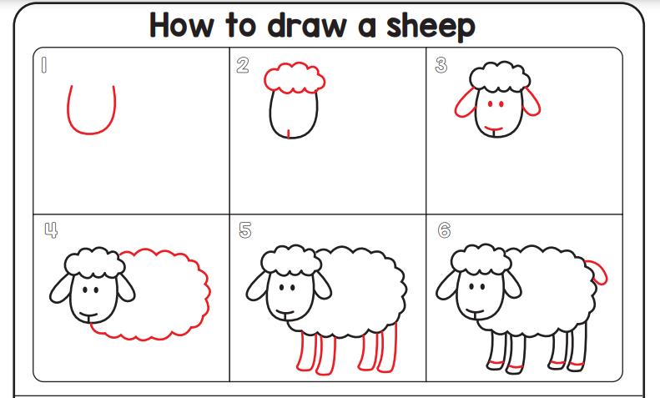

To: Pastor Deborah From: _________________________________________

