Children’s Bulletin
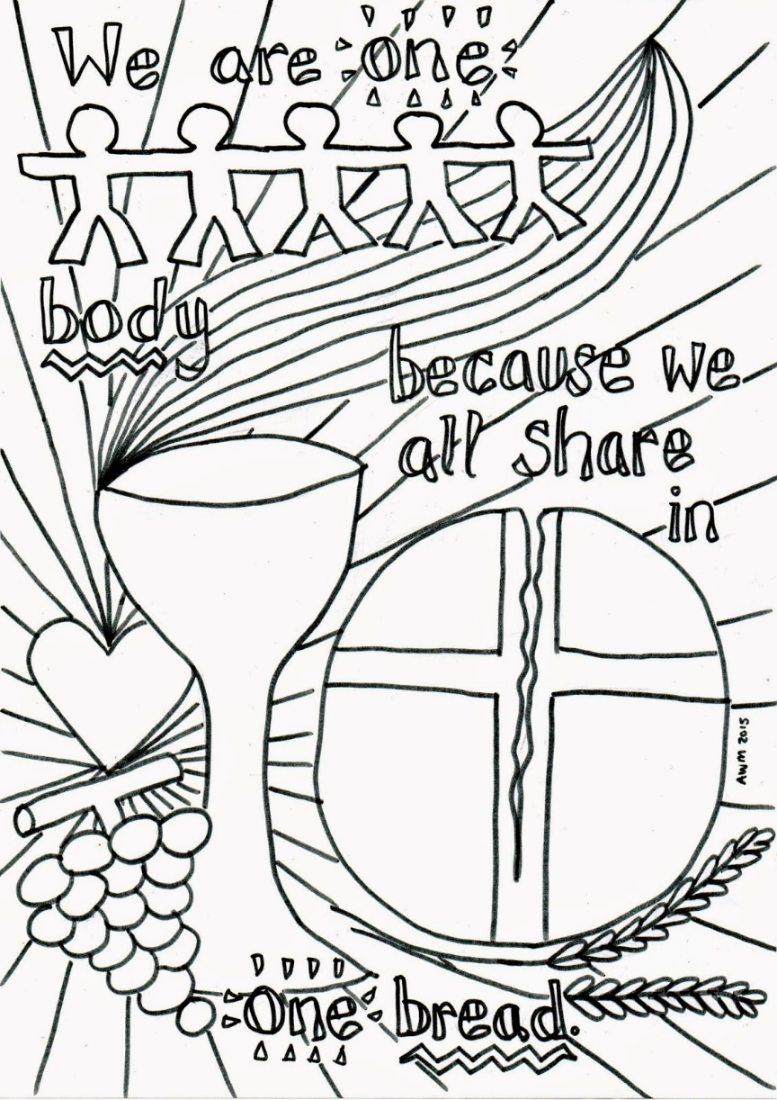
First Parish Congregational Church
OCTOBER 4, 2020

THE FIRST SUNDAY IN OCTOBER IS WORLD COMMUNION SUNDAY!

Please gather the following (optional) items to help you worship today:
- Bread and juice for communion
- Drawing paper
- Crayons, markers, or colored pencils
- You’ll also find an additional activity pages for use during the sermon on the final pages of this Children’s Bulletin

Words of Welcome

Go around the room and greet each person (and pet!)
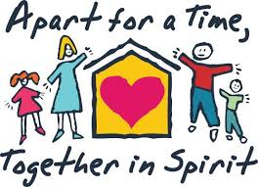

HYMN #55 Rejoice, You Pure in Heart
Rejoice, you pure in heart; lift praises to the sky:
Your festal banner wave with joy, the cross of Christ raise high!
Rejoice, rejoice, rejoice, give thanks and sing.
Yes, on through life’s long path, still chanting as you go,
From youth to age, by night and day, in gladness and in woe;
Rejoice, rejoice, rejoice, give thanks and sing.
Call to Worship & Invocation
Read out loud the words in bold or color in the footprints.

CALL TO WORSHIP
One: “Observe the Sabbath day and keep it holy” says the LORD.
Many: We gather around the world on this sacred day of unified Communion.
One: We bring our songs of joy and thankfulness to our Creator and Redeemer.
Many: And our hearts and voices join in a chorus of worldwide praise.

INVOCATION
Light of lights, shine into our days, granting knowledge of Your wonder in the
face of Christ Jesus. In many ways, Paul’s words are ours: “we are afflicted
but not crushed; perplexed but not driven to despair, struck down but not
destroyed-for we are confident of Your presence wherever we go.” Reassure
us once again of Your lavish generosity and abundant compassion. Amen.

CALL TO CONFESSION:
We hold the treasures of heaven in clay jars. We become enslaved to habits that do
build up the body of Christ. We become addicted to activities that consume our time
and energies. Let us seek forgiveness and a better way.

PRAYER OF CONFESSION:
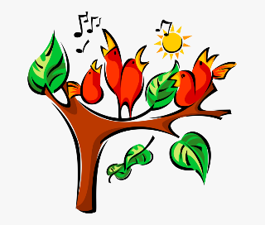
Holy God, help us know a vision of what life could be if we truly followed Your way. Your gifts are often ignored or overlooked. We admit our shortsighted views. We let our appetites rule us. We squander the gift of time in frivolous pursuits. O God, find us here. We want the life you offer in Jesus Christ. Forgive and help us, we pray. Amen.

SONG OF PRAISE #236
Halle, halle, hallelujah. Halle, halle, hallelujah
Halle, halle, hallelujah. Halleluja, hallelujah.
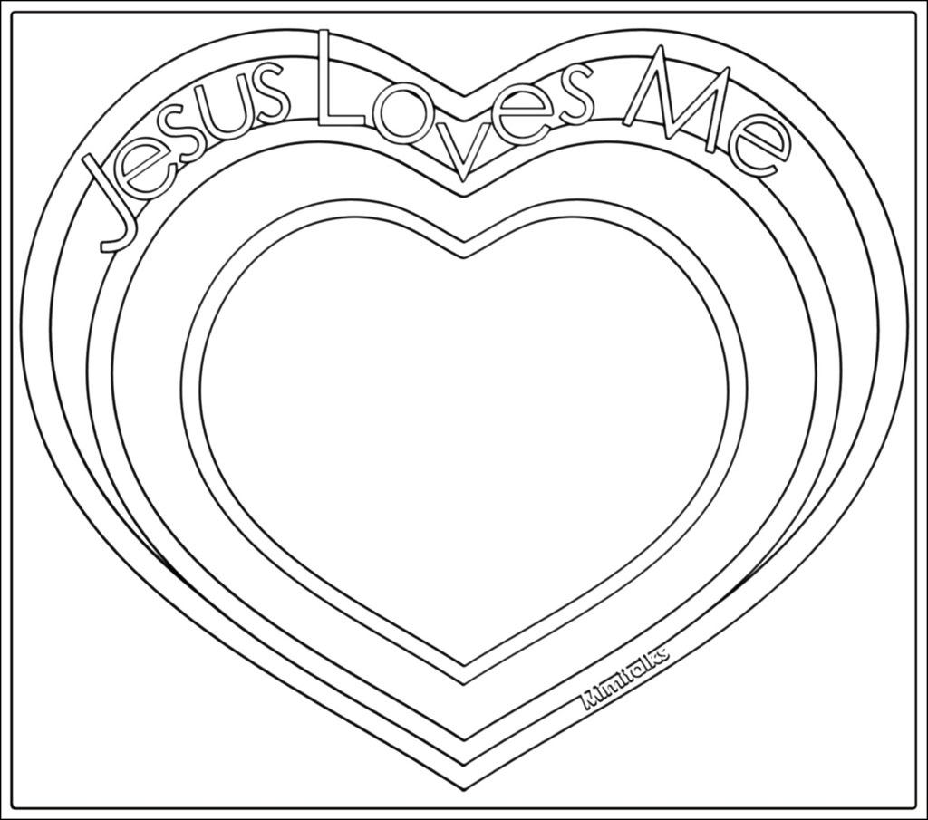
Time Especially for Children
Let’s sing “Jesus loves me”
Come in close and bring your listening ears

CHILDREN’S MESSAGE
Draw a picture of what you heard Pastor Deborah talk about:

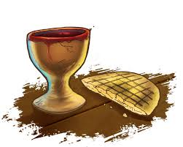
THE SACRAMENT OF HOLY COMMUNION

As we take communion together, we think about how much Jesus loves us and we know this by the sacrifices he made. We remember how to stay close to God and Jesus by praying everyday.

INVITATION TO THE TABLE

COMMUNION HYMN #332 As We Gather at Your Table
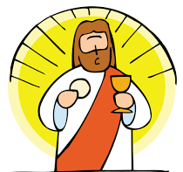
As we gather at your table, as we listen to your word,
Help us know, O God, your presence; let our hearts and minds be stirred,
Nourish us with sacred story till we claim it as our own;
Teach us through this holy banquet how to make Love’s victory known.
Turn our worship into witness in the sacrament of life;
Send us forth to love and serve you, bringing peace where there is strife.
Give us, Christ, your great compassion to forgive as you forgave;
May we still behold your image in the world you died to save.
SHARING THE PEACE OF CHRIST
Go around the room and say or sign, “Peace be with you” to everyone near and far away!

PEACE HYMN: Let there Be Peace on Earth
Let there be peace on earth and let it begin with me.
Let there be peace on earth, the peace that was meant to be.
With God our Creator, we are family,
let me walk with my neighbor, in perfect harmony.
Let peace begin with me, let this be the moment now.
With every step I take, let this be my solemn vow;
To take each moment and live each moment in peace eternally.
Let there be peace on earth and let it begin with me.

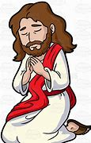
PRAYER OF CONSECRATION followed by

THE LORD’S PRAYER:
Our Father, who art in heaven, hallowed be Thy name. Thy kingdom come; Thy will be done; on earth as it is in heaven. Give us this day our daily bread and forgive us our debts as we forgive our debtors. Lead us not into temptation, but deliver us from evil; for Thine is the Kingdom, and the Power, and the Glory forever. Amen.

Scripture Reading
Draw a picture of what you hear in the Bible passages.
OLD TESTAMENT: Exodus 12:1-13; 13:1-8 OLD TESTAMENT: Exodus 12:1-13; 13:1-8
1
The LORD said to Moses and Aaron in the land of Egypt: 2
This month shall mark
for you the beginning of months; it shall be the first month of the year for you. 3
Tell
the whole congregation of Israel that on the tenth of this month they are to take a
lamb for each family, a lamb for each household. 4
If a household is too small for a
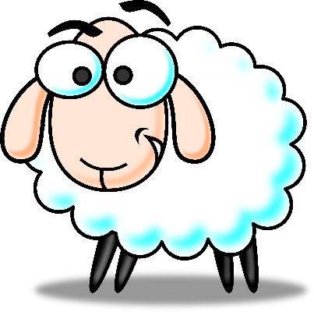
whole lamb, it shall join its closest neighbor in obtaining one; the lamb shall be
divided in proportion to the number of people who eat of it. 5 Your lamb shall be
without blemish, a year-old male; you may take it from the sheep or from the goats.
6 You shall keep it until the fourteenth day of this month; then the whole assembled
congregation of Israel shall slaughter it at twilight. 7
They shall take some of the
blood and put it on the two doorposts and the lintel of the houses in which they eat
it. 8
They shall eat the lamb that same night; they shall eat it roasted over the fire
with unleavened bread and bitter herbs. 9 Do not eat any of it raw or boiled in water,
but roasted over the fire, with its head, legs, and inner organs. 10 You shall let none
of it remain until the morning; anything that remains until the morning you shall
burn. 11 This is how you shall eat it: your loins girded, your sandals on your feet, and
your staff in your hand; and you shall eat it hurriedly. It is the passover of the LORD.
12 For I will pass through the land of Egypt that night, and I will strike down every
firstborn in the land of Egypt, both human beings and animals; on all the gods of
Egypt I will execute judgments: I am the LORD.
13 The blood shall be a sign for you
on the houses where you live: when I see the blood, I will pass over you, and no
plague shall destroy you when I strike the land of Egypt.
1
The LORD said to Moses: 2 Consecrate to me all the firstborn; whatever is the first
to open the womb among the Israelites, of human beings and animals, is mine.
3 Moses said to the people, “Remember this day on which you came out of Egypt,
out of the house of slavery, because the LORD brought you out from there by
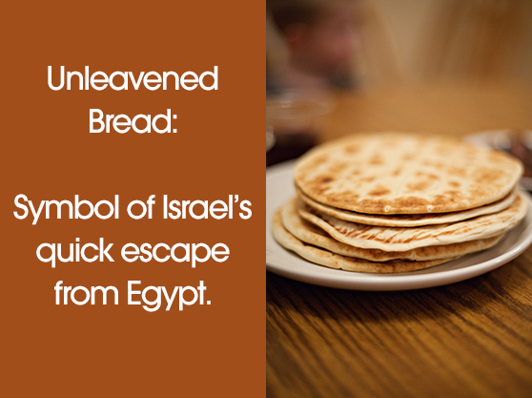
strength of hand; no leavened bread shall be eaten. 4
Today, in the month of Abib,
you are going out. 5 When the LORD brings you into the land of the Canaanites, the
Hittites, the Amorites, the Hivites, and the Jebusites, which he swore to your
ancestors to give you, a land flowing with milk and honey, you shall keep this
observance in this month. 6 Seven days you shall eat unleavened bread, and on the
seventh day there shall be a festival to the LORD.
7 Unleavened bread shall be eaten
for seven days; no leavened bread shall be seen in your possession, and no leaven
shall be seen among you in all your territory. 8 You shall tell your child on that day,
‘It is because of what the LORD did for me when I came out of Egypt.’

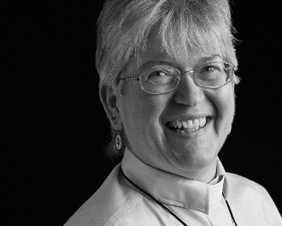
Sermon
During this time, as you listen to the sermon, please enjoy the activities found on the last pages of the Children’s Bulletin

HYMN #336 Here, O My Lord, I See You Face to Face
Here, O my Lord, I see you face to face;
Here would I touch and handle things unseen,
Here grasp with firmer hand the eternal grace,
And all my weariness upon you lean.
Here would I fee upon the bread of God.
Here share the cup, the gracious gift of heaven;
Here would I lay aside each earthly load,
Here taste afresh the calm of sin forgiven.Wherever people gather you, O God, are present there.

Invitation to Generosity

*DOXOLOGY
Masithi, Amen, siyakudumisa, Masithi
Amen, siyakudumisa, Masithi;
Amen, Bawo, Amen, Bawo, Amen, siyakudumisa.

Sing amen, Amen, we praise your name, O God, Sing Amen
Amen, we praise your name, O God. Sing Amen
Amen, Amen, Amen, Amen, Amen, we praise your name, O God.

PRAYER OF DEDICATION
Holy God of all Creation, Bless these gifts, we pray. Multiply them the way you
multiplied the loaves. May the ministries that are encouraged because of these
gifts touch countless lives in Your name and to Your glory. Amen.

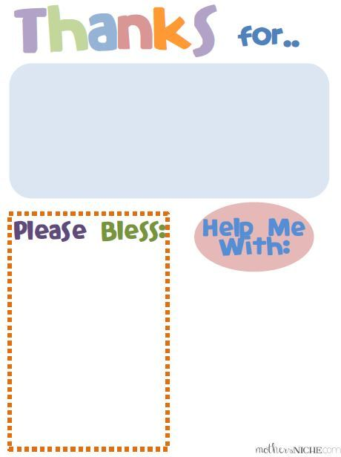
Sharing Joys and Concerns: Do you have a Joy or Concern you’d like to share with the congregation?

WE GO OUT TO LOVE AND SERVE A LOVING, SERVING GOD

HYMN #448 Take My Life and Let it Be
Take my life, God, let it be consecrated faithfully.
Take my moments and my days, let them flow in ceaseless praise.
Take my love and help it grow; let my loving overflow.
Take me now, and help me be part of Christ’s community.

BENEDICTION: The Pastor often will give a benediction at the end of service. This is like a special prayer asking for God’s help, guidance and blessing over everyone before the end of service.

POSTLUDE “Go now in peace. Go now in peace. May the love of God surround you everywhere, everywhere you may go.” Words & Music: Natalie Sleeth, © 1976 Hinshaw Music, Inc.; All rights reserved. Reprinted under ONE LICENSE #A-708716.

MINISTERS OF THE CHURCH - Members of the Congregation Members of the Congregation SENIOR PASTOR AND TEACHER - The Rev. Dr. Deborah Roof LAY READER – Liz Greenberg GREETERS – Rachel Cobban, Sue Brown GUEST MUSICIAN – Katlyn Leahy CHOIR DIRECTOR/ ORGANIST - Joan Virga CHRISTIAN EDUCATION DIRECTOR - Christine Lehoullier ADMINISTRATIVE ASSISTANT - Michelle Guerrin
Visit our Facebook page or our website for recent videos of services and moments of Christian Faith Formation and inspiration.

LET’S PRACTICE MENDALAS! We’ll be posting a video on how you can make your very own rock mendalas for yourself and for someone who will be walking the path of meditation and prayer for the meetinghouse this week on Facebook and the website! E-mail Christine Lehoullier at cedirector@fpc-ucc.org with any questions.

