A NOTE TO THE ARTIST
I encourage you all to paint a stone for yourself and one for someone else who may be walking the Meetinghouse Prayer Circles now until November 7th. Our Hope is to support all those who will be walking with Pastor Deborah in honor of the Meetinghouse Building so that they may also have a peaceful stone to hold as they offer positive thoughts and prayers for this sacred meeting space.
WHAT IS MANDALA ART?
If you’ve seen a Mandala, then you will recognize the memorizing geometric patterns and beautiful colors. If you haven’t seen one, it’s an amazing piece of artwork made up of geometric shapes and designs meant to symbolize the universe. It means circle or completion in Sanskrit. Often, many people use Mandalas as an art therapy tool: to relax our overworked minds, help treat depression and post-traumatic stress, and as a meditative tool. Painting Mandalas on rocks has become very popular, and it’s easy for beginners to master.
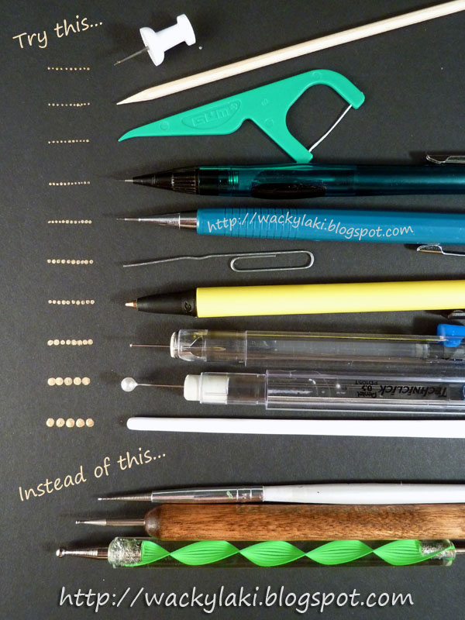
Tips & Tricks: Dotting Tool Alternatives
Push pins - these can create very fine dots, just be careful not to pin yourself in the process
Toothpick or wooden barbecue skewer
Plastic dental pick
Mechanical pencil (0.5mm) - I actually use this a lot even when I have a dotting nearby
Paper clip
Old pen - might not work afterwards, so don't try with a pen you love...
Small flat head pin - stuck into the eraser end of a pencil
Round head pin - also stuck into an eraser...
Brush handle tip
Q-tip
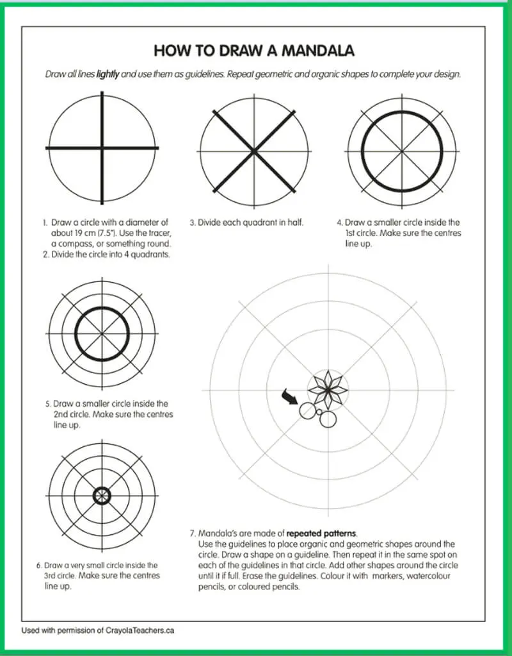
Paint – There is a lot to be said about paint, the consistency of the paint is of key importance to your project. The basic recommendation is to use a water based acrylic paint.
Basic Techniques – There are many techniques to learn as you go along but a few basic ones to start out with are …
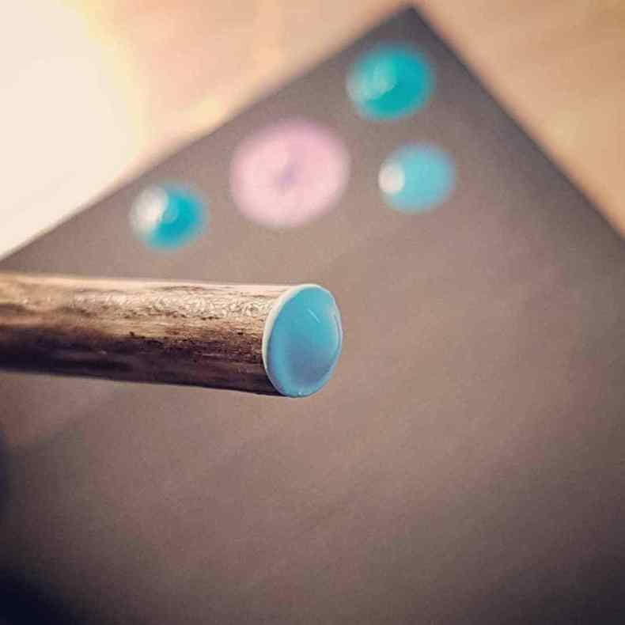
When using a flat edge tool such as a dowel, only touch the top of the paint with the end of the dowel, if you dip it all the way in you will get paint on the edges and it will not create a clean dot. You only need paint on the very end surface (be sure to cover the whole surface) and when you dot it on your canvas be careful to not touch the canvas with your tool, the lighter the touch the better.
When you want to keep your dots consistent in size in a ring, use the dip and dot dip and dot technique, wiping your tool regularly
When you want to create descending dots, dip once and dot dot dot until you run out of paint.
Here is a basic design to follow that I use when I am teaching workshops for beginners…
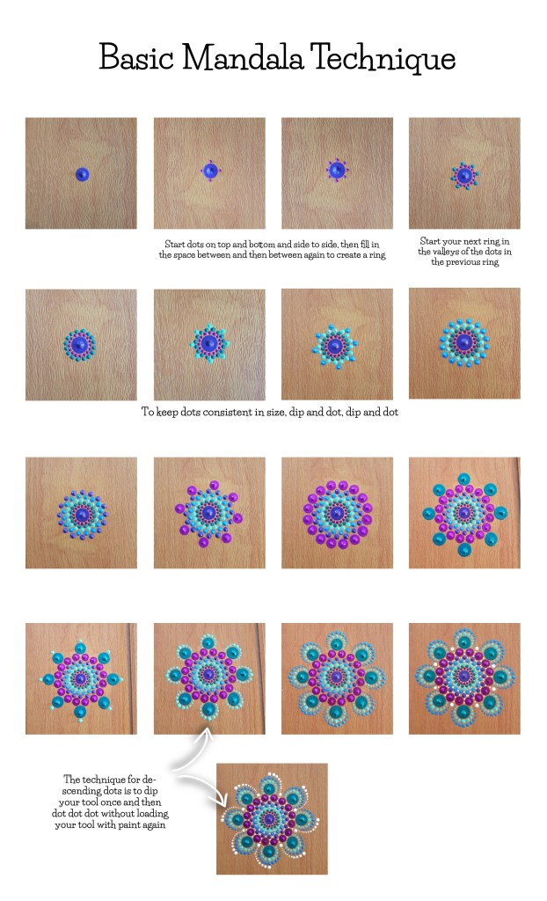
Tips and Tricks for Clean Up and Mistakes –
I use baby wipes or damp cloths for quick clean up and to wipe away unruly dots to redo
For dried on paint spots I use rubbing alcohol and a cotton swap, it cleans up quick and easy!
Often I get so caught up in my painting that my paintbrushes harden with paint and let’s be honest, I paint until the absolute last minute I have to get up and go, and often don’t have time to clean my brushes right away. If you are in the same boat I have a fabulous tip for you! I have thrown away many brushes that I thought were doomed until I found this tip that has saved me tons of money and trips to the craft store. Soak the brushes in a jar filled with a few tablespoons of Murphy’s Oil Soap and a few tablespoons of water for a couple - few days and they should be good as new!
Thank your Kelly Theresa, Online Artist Extraordinaire, for all the wonderful tips!

