Children’s Bulletin
First Parish Congregational Church
NOVEMBER 29, 2020

December 1st is National
https://hq.givingtuesday.org/#ideas
On December 1, 2020 we'll unite for a worldwide celebration of generosity.
People around the globe will come together in unity and showing kindness and generosity in all its forms by giving their voice, time, money, goods, and advocacy to support communities and causes.
Are you in?
Tune in to this page: https://hq.givingtuesday.org/#ideas
on December 1 at 9am & 7pm ET for GivingTuesday’s Day-Of Livestream, hosted by NBC’s Mario Armstrong. You’ll have a front-row seat for inspiring stories of generosity from around the world and shoutouts from special guests and everyday heroes who will share why giving back is key for building the kind of world we want to live in.

Please gather the following (optional) items to help you worship today:
- Drawing paper
- Crayons, markers, or colored pencils
- You’ll also find an additional activity pages for use during the sermon on the final pages of this Children’s Bulletin
Words of Welcome

Go around the room and greet each person (and pet!) with a Good Morning and Happy Advent!

CHRISTMAS CAROLING

The Friendly Beasts (Jesus, Our Brother, Strong and Good)

Jesus, our brother, strong and good, was humbly

Born in a stable rude, and the friendly beasts

Around him stood, Jesus our brother, strong and good.

The First Nowell

The first Nowell, the angel did say,

Was to certain poor shepherds in fields as they lay;

In fields where they lay keeping their sheep,

On a cold winter’s night that was so deep.

Nowell, nowell, nowell, nowell, Born in a manger, Emmanuel.

Angels, from the Realms of Glory

Angels, from the realms of glory of glory, wing your flight o’er all the earth;

As you sang creation’s story, now proclaim Messiah’s birth:

Come and worship, come and worship, worship Christ, give thanks and sing.

Mary Did You Know

Mary, did you know that your Baby Boy would one day walk on water?

Mary, did you know that your Baby Boy would save our sons and daughters?

Did you know that your Baby Boy has come to make you new?

This Child that you delivered will soon deliver you.

Mary, did you know that your Baby Boy will give sight to a blind man?

Mary, did you know that your Baby Boy will calm the storm with His hand?

Did you know that your Baby Boy has walked where angels trod?

When you kiss your little Baby you kissed the face of God?

The blind will see. The deaf will hear. The dead will live again.

The lame will leap. The dumb will speak The praises of The Lamb.

Mary, did you know that your Baby Boy is Lord of all creation?

Mary, did you know that your Baby Boy would one day rule the nations?

Did you know that your Baby Boy is heaven's perfect Lamb?

The sleeping Child you're holding is the Great, I Am.

What Child is This

What child is this, who, laid to rest, on Mary’s lap is sleeping?

Whom angels greet with anthems sweet while shepherds watch are keeping?

This, this, the angels sing, is Christ, God’s holy offering;

Haste, haste your praise to bring the babe, the child of Mary!

CALL TO WORSHIP and LIGHTING THE FIRST ADVENT CANDLE - HOPE
One: During the season of Advent, we talk about the light conquering
the darkness.
Many: Instead of looking at darkness as an evil to be overtaken,
what if we chose to honor the gifts that darkness can yield?
One: After all, out of darkness God created everything - including light.
Many: In faith Daniel faced the darkness of the lion’s den,
One: With the help of God our hope can grow in the darkness.
Many: Throughout this darkest and holiest time of year,
may we discover hope.
(The first candle – the candle of HOPE – is lit.)
HYMN #116 “O Come, O Come, Emmanuel”
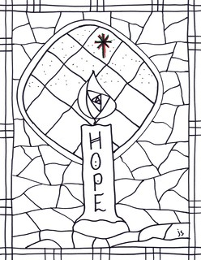
O come, O come, Emmanuel, and ransom captive Israel.
That mourns in lonely exile here, until the Child of God appear.
Rejoice! Rejoice! Emmanuel shall come to you, O Israel!
O come, O Wisdom from on high, and order all things far and nigh;
To us the path of knowledge show and help us in that way to go.
Rejoice! Rejoice! Emmanuel shall come to you, O Israel!

INVOCATION (Read by Lay Reader. Feel free to join in at home.)
In compassion and trust, we approach you, God of the Covenant. Day by day,
your promises are fulfilled among us. Help us to prepare ourselves and our
communities for Christ's coming. Amen.

SONG OF PRAISE: Praise our God together singing Alleluia! (repeat twice)
Time Especially for Children
Let’s sing “Jesus loves me”
Come in close and bring your listening ears

CHILDREN’S MESSAGE: Waiting, waiting, waiting

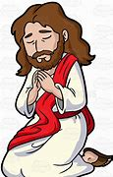
PRAYER OF CONSECRATION followed by
THE LORD’S PRAYER:
Our Father, who art in heaven, hallowed be Thy name. Thy kingdom come; Thy will be done; on earth as it is in heaven. Give us this day our daily bread and forgive us our debts as we forgive our debtors. Lead us not into temptation, but deliver us from evil; for Thine is the Kingdom, and the Power, and the Glory forever. Amen.

Scripture Reading
OLD TESTAMENT: OLD TESTAMENT: Daniel 6: 6-27 The Message (MSG)
6-7 The vice-regents and governors conspired together and then went to the king
and said, “King Darius, live forever! We’ve convened your vice-regents, governors, and all your leading officials, and have agreed that the king should issue the following decree:
For the next thirty days no one is to pray to any god or mortal except you, O king. Anyone who disobeys will be thrown into the lions’ den.
8 “Issue this decree, O king, and make it unconditional, as if written in stone like all the laws of the Medes and the Persians.” 9 King Darius signed the decree.

10 When Daniel learned that the decree had been signed and posted, he continued to pray just as he had always done. His house had windows in the upstairs that opened toward Jerusalem. Three times a day he knelt there in prayer, thanking and praising his God.

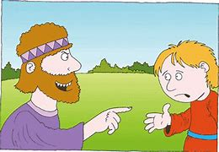
11-12 The conspirators came and found him praying, asking God for help. They went straight to the king and reminded him of the royal decree that he had signed. “Did you not,” they said, “sign a decree forbidding anyone to pray to any god or man except you for the next thirty days? And anyone caught doing it would be thrown into the lions’ den?” “Absolutely,” said the king. “Written in stone, like all the laws of the Medes and Persians.”
13 Then they said, “Daniel, one of the Jewish exiles, ignores you, O king, and defies your decree. Three times a day he prays.”
14 At this, the king was very upset and tried his best to get Daniel out of the fix he’d put him in. He worked at it the whole day long.
15 But then the conspirators were back: “Remember, O king, it’s the law of the
Medes and Persians that the king’s decree can never be changed.”
16 The king caved in and ordered Daniel brought and thrown into the lions’ den.
But he said to Daniel, “Your God, to whom you are so loyal, is going to get you out of this.”

17 A stone slab was placed over the opening of the den. The king sealed the cover with his signet ring and the signet rings of all his nobles, fixing Daniel’s fate.
18 The king then went back to his palace. He refused supper. He couldn’t sleep. He spent the night fasting.
19-20 At daybreak the king got up and hurried to the lions’ den. As he approached the den, he called out anxiously, “Daniel, servant of the living God, has your God, whom you serve so loyally, saved you from the lions?”

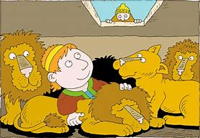
21-22 “O king, live forever!” said Daniel. “My God sent his angel, who closed the
mouths of the lions so that they would not hurt me. I’ve been found innocent before God and also before you, O king. I’ve done nothing to harm you.”
23 When the king heard these words, he was happy. He ordered Daniel taken up out of the den. When he was hauled up, there wasn’t a scratch on him. He had trusted his God. (Then the King punished the conspirators for causing trouble for no good reason.)

25-27 King Darius published this proclamation to every race, color, and creed on
earth:
Peace to you! Abundant peace!
I decree that Daniel’s God shall be worshiped and feared in all parts of my
kingdom.
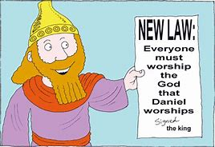
He is the living God, world without end. His kingdom never falls.
His rule continues eternally.
He is a savior and rescuer.
He performs astonishing miracles in heaven and on earth.
He saved Daniel from the power of the lions.

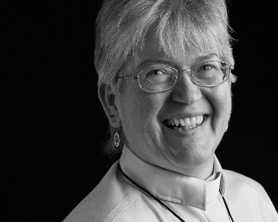
Sermon : Holding onto to Hope
During this time, as you listen to the sermon, please enjoy the activities found on the last pages of the Children’s Bulletin

HYMN #283 Spirit of the Living God
Spirit of the living God, fall afresh on me;
Spirit of the living God, fall afresh on me.
Melt me, mold me, fill me, use me.
Spirit of the living God, fall afresh on me. (Sing twice through.)
.
Invitation to Generosity: Think about how you would like to give to others, yourself and your family this week to show how you love yourself and others just like God loves us
DOXOLOGY # 303 Rejoice, Give Thanks and Sing
Rejoice, give thanks and sing; your Sovereign God adore!
For Christ has robbed death’s sting and triumphs evermore.
Lift up your heart, lift up your voice! Rejoice, again I say, rejoice.

PRAYER OF DEDICATION (lay reader)
Thank you, God, for this family of faith, which enriches our lives and enables us to share. Thank you for helping us to reach outside ourselves. We are grateful that you show us ways to lift the burdens of our sisters and brothers. May our offerings further this ministry among us and beyond our community. Amen.

Sharing Joys and Concerns: Do you have a Joy or Concern you’d like to share with the congregation?

WE GO OUT TO LOVE AND SERVE A LOVING, SERVING GOD

HYMN # 117 Lift Up Your Heads, O Mighty Gates
Lift up your heads, O mighty gates; behold the glorious Ruler waits!
The Sovereign One is drawing near; the Savior of the world is here.

BENEDICTION: The Pastor often will give a benediction at the end of service. This is like a special prayer asking for God’s help, guidance and blessing over everyone before the end of service.

POSTLUDE : “Go now in peace. Go now in peace. May the love of God surround you everywhere, everywhere you may go.” Words & Music: Natalie Sleeth, © 1976 Hinshaw Music, Inc.; All rights reserved. Reprinted under ONE LICENSE #A-708716.

MINISTERS OF THE CHURCH - Members of the Congregation
SENIOR PASTOR AND TEACHER - The Rev. Dr. Deborah Roof
LAY READER – Sue Lindemann
GREETERS –Anne-Marie Merrill, Sue Brown
CHOIR DIRECTOR/ ORGANIST - Joan Virga
CHRISTIAN EDUCATION DIRECTOR - Christine Lehoullier
ADMINISTRATIVE ASSISTANT - Michelle Guerrin
AV/ TECHNICAL – Paul Lindemann
