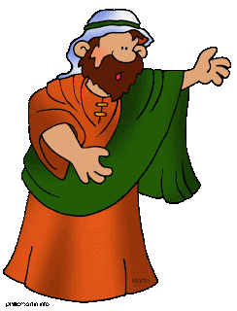
ISAIAH WAS A PROPHET
BY: RHONDA DUVALL
ISAIAH WAS A PROPHET,
A PROPHET INDEED.
ISAIAH WAS A PROPHET,
A PROPHET, YOU SEE.

SAYING, “HERE AM I, SEND ME, LORD.”
“HERE AM I, SEND ME.”
“HERE AM I, SEND ME, LORD.”
“HERE AM I, SEND ME.”

ISAIAH WAS A PROPHET,
A PROPHET INDEED.
ISAIAH WAS A PROPHET,
A PROPHET, YOU SEE.

SAYING, “HERE AM I, SEND ME, LORD.”
“HERE AM I, SEND ME.”
“HERE AM I, SEND ME, LORD.”
“HERE AM I, SEND ME.”

ISAIAH WAS A PROPHET,
A PROPHET INDEED.
ISAIAH WAS A PROPHET
“HERE I AM, SEND ME” HOT COAL CLAY CRAFT

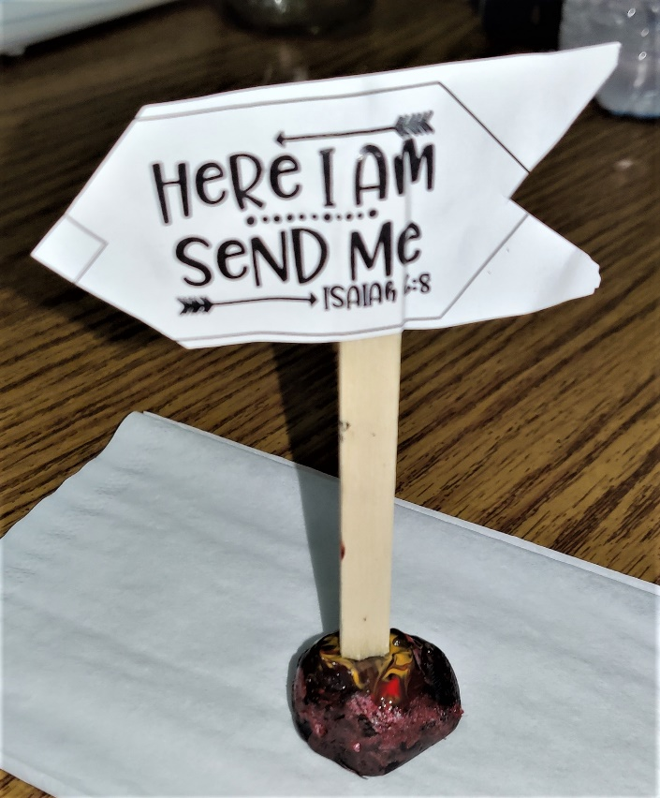
1. Print out flags and glue back to back (flags will not match up perfectly).
2. Place popscicle stick between two flags
3. Roll clay in rock shape and press bottom onto flat surface so that it doesn’t roll off table
4. Paint clay to look like hot coal
5. Stick flag into clay ball
6. Place somewhere safe to dry for a day.
7. Listen for God’s call to help others

