Children’s Bulletin
First Parish Congregational Church
DECEMBER 20, 2020

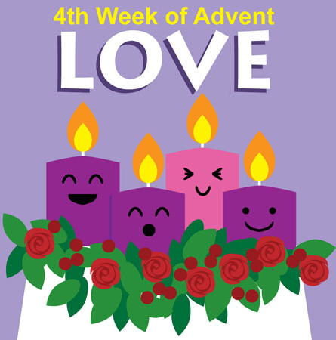
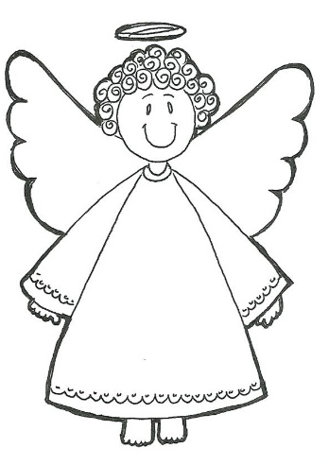
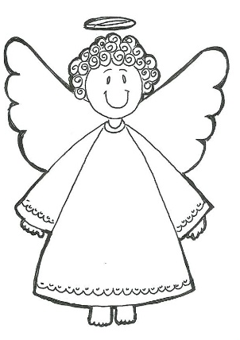

Please gather the following (optional) items to help you worship today:
- Drawing paper
- Crayons, markers, or colored pencils
- You’ll also find an additional activity pages for use during the sermon on the final pages of this Children’s Bulletin

Words of Welcome

Go around the room and greet each person (and pet!) with a Good Morning and an, “I Love You!”

CHRISTMAS CAROLING
As With Gladness
As with gladness men of old did the guiding star behold,
As with joy they hailed its light, leading onward, beaming bright,
So, most gracious Lord, may we evermore be led to thee.

Friendly Beasts vs. 2
“I,” said the donkey, shaggy and brown,
“I carried your mother uphill and down,
I carried your mother to Bethlehem town;
I,” said the donkey, shaggy and brown.

Silent Night
Silent night, Holy night, all is calm, all is bright.
Round yon Virgin Mother and child!
Holy infant so tender and mild,
Sleep in heavenly peace, sleep in heavenly peace.
It Came upon a Midnight Clear
It came upon the midnight clear that glorious song of old
From angels bending near the earth to touch their harps of gold.
“Peace on the earth goodwill to all. From heaven’s all gracious King.”
The world in solemn stillness lay, to hear the angel’s sing.

Joy to the World
Joy to the world! The Lord is come;
Let earth receive her King;
Let ev’ry heart prepare him room.
And heav’n and nature sing,
And heav’n and nature sing,
And heav’n and heav’n and nature sing.

CALL TO WORSHIP and LIGHTING THE FOURTH ADVENT CANDLE – LOVE
**READ THE BOLDED “Many” lines**
(Lay reader is “one” and Pastor Deborah will lead “many”. Please join her.)

One: We gather around wreaths to pray into our lost hopes, so we light the
candle of hope; to pray through the broken peace in our world, so we light
the candle of peace; and we pray through our limited joys, so we light the
candle of joy.
We affirm that our candles demonstrate how we claim the power to call this
season Advent, that time when God’s light comes into the world and
nothing can overcome it.

Many: We now light the candle of love even when many things dim our
sparkling love.

One: The light of God’s love cannot be extinguished.
(The candle of LOVE is lit.)
God’s love will ignite its embers under great loss and sorrow this year.
God’s love will lead us on our path to a fulfilling life.

Many: Emmanuel, God be with us in the week to come lighting hope, peace,
joy and love on the wick of our lives, so that we may shine on our
world your unconditional welcome to all. Amen

HYMN #110 Now Bless the God of Israel (vs. 1,2,3)
Now bless the God of Israel, who comes in love and power,
Who raises from the royal house deliverance in this hour.
Through holy prophets God has sworn to free us from alarm,
To save us from the heavy hand of all who wish us harm.
Remembering the covenant, God rescues us from fear.
That we might serve in holiness and peace from year to year;
And you, my child, shall go before to preach, to prophesy,
That all may know the tender love, the grace of God most high.
In tender mercy, God will send the dayspring from on high,
Our rising sun, the light of life for those who sit and sigh.
God comes to guide our way to peace, that death shall reign no more.
Sing praises to the Holy One! O worship and adore!

INVOCATION
(Read by Lay Reader. Feel free to join in at home.)
Loving God, we rejoice in this season of anticipation, as we remember your
promises. Your light breaks into our darkness so we look forward to your winks of light breaking into our lives. Strengthen us for the journey by renewing within us the gifts of your Holy Spirit: hope, peace, joy and love. We are so very
grateful for your abiding Presence in our lives. Amen.
*SONG OF PRAISE #125 Angels We Have Heard on High (Refrain)
Gloria in excelsis Deo; Gloria in excelsis Deo!

Time Especially for Children
Let’s sing “Jesus loves me”
Come in close and bring your listening ears

CHILDREN’S MESSAGE:
What were some words that stuck out to you during Children’s Time?

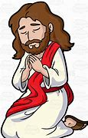
PRAYER OF CONSECRATION followed by
THE LORD’S PRAYER:
Our Father, who art in heaven, hallowed be Thy name. Thy kingdom come; Thy will be done; on earth as it is in heaven. Give us this day our daily bread and forgive us our debts as we forgive our debtors. Lead us not into temptation, but deliver us from evil; for Thine is the Kingdom, and the Power, and the Glory forever. Amen.

Scripture Reading
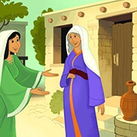
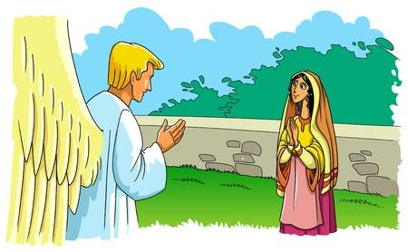
N26 In the sixth month the angel Gabriel was sent by God to a town in Galilee called Nazareth, 27 to a virgin engaged to a man whose name was Joseph, of the house of David. The virgin’s name was Mary. 28 And he came to her and said, “Greetings, favored one! The Lord is with you.” 29 But she was much perplexed by his words and pondered what sort of greeting this might be. 30 The angel said to her, “Do not be afraid, Mary, for you have found favor with God. 31 And now, you will conceive in your womb and bear a son, and you will name him Jesus. 32 He will be great, and will be called the Son of the Most High, and the Lord God will give to him the throne of his ancestor David. 33 He will reign over the house of Jacob forever, and of his kingdom there will be no end.” 34 Mary said to the angel, “How can this be, since I am a virgin?” 35 The angel said to her, “The Holy Spirit will come upon you, and the power of the Most High will overshadow you; therefore the child to be born will be holy; he will be called Son of God. 36 And now, your relative Elizabeth in her old age has also conceived a son; and this is the sixth month for her who was said to be barren. 37 For nothing will be impossible with God.” 38 Then Mary said, “Here am I, the servant of the Lord; let it be with me according to your word.” Then the angel departed from her. 39 In those days Mary set out and went with haste to a Judean town in the hill country, 40 where she entered the house of Zechariah and greeted Elizabeth. 41 When Elizabeth heard Mary’s greeting, the child leaped in her womb. And Elizabeth was filled with the Holy Spirit 42 and exclaimed with a loud cry, “Blessed are you among women, and blessed is the fruit of your womb. 43 And why has this happened to me, that the mother of my Lord comes to me? 44 For as soon as I heard the sound of your greeting, the child in my womb leaped for joy. 45 And blessed is she who believed that there would be a fulfillment of what was spoken to her by the Lord.”
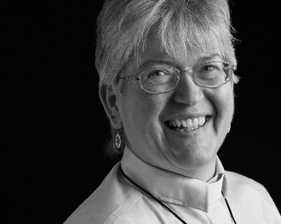
Sermon: “Blessed are You Among Women”

During this time, as you listen to the sermon, please enjoy the activities found on the last pages of the Children’s Bulletin

HYMN #122 Come, O Long-Expected Jesus (vs. 1,2)
Come, O long expected Jesus, born to set all people free;
From our fears and sins release us; grant us your true liberty.
Israel’s strength and consolation, hope to all the earth impart;
Dear desire of every nation, enter every longing heart.

Invitation to Generosity: Think about how you would like show LOVE to God, others and yourself week
DOXOLOGY # 780 Praise God From Whom All Blessing Flow
Praise God from whom all blessings flow; Praise God all creatures here below,
Praise God above you heavenly hosts Creator, Christ, and Holy Ghost.
Sharing Joys and Concerns: Do you have a Joy or Concern you’d like to share with the congregation? Fill out the box above and let us know….

PRAYER OF DEDICATION (Led by lay reader. You may join in at home.)
May our offerings proclaim Jesus in ways that will be received with joy. May
the gifts that we offer today be multiplied and spread far and near - even as
we here are blessed beyond anything we might imagine. Amen.

WE GO OUT TO LOVE AND SERVE A LOVING, SERVING GOD

HYMN #117 Lift up your Heads you Mighty Gates (vs. 4)
So come, my Sovereign; enter in!
Let new and nobler life begin;
Your Holy Spirit guide us on, until the glorious crown be won.

BENEDICTION: The Pastor often will give a benediction at the end of service. This is like a special prayer asking for God’s help, guidance and blessing over everyone before the end of service.

POSTLUDE : “Go now in peace. Go now in peace. May the love of God surround you everywhere, everywhere you may go.” Words & Music: Natalie Sleeth, © 1976 Hinshaw Music, Inc.; All rights reserved. Reprinted under ONE LICENSE #A-708716

MINISTERS OF THE CHURCH - Members of the Congregation
SENIOR PASTOR AND TEACHER - The Rev. Dr. Deborah Roof
LAY READER – Rachel Cobban
GREETERS – Anne-Marie Merrill, Sue Lindemann
CHOIR DIRECTOR/ ORGANIST - Joan Virga
CHRISTIAN EDUCATION DIRECTOR - Christine Lehoullier
ADMINISTRATIVE ASSISTANT - Michelle Guerrin
AV/ TECHNICAL – Paul Lindemann

