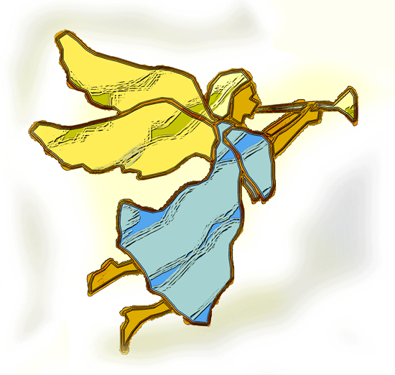
CHILDREN’S BULLETIN ~ CHRISTMAS EVE
FIRST PARISH CONGREGATIONAL CHURCH
DECEMBER 24, 2020 4:00 PM

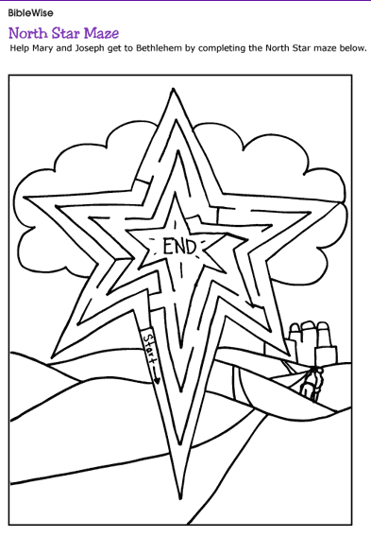

When you see this symbol | Do this action
 | = Sing, Sway, Shake your Egg Shakers or Dance to the Music
 | = Let’s bow our heads and pray together as a church family (Listen to the words OR Read along if you can)
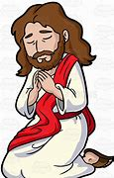 | = Let’s say The Lord’s Prayer together
 | = Listen to the story or reading from the Bible

WE ENTER INTO GOD’S PRESENCE WITH SINGING

HYMN “Hark! The Herald Angels Sing”
Hark! the herald angels sing, “Glory to the newborn King;
Peace on earth and mercy mild, God and sinners reconciled!”
Joyful all ye nations rise, join the triumph of the skies;
with the angelic host proclaim, “Christ is born in Bethlehem!”
Hark! the herald angels sing, “Glory to the new-born King!”

Christ, by highest heaven adored; Christ, the everlasting Lord!
Late in time behold Him come, off-spring of the virgin’s womb.
Veiled in flesh the God-head see; hail the incarnate Deity,
Pleased in flesh with us to dwell, Jesus, our Emmanuel.
Hark! the herald angels sing, “Glory to the new-born King!”

HYMN “It Came Upon the Midnight Clear”
It came upon the midnight clear, That glorious song of old,
From angels bending near the earth, To touch their harps of gold:
"Peace on the earth, goodwill to men, From heaven's all-gracious King."
The world in solemn stillness lay, To hear the angels sing.

Still through the cloven skies they come, With peaceful wings unfurled,
And still their heavenly music floats O'er all the weary world;
Above its sad and lowly plains, They bend on hovering wing,
And ever o'er its babel sounds The blessed angels sing.

WELCOME AND CENTERING BREATH
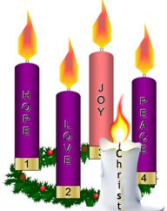
Imagining Together An Advent Wreath Lighting – Picture your favorite Advent Wreath
PRAYERS OF THE PEOPLE
Creating God,
We gather this night to return and remember once again the pillars of our faith:
Hope is ours
Peace is on the way
Sorrow has lost its grip
Love has flooded every heart
Emmanuel, God with us
Light has come back into the world
And the darkness of despair, and pandemic, and hurt,
and hate shall not overcome it
Tonight you are with us
And we will never be the same
We will be more tender
We will protect the vulnerable
We will stand watch
We will come running to soothe the pain, to befriend the lonely, to lift up the lowly
To live as your people, to walk with you in love
We pray all of this in the name of Emmanuel, God with us
In Jesus’ name we pray, even as we pray together the prayer that he taught us:

Our Father, who art in heaven, Hallowed be Thy name. Thy kingdom come; Thy will be done; on earth as it is in heaven. Give us this day our daily bread and forgive us our debts as we forgive our debtors. Lead us not into temptation, but deliver us from evil; for Thine is the Kingdom, and the Power, and the Glory forever. Amen.

A SERVICE OF LESSONS AND CAROLS

HYMN “O Come, All Ye Faithful”
O come, all ye faithful, joyful and triumphant,
O come ye, O come ye to Bethlehem;
Come and behold Him, born the King of angels;
O come let us adore Him, O come let us adore Him,
O come, let us adore Him, Christ, the Lord!

Sing, choirs of angels, sing in exultation,
Sing, all ye citizens of heaven above!
Glory to God, all glory in the highest;
O come let us adore Him, O come let us adore Him,
O come, let us adore Him, Christ, the Lord!
“In the beginning…” John 1:1-5
In the beginning was the Word, and the Word was with God, and the Word was God. He was in the beginning with God. All things came into being through him, and without him not one thing came into being. What has come into being in him was life, and the life
was the light of all people. The light shines in the darkness, and the darkness did not overcome it.

HYMN “O Come, O Come Emmanuel”
O come, O come, Emmanuel And ransom captive Israel
That mourns in lonely exile here Until the Son of God appear
Rejoice! Rejoice! Emmanuel Shall come to thee, O Israel.

“Greetings, favored one…” Luke 1: 26-33; 38
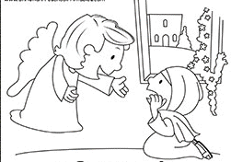
In the sixth month the angel Gabriel was sent by God to a town in Galilee called Nazareth, to a virgin engaged to a man whose name was Joseph, of the house of David. The virgin’s name was Mary. And he came to her and said, “Greetings, favored one! The Lord is with you.” But she was much perplexed by his words and pondered what sort of greeting this might be. The angel said to her, “Do not be afraid, Mary, for you have found favor with God. And now, you will conceive in your womb and bear a son, and you will name him Jesus. He will be great, and will be called the Son of the Most High, and the Lord God will give to him the throne of his ancestor David. He will reign over the house of Jacob forever, and of his kingdom there will be no end.”
Then Mary said, “Here am I, the servant of the Lord; let it be with me according to your word.” Then the angel departed from her.

HYMN “O Little Town of Bethlehem”
O little town of Bethlehem, how still we see thee lie!
Above thy deep and dreamless sleep the silent stars go by.
Yet in thy dark streets shineth the everlasting Light;
the hopes and fears of all the years are met in thee tonight.

For Christ is born of Mary, and gathered all above
while mortals sleep, the angels keep their watch of wondering love.
O morning stars together proclaim the holy birth.
Your voices raise to God in praise; and peace to all on earth!
“a decree went out” Luke 2: 1-7
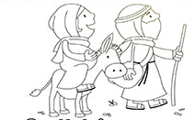
In those days a decree went out from Emperor Augustus that all the world should be registered. This was the first registration and was taken while Quirinius was governor of Syria. All went to their own towns to be registered. Joseph also went from the town of Nazareth in Galilee to Judea, to the city of David called Bethlehem, because he was descended from the house and family of David. He went to be registered with Mary, to whom he was engaged and who was expecting a child. While they were there, the time came for her to deliver her child. And she gave birth to her firstborn son …and wrapped him in bands of cloth, and laid him in a manger, because there was no place for them
in the inn.

HYMN “Away in a Manger”
Away in a manger, no crib for a bed, the little Lord Jesus laid down His sweet head.
The stars in the sky looked down where He lay, the little Lord Jesus, asleep on the hay.

Be near me, Lord Jesus, I ask Thee to stay close by me forever, and love me, I pray.
Bless all the dear children in Thy tender care, and fit us for heaven to live with you there.
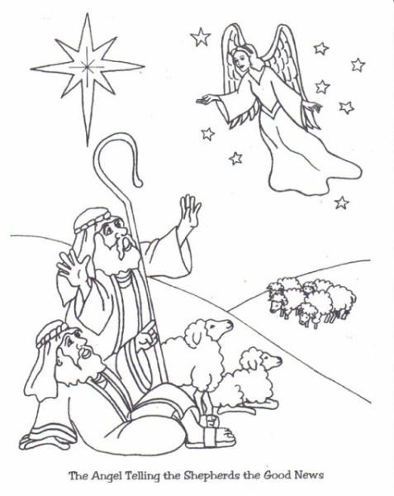
“the glory of the LORD shone around them” Luke 2:8-14
In that region there were shepherds living in the fields, keeping watch over their flock by night. Then an angel of the Lord stood before them, and the glory of the Lord shone around them, and they were terrified.
But the angel said to them, “Do not be afraid; for see—I am bringing you good news of great joy for all the people: to you is born this day in the city of David a Savior, who is the Messiah, the Lord. This will be a sign for you: you will find a child wrapped in bands of cloth and lying in a manger.” And suddenly there was with the angel a multitude of the heavenly host, praising God and saying, “Glory to God in the highest heaven, and on earth peace among those whom he favors!”

HYMN “The First Noel”
The first Noel, the angel did say, was to certain poor shepherds in fields as they lay;
In fields where they lay keeping their sheep, on a cold winter’s night that was so deep.
Noel, Noel, Noel, Noel, born is the King of Israel.

They looked up and saw a star shining in the east, beyond them far,
And to the earth it gave great light, and so it continued both day and night.
Noel, Noel, Noel, Noel, born is the King of Israel.

“they found the child lying in the manger” Luke 2:15-20
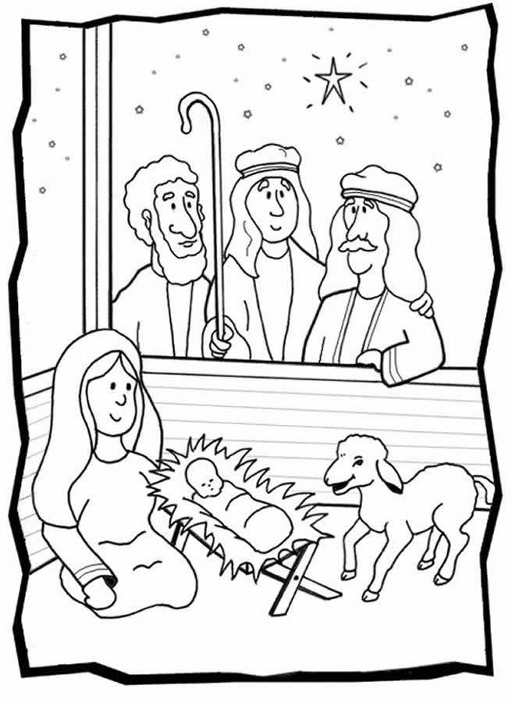
When the angels had left them and gone into heaven, the shepherds said to one another, “Let us go now to Bethlehem and see this thing that has taken place, which the Lord has made known to us.” So they went with haste and found Mary and Joseph, and the child lying in the manger. When they saw this, they made known what had been told them about this child; and all who heard it were amazed at what the shepherds told them. But Mary treasured all these words and pondered them in her heart. The shepherds returned, glorifying and praising God for all they had heard and seen, as it had been told them.

HYMN “Angels We Have Heard on High”
Angels we have heard on high, sweetly singing o’er the plains,
and the mountains in reply, echo back their joyous strains.
Gloria, in excelsis Deo, Gloria, in excelsis Deo.

Come to Bethlehem and see Christ whose birth the angels sing;
Come adore on bended knee, God, our world now entering.
Gloria, in excelsis Deo, Gloria, in excelsis Deo.

“wise men came from the east” Matthew 2:1-10
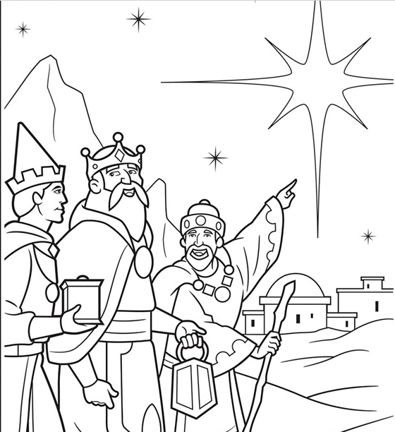
In the time of King Herod, after Jesus was born in Bethlehem of Judea, wise men from the East came to Jerusalem, asking, “Where is the child who has been born king of the Jews? For we observed his star at its rising, and have come to pay him homage.” When King Herod heard this, he was frightened, and all Jerusalem with him; and calling together all the chief priests and scribes of the people, he inquired of them where the Messiah was to be born. They told him, “In Bethlehem of Judea; for so it has been written by
the prophet: ‘And you, Bethlehem, in the land of Judah,
are by no means least among the rulers of Judah;
for from you shall come a ruler
who is to shepherd my people Israel.’”
Then Herod secretly called for the wise men and learned from them the exact time when
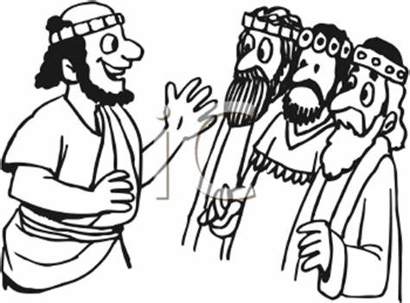
the star had appeared. Then he sent them to Bethlehem, saying, “Go and search diligently for the child; and when you have found him, bring me word so that I may also go and pay him homage.”
When they had heard the king, they set out; and there, ahead of them, went the star that they had seen at its rising, until it stopped over the place where the child was. When they saw that the star had stopped, they were overwhelmed with joy.

HYMN “We Three Kings of Orient Are”
We three kings of Orient are bearing gifts we traverse afar
Field and fountain, moor and mountain Following yonder star
O Star of wonder, star of night Star with royal beauty bright
Westward leading, still proceeding Guide us to thy Perfect Light.

Glorious now behold Him arise, King and God and Sacrifice.
Alleluia, alleluia! Sounds through the earth and skies.
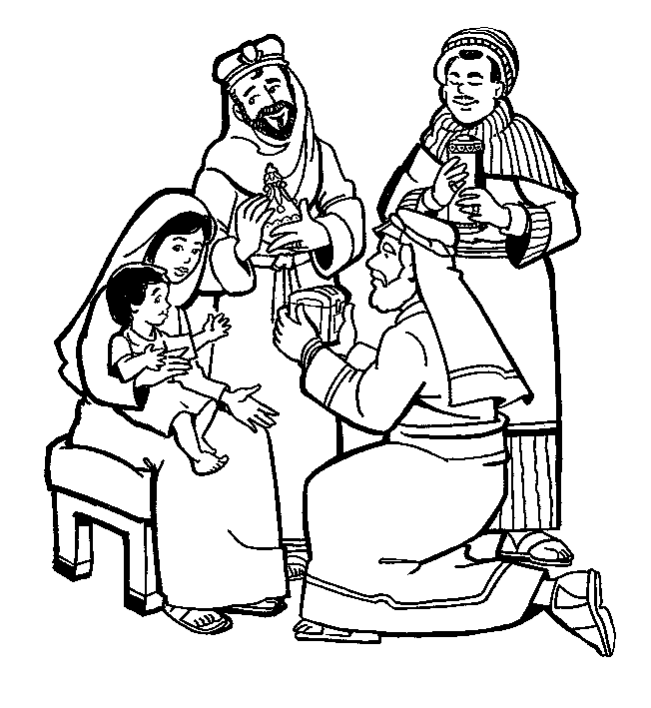
O Star of wonder, star of night Star with royal beauty bright
Westward leading, still proceeding Guide us to thy Perfect Light

“Joseph’s dream” Matthew 2:11-15
On entering the house, they saw the child with Mary his mother; and they knelt down and paid him homage. Then, opening their treasure chests, they offered him gifts of gold, frankincense, and myrrh. And having been warned in a dream not to return to Herod, they left for their own country by another road.
Now after they had left, an angel of the Lord appeared to Joseph in a dream and said, “Get up, take the child and his mother, and flee to Egypt, and remain there until I tell you; for Herod is about to search for the child, to destroy him.” Then Joseph got up, took the child and his mother by night, and went to Egypt, and remained there until the death of Herod.

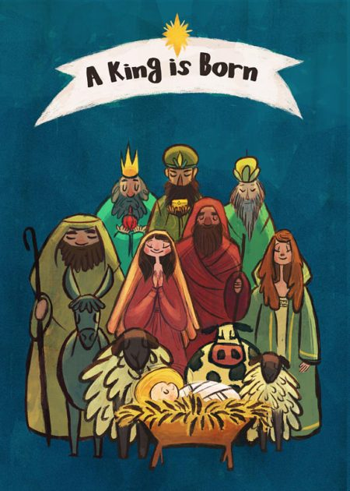
HYMN “Joy to the World”
Joy to the World, the LORD is come Let earth its praises bring;
Let every heart prepare Him room, And heaven and nature Sing,
And heaven and nature Sing, and heaven and nature Sing.

Joy to the world! the Savior reigns Let men their songs employ
While fields and floods Rocks, hills and plains
Repeat the sounding joy, Repeat the sounding joy;
Repeat, repeat the sounding joy.

A READING followed by a Reflection: “First Coming” by Madeleine L’Engle read by Pastor Deborah
God did not wait till the world was ready, till nations were at peace.
God came when the Heavens were unsteady and prisoners cried out for release.
God did not wait for the perfect time.
God came when the need was deep and great.
God dined with sinners in all their grime, turned water into wine.
God did not wait till hearts were pure.
In joy God came to a tarnished world of sin and doubt.
To a world like ours, of anguished shame, God came and God’s Light would not go out.
God came to a world that did not mesh; to heal its tangles, shield its scorn.
In the mystery of the Word made Flesh, the maker of the stars was born.
We cannot wait till the world is sane to raise our songs with joyful voice,
or to share our grief.
God came with Love to touch our pain.
He came with Love: Rejoice! Rejoice!

HYMN: “Silent Night, Holy Night”
Silent night, holy night, all is calm, all is bright
round yon virgin mother and child, holy infant so tender and mild,
sleep in heavenly peace, sleep in heavenly peace.

Silent night, holy night, shepherds quake at the sight,
glories stream from heaven afar, heavenly hosts sing alleluia;
Christ, the Savior is born! Christ, the Savior, is born!

Silent night, holy night, Son of God, love’s pure light
Radiant beams from thy holy face, with the dawn of redeeming grace,
Jesus, Lord, at thy birth, Jesus, Lord, at thy birth.

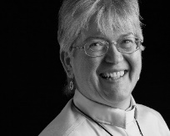
BENEDICTION: Pastor Deborah (The Pastor often will give a benediction at the end of service. This is like a special prayer asking for God’s help, guidance and blessing over everyone before the end of service.)

MERRY CHRISTMAS TO YOU AND YOURS!
MAY YOU BRING TONIGHT’S CHRISTMAS LOVE
WITH YOU INTO THE COMING YEAR!

FINGER PUPPETS: Color, cut out and glue matching sized paper to back of pictures to create finger puppets and re-create your own nativity play at home!