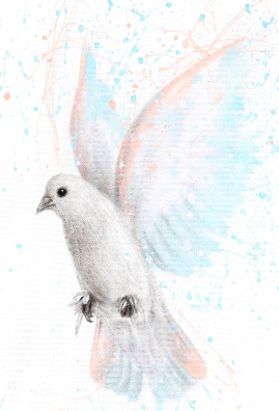
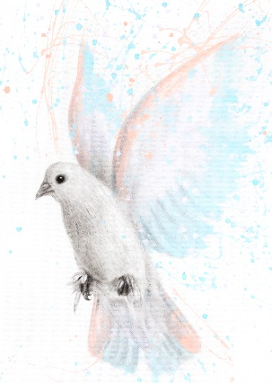
Children’s Bulletin
First Parish Congregational Church
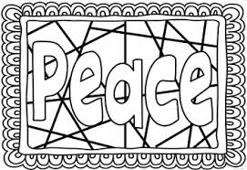
DECEMBER 6, 2020

Please gather the following (optional) items to help you worship today:
- Bread and juice for communion
- Drawing paper
- Crayons, markers, or colored pencils
- You’ll also find an additional activity pages for use during the sermon on the final pages of this Children’s Bulletin
Words of Welcome

Go around the room and greet each person (and pet!) with your favorite greeting, here are some examples:

CHRISTMAS CAROLING

O Little Town of Bethlehem
O little town of Bethlehem, how still we see thee lie!
Above thy deep and dreamless sleep the silent stars go by.
Yet in thy dark streets shineth the everlasting Light;
the hopes and fears of all the years are met in thee tonight.

Angels We Have Heard On High
Angels we have heard on high, sweetly singing o’er the plains,
and the mountains in reply, echo back their joyous strains.
Gloria, in excelsis Deo, Gloria, in excelsis Deo.
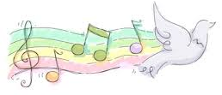
Go Tell it on a Mountain
Go, tell it on the mountain Over the hills and everywhere
Go, tell it on the mountain That Jesus Christ is born!
While shepherds kept their watching O'er their silent flocks night
Behold throughout the heavens here shone a holy light
O Come All ye Faithful
O come, all ye faithful, joyful and triumphant,
O come ye, O come ye to Bethlehem;
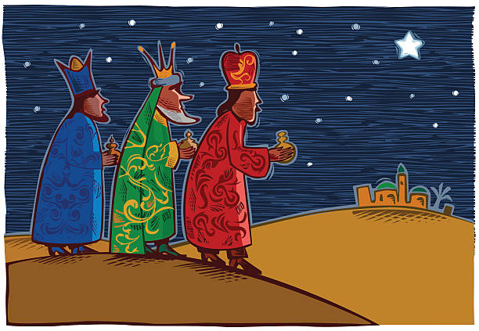
Come and behold Him, born the King of angels;
O come let us adore Him, O come let us adore Him,
O come, let us adore Him, Christ, the Lord!

We Three Kings
We three kings of Orient are bearing gifts we traverse afar
Field and fountain, moor and mountain following yonder star
O Star of wonder, star of night Star with royal beauty bright
Westward leading, still proceeding Guide us to thy Perfect Light.

Call to Worship & Invocation
Read out loud the words in bold or color in the footprints.

CALL TO WORSHIP AND LIGHT THE ADVENT CANDLE OF PEACE:
One: Psalm 33:20 says: “We wait in hope for the LORD;
who is our help and our shield.”
Many: As we await the coming of our savior, may our Eternal God grant us the courage to hope.
(The first candle – the candle of HOPE – is lit.)
One: Colossians 3:15 says: “Let the peace of Christ rule in your hearts, since as members of one body you were called to peace.”
Many: May our Almighty God offer rest for our hearts, and peace for our souls. May we draw upon God’s grace to seek peace in our lives, peace in this community, and peace in the world.
(The second candle – the candle of PEACE – is lit.)

PEACE HYMN: LET THERE BE PEACE ON EARTH
Let there be peace on earth and let it begin with me.
Let there be peace on earth, the peace that was meant to be.
With God our Creator, we are family,
Let me walk with my neighbor, in perfect harmony.

Let peace begin with me, let this be the moment now.
With every step I take, let this be my solemn vow;
To take each moment and live each moment in peace eternally.
Let there be peace on earth and let it begin with me.

INVOCATION (Read by Lay Reader. Join in at home.)
Come, O God, to bring light into our days of worry and anxiety. Enrich us with spiritual gifts that transcend disappointments and spill out in generous compassion for all your suffering children. Meet us today where we are so we may be equipped for trials yet to come and for joys yet to be revealed. In Jesus' name. Amen.

HYMN # 101 (vs 1, 2) Comfort, Comfort O My People
Comfort, comfort O my people, tell of peace, thus says our God;
Comfort those whose hearts are shrouded, mourning under sorrow’s load.
Speak unto Jerusalem of the peace that waits for them;
Tell them that their sins I cover, and their warfare now is over.

For the herald’s voice is calling in the desert far and near.
Bidding us to make repentance since the realm of God is here.
Oh, that warning cry obey! Now prepare for God a way;
Let the valleys rise in meeting and the hills bow down in greeting.

CALL TO CONFESSION (lay reader)
When God invites us out of our privilege, we want to act as if we do not truly understand. Let us confess the honesty of our fears.

PRAYER OF CONFESSION (Join in at home.)
Holy God, You show us over and over again that your Word is for our good. We hold on to our imagined comfort and we argue, or we try to get away. Thank you, God, for giving us this opportunity to see our error, to turn and grow closer to your will for our lives. Amen.
*SONG OF PRAISE #125 Angels We Have Heard on High (Refrain)
Gloria in excelsis Deo

CHILDREN’S MESSAGE: PEACE

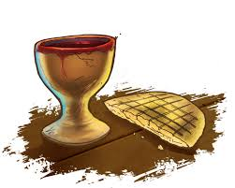
THE SACRAMENT OF HOLY COMMUNION

As we take communion together, we think about how much Jesus loves us and we know this by the sacrifices he made. We remember how to stay close to God and Jesus by praying everyday.

INVITATION TO THE TABLE
COMMUNION HYMN #336 Here, O My Lord, I See You Face to Face (vs. 2, 3)
Here would I feed upon the bread of God,
Here share the cup, the gracious gift of heaven;
Here would I lay aside each earthly load,
Here taste a fresh the calm of sin forgiven.

This is the hour of banquet and of song;
This is the heavenly table spread anew;
Here let me feast, and, feasting still prolong
The brief, bright hour together here with you.

OUR SACRED STORY
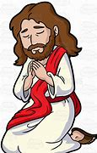
PRAYER OF CONSECRATION followed by
THE LORD’S PRAYER:
Our Father, who art in heaven, hallowed be Thy name. Thy kingdom come; Thy will be done; on earth as it is in heaven. Give us this day our daily bread and forgive us our debts as we forgive our debtors. Lead us not into temptation, but deliver us from evil; for Thine is the Kingdom, and the Power, and the Glory forever. Amen.

SHARING the MEAL
As we celebrate Communion today, you will first be invited to take the bread – which you will HOLD. If you are with your family, please serve one another. Once everyone is served we will ALL take the bread at the same time. This act symbolizes that we are ONE BODY and that we are all one in the Spirit of Christ.

You will then be invited to take the cup of love which symbolizes the cup of wine that Jesus shared with his friends, saying “This is the cup of love poured out for you.” You are invited to prayerfully drink from the cup at your own pace, in your own time. This demonstrates that we are each individuals in God’s Presence - each one doing the best that he/she/they can to be the hands and feet of Christ on this earth.

Scripture Reading
OLD TESTAMENT: Joel 2:12-13, 28-29
¹² Yet even now, says the Lord,
return to me with all your heart,
with fasting, with weeping, and with mourning;
¹³ rend your hearts and not your clothing.
Return to the Lord, your God,
for he is gracious and merciful,
slow to anger, and abounding in steadfast love,
and relents from punishing.

²⁸ Then afterward
I will pour out my spirit on all flesh;
your sons and your daughters shall prophesy,
your old men shall dream dreams,
and your young men shall see visions.
²⁹ Even on the male and female slaves,
in those days, I will pour out my spirit.

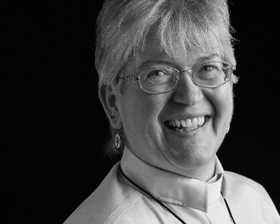

Sermon: “Rend Your Hearts and Not Your Clothing”
During this time, as you listen to the sermon, please enjoy the activities found on the last pages of the Children’s Bulletin

HYMN # 281 Come, Holy Spirit, Heavenly Dove
Come, Holy Spirit, heavenly Dove, with all your quickening powers;
Kindle a flame of sacred love in these cold hearts of ours.

Come, Holy Spirit, heavenly Dove, with all your quickening powers;
Come, shed on us the Savior’s love, that it may kindle ours.

Invitation to Generosity

OFFERTORY MUSIC Chimes: O Come, O Come Emmanuel

DOXOLOGY # 780 Praise God From Whom All Blessing Flow
Praise God from whom all blessings flow; Praise God all creatures here below,
Praise God above you heavenly hosts Creator, Christ, and Holy Ghost.

PRAYER OF DEDICATION
Thank you, God, for this family of faith, which enriches our lives and enables us to share. Thank you for making us aware that some faint with fear and others dwell in hopelessness. We are grateful that you show us ways to lift the burdens of our sisters and brothers. May our offerings further this ministry among us and beyond our community. Amen.

Sharing Joys and Concerns: Do you have a Joy or Concern you’d like to share with the congregation?

WE GO OUT TO LOVE AND SERVE A LOVING, SERVING GOD

HYMN # 117 Lift Up Your Heads Ye Mighty Gates
Fling wide the portals of your heart; make it a temple, set apart
From earthly use for heaven’s employ, adorned with prayer and love and joy.

BENEDICTION: The Pastor often will give a benediction at the end of service. This is like a special prayer asking for God’s help, guidance and blessing over everyone before the end of service.

POSTLUDE “Go now in peace. Go now in peace. May the love of God surround you everywhere, everywhere you may go.” Words & Music: Natalie Sleeth, © 1976 Hinshaw Music, Inc.; All rights reserved. Reprinted under ONE LICENSE #A-708716.

MINISTERS OF THE CHURCH - Members of the Congregation
SENIOR PASTOR AND TEACHER - The Rev. Dr. Deborah Roof
LAY READER – Rachel Cobban
GREETERS – Jack Martin and Sue Brown
CHOIR DIRECTOR/ ORGANIST - Joan Virga
CHRISTIAN EDUCATION DIRECTOR - Christine Lehoullier
ADMINISTRATIVE ASSISTANT - Michelle Guerrin
AV/ TECHNICAL – Paul Lindemann
