DOVE PEACE ROLLS

Start with your favorite yeast roll recipe or simply purchase some pre-made frozen bread dough and thaw according to the instructions. Proceed to the point in the recipe that you're ready to shape the dough and bake them.

Roll the dough out and cut it into strips, approximately 1" wide by 4" long.
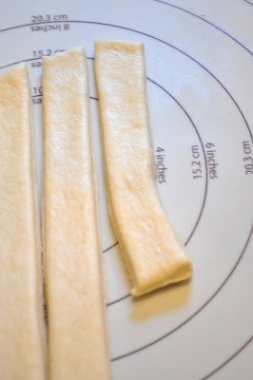
Carefully tie the dough in a knot, creating a short piece on one end and a longer tail on the other end. Shape the shorter tail into a rounded head with a pointed beak.
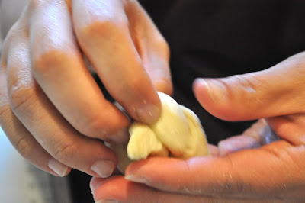

Flatten the longer tail and use a knife to cut three, four, or even five tail feathers.

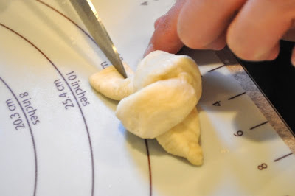

For the eyes, the cooks in this picture used cut dried blueberries and pressed them into the sides of the bird's head.
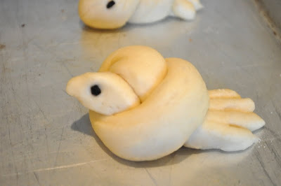
Space your birdies out on a baking sheet lined with parchment paper and bake according to your recipe's directions.
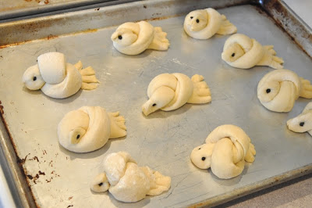

As soon as the birdies come out of the oven, immediately brush with melted butter. Then enjoy your yummy little peace doves!

