CHILDREN’S BULLETIN
FIRST PARISH CONGREGATIONAL CHURCH
JANUARY 24, 2021

The 4th Sunday in January is National Bible Sunday!
Try your best at these Bible Trivia with your family this week…

https://youtu.be/copRjNujlyI?list=PLh_ZCcaNyX7fgEdLV0WI2ddwpKVFltvjm

Or

http://fpc-ucc.org/Wordpress/wp-content/uploads/2021/01/Bible-Trivia-Questions-and-Answers.pdf

When you see this symbol | Let’s do this together
 | = Sing, Sway, Clap Along, Dance or Shake your Egg Shakers to the Music
 | = Let’s Bow Our heads and Pray Together as a Church Family (Listen to the words OR Read along if you can)
 | = Let’s Say The Lord’s Prayer Together
 | Listen closely to the Children’s Message
 | During this time, as you listen to the stories from the bible and the sermon, please enjoy the activities found on the last pages of the Children’s Bulletin or other coloring activities throughout the bulletin.

CALL TO WORSHIP
One: We thank God for our unity in diversity: There are different kinds of gifts:
Many: but the same Spirit.
One: There are different kinds of service:
Many: but the same Lord.
One: There are different kinds of working:
Many: but the same God.
One: Praise to God, our Creator, our Redeemer, our Sustainer:
Many: who works in us, with us and through us in all of these ways.

HYMN #172 Jesus Calls Us O’er the Tumult (vs. 1, 3, 5)
Jesus calls us, o’er the tumult of our life’s wild, restless sea;
Day by day that voice still calls us, saying, “Christian, follow me.”
Jesus calls us from the worship of the treasures we adore,
From each idol that would keep us, saying, “Christian, love me more.”
Jesus calls us! By your mercies, Savior, may we hear your call,
Give our hearts to your obedience, serve and love you best of all.

INVOCATION (Lay Reader – join in at home.)
We ask your healing blessing, O God, in all of the broken pieces of our lives and our culture and our world. Heal us with your love and compel us to share your love wherever and however we are able. No act of love is too small to make a difference. Come, Holy Spirit, come to be with us this hour and beyond. Amen.

SONG OF PRAISE: Arise, your light is come! The Spirit’s call obey;
Show forth the glory of your God which shines on you today!
Time Especially for Children
Let’s sing “Jesus loves me”
Come in close and bring your listening ears

CHILDREN’S MESSAGE:
What were some words that stuck out to you during Children’s Time?

PRAYER OF CONSECRATION followed by
THE LORD’S PRAYER:
Our Father, who art in heaven, hallowed be Thy name. Thy kingdom come; Thy will be done; on earth as it is in heaven. Give us this day our daily bread and forgive us our debts as we forgive our debtors. Lead us not into temptation but deliver us from evil; for Thine is the Kingdom, and the Power, and the Glory forever. Amen.

WE HEAR GOD’S WORD FOR US

NEW TESTAMENT: Luke 5: 1-11 1 Once while Jesus was standing beside the lake of Gennesaret, and the crowd was pressing in on him to hear the word of God, 2 he saw two boats there at the shore of the lake; the fishermen had gone out of them and were washing their nets. 3 He got into one of the boats, the one belonging to Simon, and asked him to put out a little way from the shore. Then he sat down and taught the crowds from the boat. 4 When he had finished speaking, he said to Simon, “Put out into the deep water and let down your nets for a catch.” 5 Simon answered, “Master, we have worked all night long but have caught nothing. Yet if you say so, I will let down the nets.” 6 When they had done this, they caught so many fish that their nets were beginning to break. 7 So they signaled their partners in the other boat to come and help them. And they came and filled both boats, so that they began to sink. 8 But when Simon Peter saw it, he fell down at Jesus’ knees, saying, “Go away from me, Lord, for I am a sinful man!” 9 For he and all who were with him were amazed at the catch of fish that they had taken; 10 and so also were James and John, sons of Zebedee, who were partners with Simon. Then Jesus said to Simon, “Do not be afraid; from now on you will be catching people.” 11 When they had brought their boats to shore, they left everything and followed him.

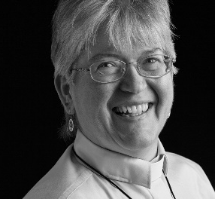
Sermon: “If you say so, Jesus”
During this time, as you listen to the sermon, please enjoy the activities found on the last pages of the Children’s Bulletin

HYMN #173 You Have Come Down to the Lakeshore (vs. 1, 2)
You have come down to the lakeshore seeking neither the wise nor the wealthy But only asking for me to follow.
Refrain: O Jesus, you have looked into my eyes; kindly smiling, you’ve called out my name. On the sand I have abandoned my small boat; now with you I will seek other seas.
You know full well my possessions. Neither treasure nor weapons for conquest, Just these my fish nets and will for working. (Repeat refrain)

Invitation to Generosity: Think about how you would like show LOVE to God, others and yourself this week

*DOXOLOGY
When morning gilds the skies, my heart awaking cries,
May Jesus Christ be praised!
Alike at work and prayer, one purpose I declare:
May Jesus Christ be praised!
PRAYER OF DEDICATION: (Pastor Deborah)
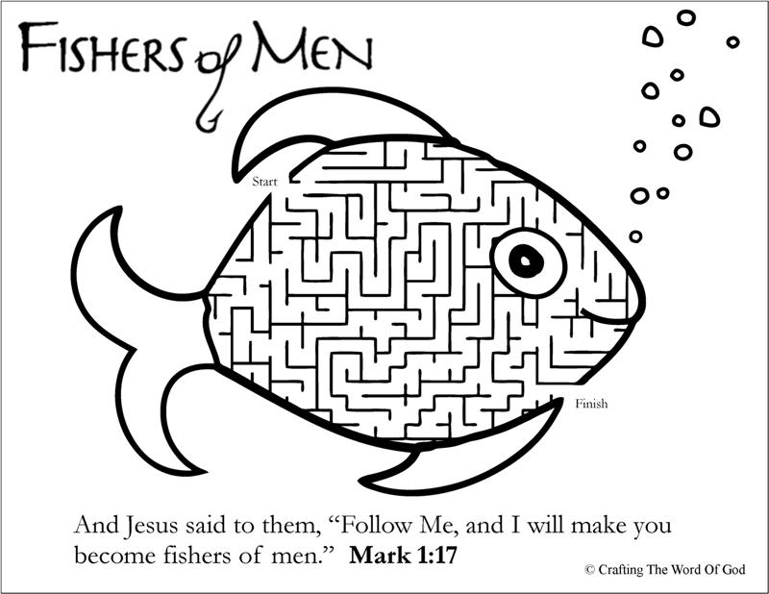
We hear your call to generosity, Divine Love. We respond even as we rededicate ourselves to your work in our world. We ask you to multiply our efforts today that they may contribute to making your Presence be made known. Amen.
WE GO OUT TO LOVE AND SERVE A LOVING, SERVING GOD
Sharing Joys and Concerns: Do you have a Joy or Concern you’d like to share with the congregation? Fill out the box above and let us know….

HYMN #493 O Jesus, I Have Promised (vs. 1, 3)
O Jesus, I have promised to serve you to the end;
Remain forever near me, my Savior and my Friend:
I shall not fear life’s struggles if you are by my side,
Nor wander from the pathway if you will be my guide.
O Jesus, you have promised to all who follow you
That where you are in glory your servant shall be, too;
And, Jesus, I have promised to serve you to the end;
O give me grace to follow my Savior and my Friend!
BENEDICTION: The Pastor often will give a benediction at the end of service. This is like a special prayer asking for God’s help, guidance and blessing over everyone before the end of service.

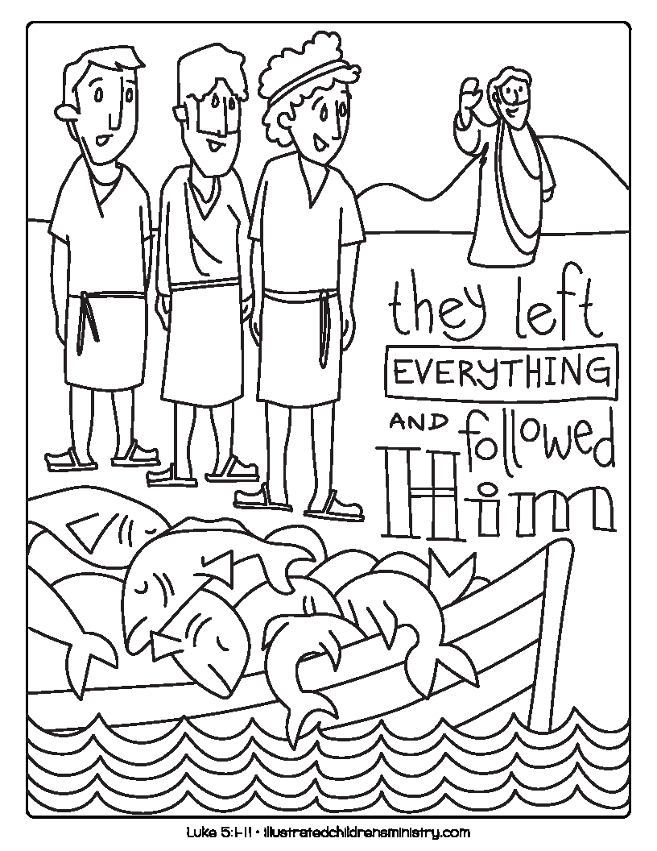
POSTLUDE : “Go now in peace. Go now in peace. May the love of God surround you everywhere, everywhere you may go.” Words & Music: Natalie Sleeth, © 1976 Hinshaw Music, Inc.; All rights reserved. Reprinted under ONE LICENSE #A-708716

MINISTERS OF THE CHURCH - Members of the Congregation
SENIOR PASTOR AND TEACHER - The Rev. Dr. Deborah Roof
LAY READER – Katie Cobban
GREETERS – Anne-Marie Merrill, Sue Brown
CHOIR DIRECTOR/ ORGANIST - Joan Virga
CHRISTIAN EDUCATION DIRECTOR - Christine Lehoullier
ADMINISTRATIVE ASSISTANT - Michelle Guerrin

