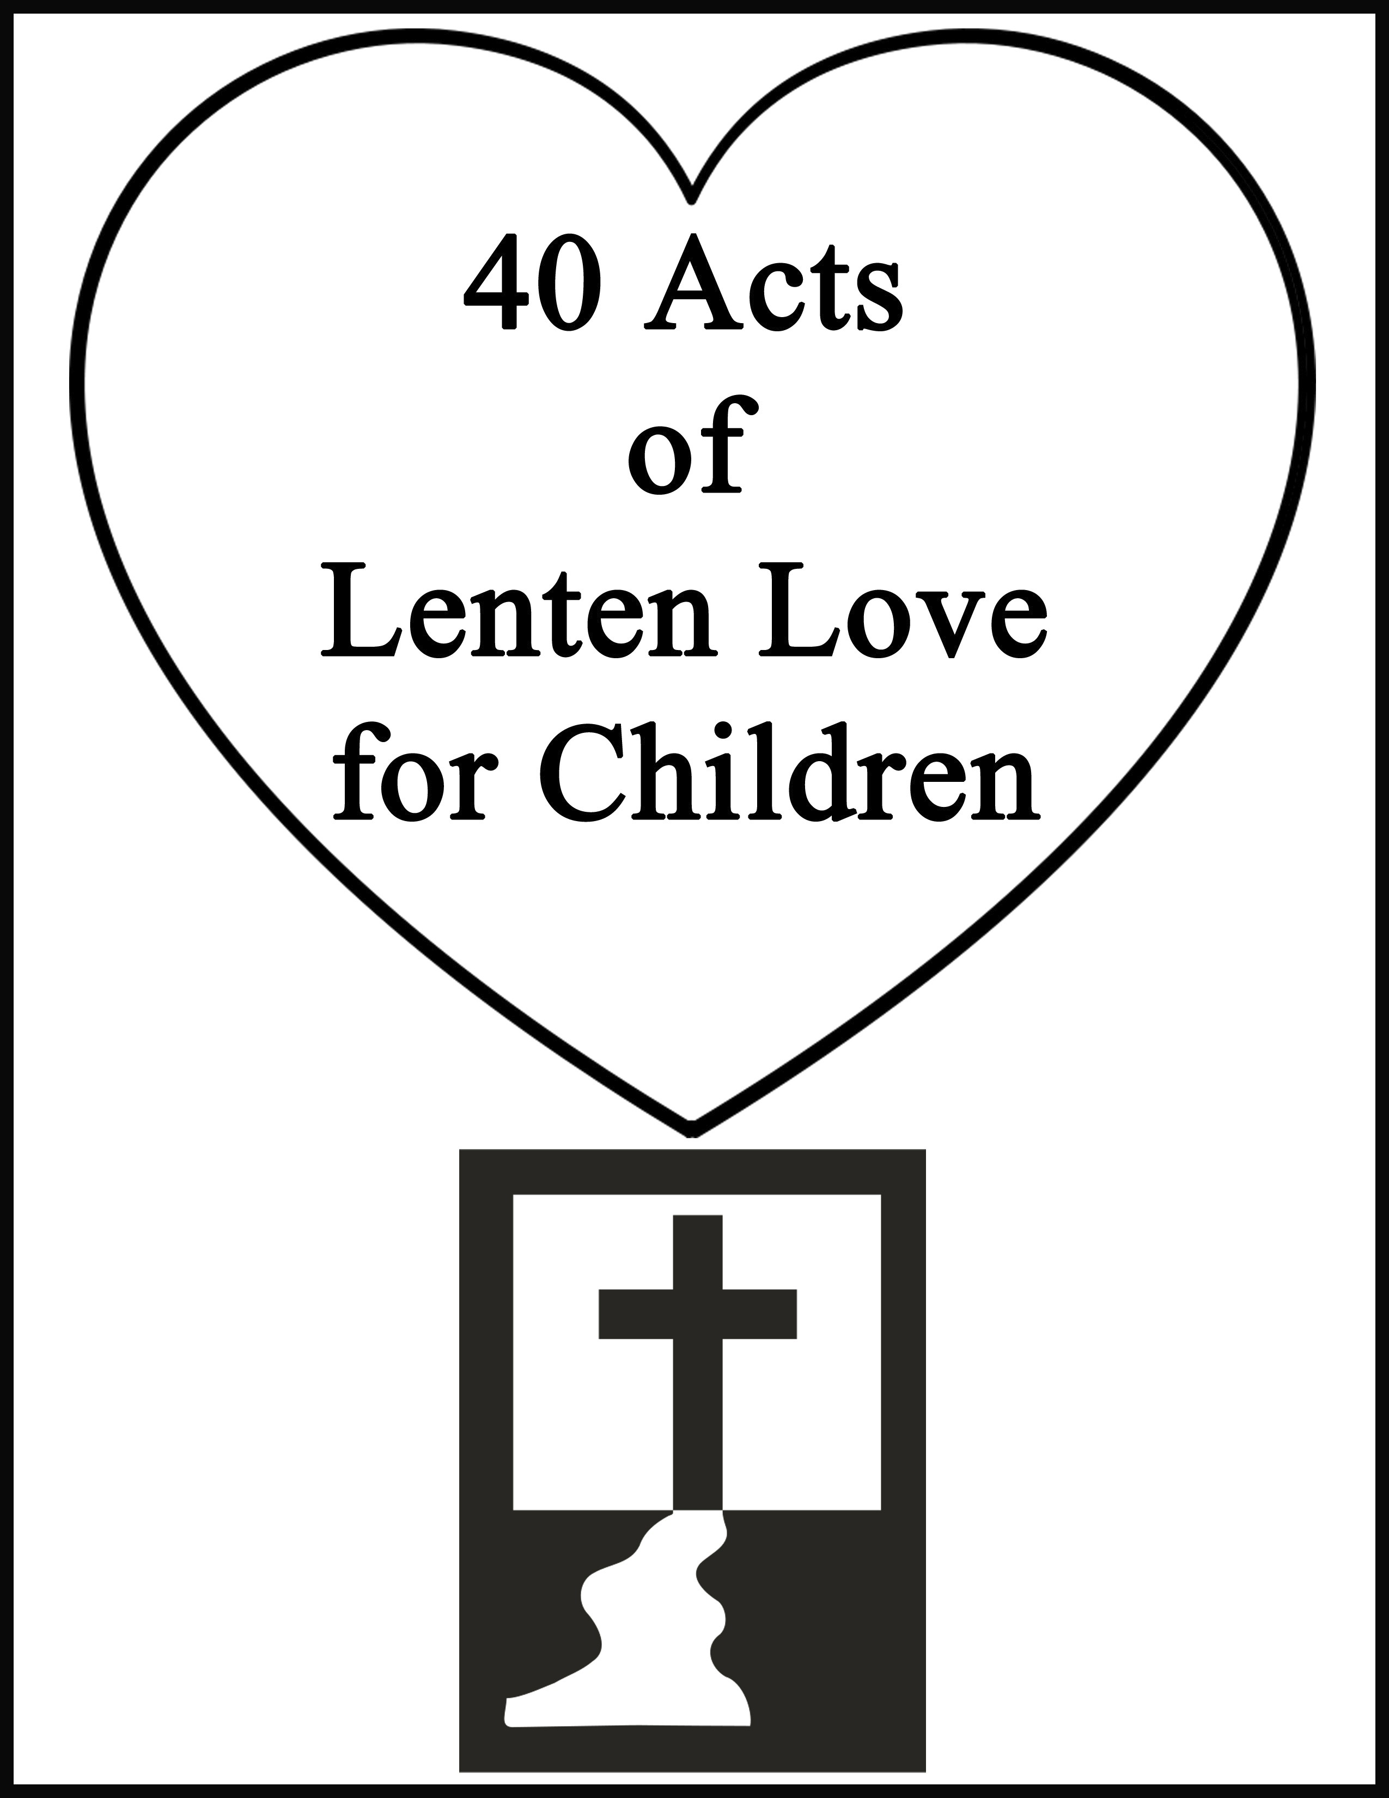

40 Acts of Lenten Love for Children

Directions: Show your love for Jesus with these 40 Acts of Lenten Love. Beginning with Ash Wednesday, follow the instructions for each day. Take a break to rest and pray on Sundays.
Day 1: Ask the Holy Spirit to guide you this Lenten season towards loving other people as Jesus loves you. Day 2: Offer your work to Jesus today.
Day 3: Say a prayer for the needs of the poor.
Day 4: Sing a song of love to Jesus. You can make one up or choose one that you know like a “Jesus Loves Me”.
Sunday: Day of rest and prayer ~ Enjoy watching the brief Sunday School Video and enjoy some fun activities!
Day 5: Animals are part of God’s gift of creation. Do a kind deed for an animal or say a prayer for animals. Day 6: Do a chore for someone else in your family as an act of kindness.
Day 7: Using polite words such as “please,” “thank you,” “sir,” and “ma’am” is an act of love and respect. Try to make a special effort to use these words and other polite words today.
Day 8: Pray for other children in the world that they may come to know and love God. Day 9: Thank God for the food you have.
Day 10: Read or tell a story to someone.
Sunday: Day of rest and prayer ~ Enjoy watching the brief Sunday School Video and enjoy some fun activities!

Day 11: Hug someone today (close to you that lives with you) to show your love for them.

Day 12: Make a special effort to do your very best in all you do today because that is pleasing to God.

Day 13: Make a thank you card for someone in your family. You can thank this person for something he or she has done or for just being a good person.
Day 14: Find a way to praise God today through song, writing, art, or prayer. Day 15: Draw a picture just for Jesus.

Day 16: Find some way to show mercy to another person, perhaps by forgiving or helping that person.
Sunday: Day of rest and prayer ~ Enjoy watching the brief Sunday School Video and enjoy some fun activities!
Day 17: Give someone a compliment today.

Day 18: Obedience to your parents is an act of love. Spend the entire day doing what your parents ask without questioning or arguing.

Day 19: Help someone learn something new.

Day 20: Ask God to help you learn all that He wants you to today.

Day 21: Tell your family that you love them today either out loud or in writing.
Day 22: Joy is one of the fruits of the spirit. Try to be joyful all day today and spread your joy to others. Sunday: Day of rest and prayer ~ Enjoy watching the brief Sunday School Video and enjoy some fun activities!
Day 23: Pray for world peace.

Day 24: Do a secret act of kindness today.

Day 25: Say encouraging words to someone.

Day 26: Find a special Saint Patrick’s Day Blessing today and pray it with someone special in mind.

Day 27: Make a get well card for someone you know that is sick. Or make one and deliver it to a hospital.

Day 28: An apology is an act of love. If you have hurt someone, say, “I’m sorry” to that person.
Sunday: Day of rest and prayer ~ Enjoy watching the brief Sunday School Video and enjoy some fun activities!

Day 29: Play a game or do something else fun with a sibling today with the intent to bless that person.

Day 30: Listening to others is an act of love. Try to really listen with your whole mind and heart to everyone you speak to today.
Day 31: Put together a bag of food to deliver to a needy person or to the food pantry near your house.
Day 32: Say a prayer for the sick that they may be healed by God.

Day 33: Every person on this Earth is a gift from God. Do you look for the good in everyone you meet? Make a point of finding something (or several things) good in everyone you see today.
Day 34: Clean some part of the house for your family today.
Sunday: Day of rest and prayer ~ Enjoy watching the brief Sunday School Video and enjoy some fun activities!
Day 35: Laughter is a gift from God. Try to make someone laugh today.

Day 36: Forgiveness is an act of love. Think of someone that you’ve been angry with and forgive them in your heart.
Day 37: Pray for the families of people who have passed away, that they may find comfort.

Day 38: Find some way to be of service to another person.

Day 39: Make a thank you card to Jesus for giving his life on the cross for you.
Day 40: Go through your things and find something to donate to the poor. Happy Easter! Rejoice in the love of Christ.

HomeschoolWithLove.com 3 Warm Hearts Publishing

