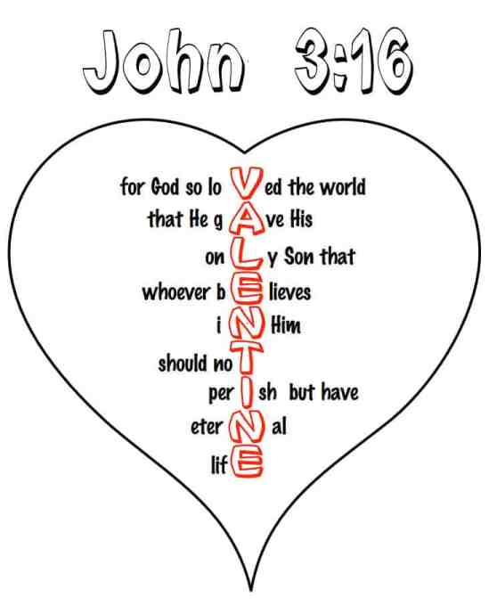
CHILDREN’S BULLETIN
FIRST PARISH CONGREGATIONAL CHURCH
FEBRUARY 14TH, 2021
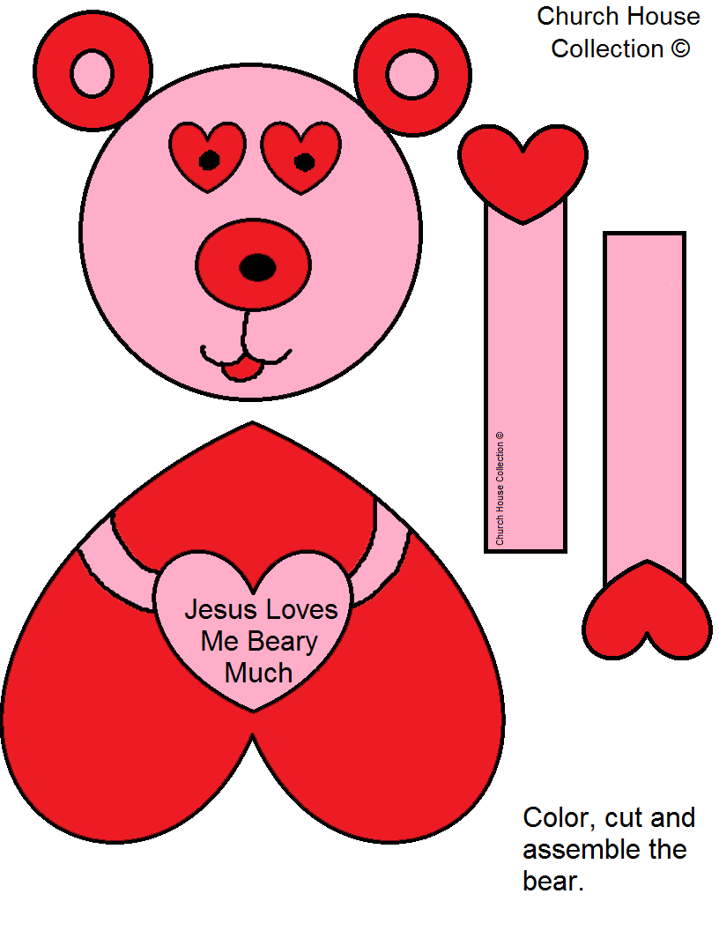

Find this cute bear craft at the end of your bulletin
Make it for yourself or for someone you love!

When you see this symbol | Let’s do this together
 | = Sing, Sway, Clap Along, Dance or Shake your Egg Shakers to the Music
 | = Let’s Bow Our heads and Pray Together as a Church Family (Listen to the words OR Read along if you can)
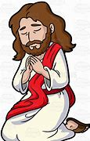 | = Let’s Say The Lord’s Prayer Together
 | = Listen closely to the Children’s Message
 | During this time, as you listen to the stories from the bible and the sermon, please enjoy the activities found on the last pages of the Children’s Bulletin or other coloring activities throughout the bulletin.

CALL TO WORSHIP
One: Awe-inspiring, brilliantly shining God of all the generations:
Many: We come to be in your holy Presence and to hear Your voice.
One: The voice of God is sometimes thunder and sometimes a still small voice.
Many: Let us be attentive to all the ways in which God tries to speak to us.
HYMN: #282 Every Time I Feel the Spirit
Refrain: Every time I feel the Spirit moving in my heart I will pray.
Yes, every time I feel the Spirit moving in my heart I will pray.

Upon the mountain my God spoke, out of God’s mouth came fire and smoke.
Looked all around me; looked so fine; I asked my God if all were mine. (Refrain)

Oh, Jordan river, chilly and cold, it chills the body, not the soul.
There’s only one train on this track; it runs to heaven, then right back. (Refrain)
INVOCATION (Lay Reader – join in at home.)
Good and gracious God, awaken within us the fire of our faith. Ignite the embers of our yearning that bursts into flames of hope in action before our very eyes. We are ready, O God, to see Your miraculous Presence all around us! Amen.

SONG OF PRAISE: “Glory, glory Hallelujah”

CHILDREN’S MESSAGE:
Time Especially for Children
Let’s sing “He’s Got the Whole World In His Hands”
Come in close and bring your listening ears

THE LORD’S PRAYER:
Our Father, who art in heaven, hallowed be Thy name. Thy kingdom come; Thy will be done; on earth as it is in heaven. Give us this day our daily bread and forgive us our debts as we forgive our debtors. Lead us not into temptation but deliver us from evil; for Thine is the Kingdom, and the Power, and the Glory forever. Amen.

WE HEAR GOD’S WORD FOR US

NEW TESTAMENT: Luke 9:28-36 (37-45) 28 Now about eight days after these sayings Jesus took with him Peter and John and James, and went up on the mountain to pray. 29 And while he was praying, the appearance of his face changed, and his clothes became dazzling white. 30 Suddenly they saw two men, Moses and Elijah, talking to him. 31 They appeared in glory and were speaking of his departure, which he was about to accomplish at Jerusalem. 32 Now Peter and his companions were weighed down with sleep; but since they had stayed awake, they saw his glory and the two men who stood with him. 33 Just as they were leaving him, Peter said to Jesus, “Master, it is good for us to be here; let us make three dwellings, one for you, one for Moses, and one for Elijah”—not knowing what he said. 34 While he was saying this, a cloud came and overshadowed them; and they were terrified as they entered the cloud. 35 Then from the cloud came a voice that said, “This is my Son, my Chosen; listen to him!” 36 When the voice had spoken, Jesus was found alone. And they kept silent and in those days told no one any of the things they had seen.

HYMN: #182 We Have Come at Christ’s Own Bidding
Light breaks through our clouds and shadows,
splendor bathes the flesh joined Word,
Moses and Elijah marvel as the heavenly voice is heard.
Eyes and hearts behold with wonder how the Law and Prophets meet;
Christ with garments drenched in brightness, stands transfigured and complete.

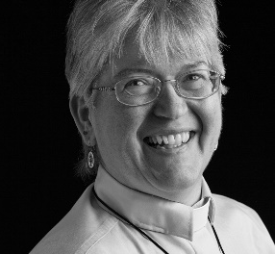

Sermon: “We Can Do Better”
During this time, as you listen to the sermon, please enjoy the activities found on the last pages of the Children’s Bulletin.

Invitation to Generosity: Think about how you would like show LOVE to God, others and yourself this week

*DOXOLOGY: I’m so glad
PRAYER OF DEDICATION: (Pastor Deborah) We give thanks, Glowing God, that Your light shines regardless of our ability to perceive it. May the gifts we now offer to Your church glow brightly in our community and in our world not because of who we are, but because You love us ! In love and light we pray, Amen.
Sharing Joys and Concerns: Do you have a Joy or Concern you’d like to share with the congregation? Fill out the box above and let us know….

WE GO OUT TO LOVE AND SERVE A LOVING, SERVING GOD

HYMN: #2 Glory, Glory Hallelujah
Glory, glory hallelujah, since I laid my burdens down. (Sing twice)
I feel better, so much better, since I laid my burdens down. (Sing twice)
Feel like shouting Hallelujah! Since I laid my burdens down. (Sing twice)
Every round goes higher and higher, since I laid my burdens down. (Sing twice)
BENEDICTION: The Pastor often will give a benediction at the end of service. This is like a special prayer asking for God’s help, guidance and blessing over everyone before the end of service.

POSTLUDE : “Go now in peace. Go now in peace. May the love of God surround you everywhere, everywhere you may go.” Words & Music: Natalie Sleeth, © 1976 Hinshaw Music, Inc.; All rights reserved. Reprinted under ONE LICENSE #A-708716

MINISTERS OF THE CHURCH - Members of the Congregation
SENIOR PASTOR AND TEACHER - The Rev. Dr. Deborah Roof
LAY READER – Katie Cobban
GREETERS – Anne-Marie Merrill, Sue Brown
CHOIR DIRECTOR/ ORGANIST - Joan Virga
CHRISTIAN EDUCATION DIRECTOR - Christine Lehoullier
ADMINISTRATIVE ASSISTANT - Michelle Guerrin
AV/ TECHNICAL – Paul Lindemann

