CHILDREN’S BULLETIN
FIRST PARISH CONGREGATIONAL CHURCH
FEBRUARY 28TH, 2021
Check out this amazing list of resources for kids to explore all year round including books, music, videos, museums and more: https://homeschoolsuperfreak.com/free-black-history-homeschool-curriculum-resources/

When you see this symbol | Let’s do this together
 | = Sing, Sway, Clap Along, Dance or Shake your Egg Shakers to the Music
 | = Let’s Bow Our heads and Pray Together as a Church Family (Listen to the words OR Read along if you can)
 | = Let’s Say The Lord’s Prayer Together
 | = Listen closely to the Children’s Message
 | During this time, as you listen to the stories from the bible and the sermon, please enjoy the activities found on the last pages of the Children’s Bulletin or other coloring activities throughout the bulletin.
CALL TO WORSHIP (Led by the Lay Reader) (based on Psalm 122: 1-4)
One: I was glad when they said to me, “Let us go to the house of the Lord!”
Many: Our feet are standing within your gates, O Jerusalem.
One: Jerusalem—built as a city that is bound firmly together.
Many: To it the tribes go up, the tribes of the Lord, as was decreed for Israel,
to give thanks to the name of the Lord.
HYMN: #13 O My Soul, Bless Your Creator (vs. 1, 2, 3)
O my soul, bless your Creator; all within me bless God’s name;
Bless your Maker, and forget not all God’s mercies to proclaim.

God forgives all your transgressions, all who suffer, gently heals;
God redeems you from destruction, and with you so kindly deals.

Far as east from west is distant, God has put away our sin;
Like a mother and a father, God compassionate has been.

INVOCATION (Lay Reader – join in at home.)
We come before you, gracious God, seeking what money canot buy. Only You can provide nourishment for our souls. We cannot find true peace without knowledge of You. As a community of faith, we call on you, believing that You are as close as our very breath. Uphold us now as we worship on wings of joy. Amen.

SONG OF PRAISE: Praise to you Lord Jesus Christ, King of endless glory, 2x

CHILDREN’S MESSAGE:
Time Especially for Children
Let’s sing “He’s Got the Whole World In His Hands”
Come in close and bring your listening ears

THE LORD’S PRAYER:
Our Father, who art in heaven, hallowed be Thy name. Thy kingdom come; Thy will be done; on earth as it is in heaven. Give us this day our daily bread and forgive us our debts as we forgive our debtors. Lead us not into temptation but deliver us from evil; for Thine is the Kingdom, and the Power, and the Glory forever. Amen.

WE HEAR GOD’S WORD FOR US

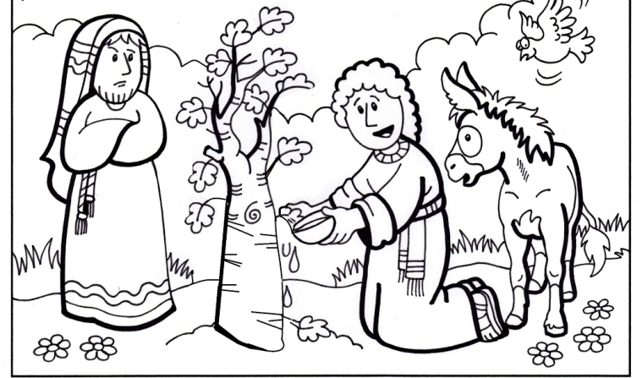
NEW TESTAMENT: Luke 13: 1-9, 31-35 1At that very time there were some present who told him about the Galileans whose blood Pilate had mingled with their sacrifices. 2 (Jesus) asked them, “Do you think that because these Galileans suffered in this way they were worse sinners than all other Galileans? 3 No, I tell you; but unless you repent, you will all perish as they did. 4 Or those eighteen who were killed when the tower of Siloam fell on them—do you think that they were worse offenders than all the others living in Jerusalem? 5 No, I tell you; but unless you repent, you will all perish just as they did.” 6 Then he told this parable: “A man had a fig tree planted in his vineyard; and he came looking for fruit on it and found none. 7 So he said to the gardener, ‘See here! For three years I have come looking for fruit on this fig tree, and still I find none. Cut it down! Why should it be wasting the soil?’ 8 He replied, ‘Sir, let it alone for one more year, until I dig around it and put manure on it. 9 If it bears fruit next year, well and good; but if not, you can cut it down.’” 31 At that very hour some Pharisees came and said to him, “Get away from here, for Herod wants to kill you.” 32 (Jesus) said to them, “Go and tell that fox for me, ‘Listen, I am casting out demons and performing cures today and tomorrow, and on the third day I finish my work. 33 Yet today, tomorrow, and the next day I must be on my way, because it is impossible for a prophet to be killed outside of Jerusalem.’ 34 Jerusalem, Jerusalem, the city that kills the prophets and stones those who are sent to it! How often have I desired to gather your children together as a hen gathers her brood under her wings, and you were not willing! 35 See, your house is left to you. And I tell you, you will not see me until the time comes when you say, ‘Blessed is the one who comes in the name of the Lord.’”

HYMN: #553 There is a Balm in Gilead (vs: 1, 2, 3)
There is a balm in Gilead, to make the wounded whole, There is a balm in Gilead, to heal the sinsick soul. Sometimes I feel discouraged, and think my work’s in vain, But then the Holy Spirit revives my soul again. Refrain Don’t ever feel discouraged, for Jesus is your friend, Who, if you ask for knowledge, will never fail to lend. Refrain If you cannot preach like Peter, if you cannot pray like Paul, You can tell the love of Jesus, who died to save us all. Refrain
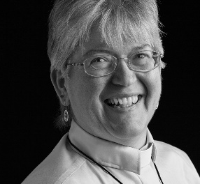

Sermon: “A Time For Everything Under Heaven”
During this time, as you listen to the sermon, please enjoy the activities found on the last pages of the Children’s Bulletin.

Invitation to Generosity: Think about how you would like show LOVE to God, others and yourself this week

DOXOLOGY: Masithi
(Masithi) Amen, si ya ku du mi sa, (masithi) (Repeat)
Amen, Bawo, Amen, Bawo ; Amen, si ya ku du mi sa.
(sing amen) Amen, we praise your name, O God. (Sing amen)
Amen, amen, amen, amen; Amen, we praise your name, O God.

PRAYER OF DEDICATION: (Please join Pastor Deborah)
We return to You, O God, but a portion of the wealth that You have bestowed upon us. We give financially to this church because there is much work to be done in Your name. This church is faithful to that mission sending blessings far and wide –in Your name, O God. Multiply our efforts, we pray. Amen.

NELSON MANDALA
Sharing Joys and Concerns: Do you have a Joy or Concern you’d like to share with the congregation? Fill out the box above and let us know….

WE GO OUT TO LOVE AND SERVE A LOVING, SERVING GOD

HYMN: #35 A Mighty God (vs 1 and 4)
O mighty God, when I survey in wonder the world that
Formed when once the word you said, The strands of life
All woven close together, the whole creation at your table fed.
My soul cries out in songs of praise to you, O mighty God! mighty God!
My soul cries out in songs of praise to you, O mighty God! O Mighty God!
And when, at last, the clouds of doubt dispersing, you will reveal
What we but dimly see; With trumpet call, our great rebirth
Announcing, we shall rejoin you for eternity.
Then we will sing your praise forevermore, O mighty God! O mighty God!
Then we will sing your praise forevermore, O mighty God! O mighty God!

BENEDICTION: The Pastor often will give a benediction at the end of service. This is like a special prayer asking for God’s help, guidance and blessing over everyone before the end of service.

POSTLUDE : “Go now in peace. Go now in peace. May the love of God surround you everywhere, everywhere you may go.” Words & Music: Natalie Sleeth, © 1976 Hinshaw Music, Inc.; All rights reserved. Reprinted under ONE LICENSE #A-708716

MINISTERS OF THE CHURCH - Members of the Congregation
SENIOR PASTOR AND TEACHER - The Rev. Dr. Deborah Roof
LAY READER – Katie Cobban
GREETERS – Anne-Marie Merrill, Sue Brown
CHOIR DIRECTOR/ ORGANIST - Joan Virga
CHRISTIAN EDUCATION DIRECTOR - Christine Lehoullier
ADMINISTRATIVE ASSISTANT - Michelle Guerrin
AV/ TECHNICAL – Paul Lindemann

