STRAW WEAVING INSTRUCTIONS:

https://happyhooligans.ca/straw-weaving/ (for video tutorial)
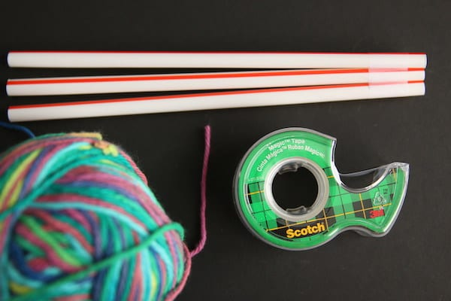

SUPPLIES:
- 3 or more drinking straws
- yarn (approx 7-8 meters or about 22- 26 feet)
- tape
- scissors
- beads (optional)
- Tape straws.
Tape 3 drinking straws together at one end, leaving a very small gap between the straws.
- Weave.
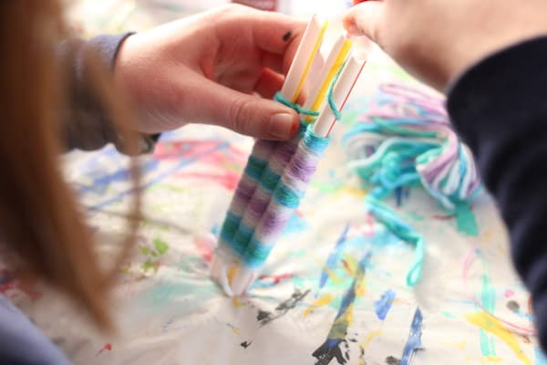
To weave on your straws, leave a long tail, and insert your yarn between two of the straws, close to the taped end. Weave over and under the straws until you get to the 3rd straw and then weave your way back to the first straw. Repeat this motion as you weave your way up the straws.
Note: From time to time, stop and slide your weaving down towards the taped end so your stitches are snug. Weave all the way to the top end of the straws.
- Prepare to take project off the straws.
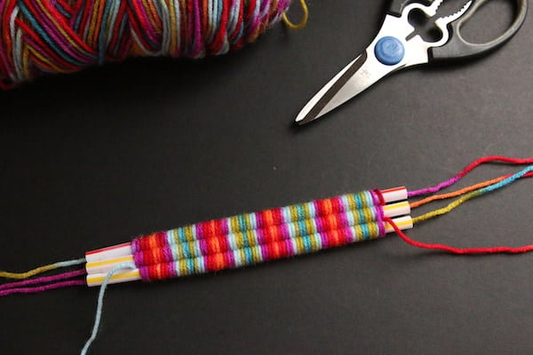
When you get to the end of the straws, snip your yarn, leaving a tail.
Cut 3 new pieces of yarn that are several inches longer than the straws and drop one piece through each straw.
- Tie the top tails.
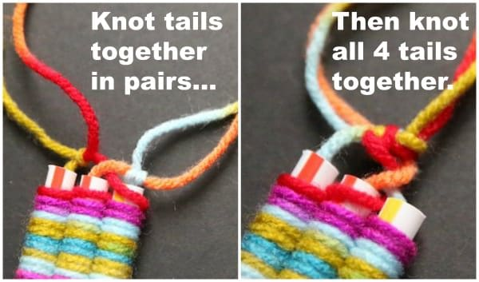
At the top (untaped) end of the straw, tie the piece that you finished weaving with to one of the new pieces of yarn and secure with a knot. Next, knot the other two pieces of yarn together. Then knot all 4 tails together in one knot.
- Slide project off straws.
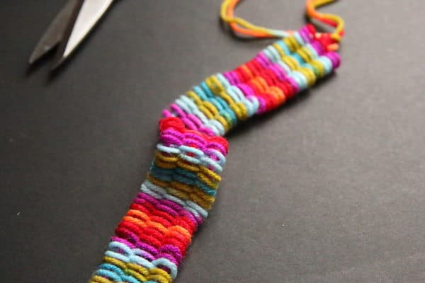
Gently push and shimmy your weaving off the straws. Lay your project flat and gently smooth it out.
- Tie the bottom tails.
Much like you did with the top tails, knot the bottom tails together.
- Decorate with beads.
If you’re making a bookmark, add some pony beads to the tails of your woven project.

