CHILDREN’S BULLETIN
FIRST PARISH CONGREGATIONAL CHURCH
MARCH 7TH, 2021 COMMUNION SUNDAY

#GirlScoutWeek
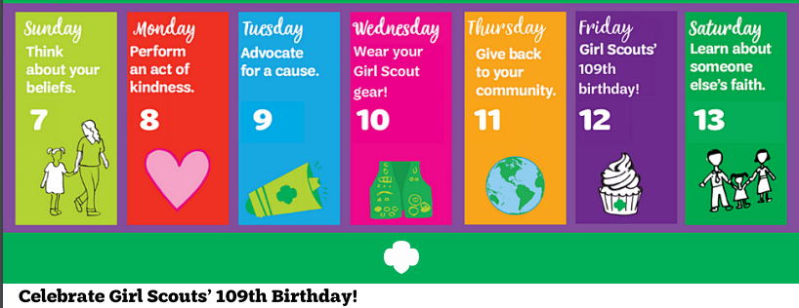
March 7-13, 2021
https://www.girlscoutsnca.org/content/dam/girlscouts-girlscoutsnca/documents/GS_Week_Flyer.pdf

When you see this symbol | Let’s do this together
 | = Sing, Sway, Clap Along, Dance or Shake your Egg Shakers to the Music
 | = Let’s Bow Our heads and Pray Together as a Church Family (Listen to the words OR Read along if you can)
 | = Let’s Say The Lord’s Prayer Together
 | = Listen closely to the Children’s Message
 | During this time, as you listen to the stories from the bible and the sermon, please enjoy the activities found on the last pages of the Children’s Bulletin or other coloring activities throughout the bulletin.

CALL TO WORSHIP (Psalm 119: 169-172) (Led by lay reader.)

One: Let my cry come before you, O Lord;
give me understanding according to your word.

Many: Let my supplication come before you;
deliver me according to your promise.

One: My lips will pour forth praise, because you teach me your statutes.

Many: My tongue will sing of your promise,
for all your commandments are right.

HYMN: # 459 Come, O Fount of Every Blessing (vs 1, 3)
Come, O Fount of every blessing, tune my heart to sing your grace,
Streams of mercy, never ceasing, call for songs of endless praise.
Teach me some melodious sonnet, sung by flaming tongues above,
Praise the mount; I’m fixed upon it, mount of God’s unfailing love.

O to grace how great a debtor daily I am drawn a new!
Let that grace now, like a fetter, bind my wandering heart to you.
Prone to wander, I can feel it, wander from the love I’ve known,
Here’s my heart, O take and seal it, seal it for your very own.

INVOCATION (based on Psalm 119: 173-176) (Led by lay reader. Join in at home.) Wonderful God, Let your hand be ready to help me, for I have chosen your precepts. We long for your salvation, O Lord. May we live to praise you, and may Your ordinances help me stay on Your path. When we have gone astray like a lost sheep; seek out your servant, for we do not forget your commandments. Amen.

CALL TO CONFESSION: (lay reader)
Words escape us; meaningful conversation in this twilight zoom zone escapes
us. We wonder where You are as we wander from your Presence.

PRAYER OF CONFESSION: (Led by lay reader. Join in at home.)
We are so weary, O LORD, of this pandemic reality that numbs our senses.
How much longer must we endure masked faces we once knew so well and
hug-less encounters with old friends at a safe distance? Help us to hold on and to rise up and to endure until this is over. Give us strength not only to walk with Jesus to Jerusalem, but also to continue a life of faith in spite of the numbness we feel.

ASSURANCE OF PARDON: (lay reader)
It is written: “nothing can separate us from the love of God”: not even spotty
zoom connections, claustrophobic cabin fever, or apathy born out of boredom.
Hold on; hold on; hold on. The promise of the manger lives on: Emmanuel!
SONG OF PRAISE: Praise to You Lord Jesus Christ

CHILDREN’S MESSAGE:
Time Especially for Children
Let’s sing “He’s Got the Whole World In His Hands”
Come in close and bring your listening ears

THE SACRAMENT OF HOLY COMMUNION

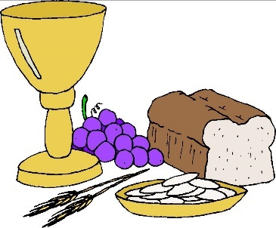
Communion is a holy meal, we don’t take communion just because we’re hungry in the middle of the service. It’s a meal for the soul, not the body. As we take communion together, we think about how much Jesus loves us and we know this by the sacrifices he made. We remember how to stay close to God and Jesus by praying everyday.
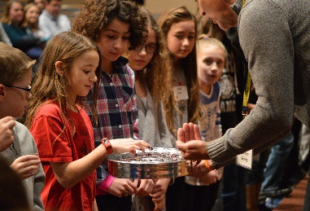
INVITATION TO THE TABLE:
As we take communion together, everyone, no matter what age, is welcome to receive communion at the Lord’s Table.

COMMUNION HYMN: #321 Break Now the Bread of Life
Break now the bread of life, Savior, to me,
As you once broke the loaves beside the sea;
Beyond the sacred page I seek you, Lord;
My spirit yearns for you, O Living Word.
Bless now the truth, dear Christ, to me, to me,
As you once blessed the bread by Galilee;
Then shall all bondage cease, all shackles fall,
And I shall find my peace, my all in all.

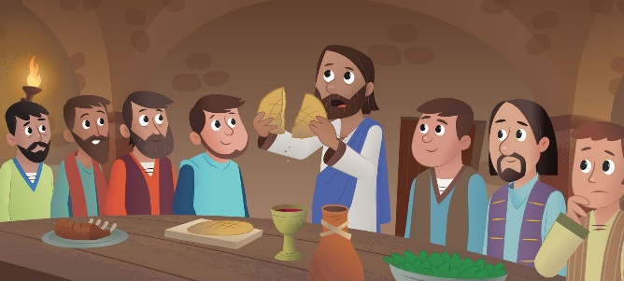
OUR SACRED STORY: Communion connects us to the disciples at the Last Supper.
And it connects us to everyone who, like us, have followed Jesus for hundreds and thousands of years. When we take communion, our connection to, or relationship with Jesus and one another is made stronger.

PEACE HYMN: Let There Be Peace on Earth
SHARING THE PEACE OF CHRIST
(Please extend a hug or a handshake and say “Peace be with you” to others.)

SHARING the MEAL
As we celebrate Communion today, you will first be invited to take the bread and hold it until everyone is served. Once everyone is served the bread we ALL eat the bread at the same time. This act symbolizes that we are ONE BODY and that we are all one in the Spirit of Christ. Matthew 18:20, “ For where two or three are gathered in my name, I am there among them.” New Revised Standard Version.

You will then be invited to take the cup of love which symbolizes the cup of wine that Jesus shared with his friends, saying “This is the cup of love poured out for you.” You are invited to prayerfully drink from the cup at your own pace. This demonstrates that we are each individuals in God’s Presence - each one doing the best we can to spread God’s love.

THE LORD’S PRAYER:
Our Father, who art in heaven, hallowed be Thy name. Thy kingdom come; Thy will be done; on earth as it is in heaven. Give us this day our daily bread and forgive us our debts as we forgive our debtors. Lead us not into temptation but deliver us from evil; for Thine is the Kingdom, and the Power, and the Glory forever. Amen.

WE HEAR GOD’S WORD FOR US

SCRIPTURE: Luke 15: 1-32 1 Now all the tax collectors and sinners were coming near to listen to him. 2 And the Pharisees and the scribes were grumbling and saying, “This fellow welcomes sinners and eats with them.”
3 So (Jesus) told them this parable: 4 “Which one of you, having a hundred sheep and losing one of them, does not leave the ninety-nine in the wilderness and go after the one that is lost until he finds it? 5 When he has found it, he lays it on his shoulders and rejoices. 6 And when he comes home, he calls together his friends and neighbors, saying to them, ‘Rejoice with me, for I have found my sheep that was lost.’ 7 Just so, I tell you, there will be more joy in heaven over one sinner who repents than over ninety-nine righteous persons who need no repentance.

Pause to Reflect with Pastor Deborah

8 “Or what woman having ten silver coins, if she loses one of them, does not light a lamp, sweep the house, and search carefully until she finds it? 9 When she has found it, she calls together her friends and neighbors, saying, ‘Rejoice with me, for I have found the coin that I had lost.’ 10 Just so, I tell you, there is joy in the presence of the angels of God over one sinner who repents.”

Pause to Reflect with Pastor Deborah

11 Then Jesus said, “There was a man who had two sons. 12 The younger of them said to his father, ‘Father, give me the share of the property that will belong to me.’ So he divided his property between them. 13 A few days later the younger son gathered all he had and traveled to a distant country, and there he squandered his property in dissolute living. 14 When he had spent everything, a severe famine took place throughout that country, and he began to be in need. 15 So he went and hired himself out to one of the citizens of that country, who sent him to his fields to feed the pigs. 16 He would gladly have filled himself with the pods that the pigs were eating; and no one gave him anything. 17 But when he came to himself he said, ‘How many of my father’s hired hands have bread enough and to spare, but here I am dying of hunger! 18 I will get up and go to my father, and I will say to him, “Father, I have sinned against heaven and before you; 19 I am no longer worthy to be called your son; treat me like one of your hired hands.”’ 20 So he set off and went to his father. But while he was still far off, his father saw him and was filled with compassion; he ran and put his arms around him and kissed him. 21 Then the son said to him, ‘Father, I have sinned against heaven and before you; I am no longer worthy to be called your son.’ 22 But the father said to his slaves, ‘Quickly, bring out a robe—the best one—and put it on him; put a ring on his finger and sandals on his feet. 23 And get the fatted calf and kill it, and let us eat and celebrate; 24 for this son of mine was dead and is alive again; he was lost and is found!’ And they began to celebrate.

25 “Now his elder son was in the field; and when he came and approached the house, he heard music and dancing. 26 He called one of the slaves and asked what was going on. 27 He replied, ‘Your brother has come, and your father has killed the fatted calf, because he has got him back safe and sound.’ 28 Then he became angry and refused to go in. His father came out and began to plead with him. 29 But he answered his father, ‘Listen! For all these years I have been working like a slave for you, and I have never disobeyed your command; yet you have never given me even a young goat so that I might celebrate with my friends. 30 But when this son of yours came back, who has devoured your property with prostitutes, you killed the fatted calf for him!’ 31 Then the father said to him, ‘Son, you are always with me, and all that is mine is yours. 32 But we had to celebrate and rejoice, because this brother of yours was dead and has come to life; he was lost and has been found.’”

Pause to Reflect with Pastor Deborah: Never “lost” to God

HYMN: #202, O God, How We Have Wandered
Our God, how we have wandered and hidden from your face;
In foolishness have squandered your legacy of grace.
But now in exile dwelling, we turn with fear and shame,
As distant but compelling, you call us each by name.

And now at length discerning the evil that we do,
By faith we are returning with hope and trust, to you.
In haste you come to meet us and home rejoicing bring,
In gladness there to greet us with calf and robe and ring.

O God of all the living, both banished and restored,
Compassionate, forgiving, our peace and hope assured.
Grant now that our transgressing, our faithlessness may cease,
Stretch out your hand in blessing, in pardon and in peace.

Invitation to Generosity: Think about how you would like show LOVE to God, others and yourself this week
MUSICAL RESPONSE: Use the next few moments to share joys and concerns in the
Sharing Joys and Concerns: Do you have a Joy or Concern you’d like to share with the congregation? Fill out the box below and let us know….

chat. Our services are recorded. Please use first names. God knows who you mean.

GETTING TO KNOW ANOTHER CHILD OF GOD - Nancy Murdock

MOMENT OF SILENCE

DOXOLOGY: Masithi
(Masithi) Amen, si ya ku du mi sa, (masithi) (Repeat)
Amen, Bawo, Amen, Bawo ; Amen, si ya ku du mi sa.

(sing amen) Amen, we praise your name, O God. (Sing amen)
Amen, amen, amen, amen; Amen, we praise your name, O God.
PRAYER OF DEDICATION (Led by lay reader. Join in at home.)
Thank you, God, that we are never lost to You nor to You judge our value – other
than seeing us as priceless in Your eyes. Thank You for the privilege of sharing the
bounty you have entrusted to us, so that those less fortunate may receive Your
blessing by our hands. Amen.

WE GO OUT TO LOVE AND SERVE A LOVING, SERVING GOD

HYMN: #18 Guide Me, O My Great Redeemer (vs 1, 2)
Guide me, O my great Redeemer, pilgrim through this barren land;
I am weak, but you are mighty; hold me with your powerful hand.
Bread of heaven, bread of heaven, feed me till I want no more,
Feed me till I want no more.
Open now the crystal fountain, where the healing waters flow.
Let the fire and cloudy pillar lead me all my journey through
Strong deliverer, strong deliverer, ever be my strength and shield,
Ever be my strength and shield.

BENEDICTION: The Pastor often will give a benediction at the end of service. This is like a special prayer asking for God’s help, guidance and blessing over everyone before the end of service.

POSTLUDE: “Go now in peace. Go now in peace. May the love of God surround you everywhere, everywhere you may go.”
Words & Music: Natalie Sleeth, © 1976 Hinshaw Music, Inc.; All rights reserved. Reprinted under ONE LICENSE #A-708716.

MINISTERS OF THE CHURCH - Members of the Congregation
SENIOR PASTOR AND TEACHER - The Rev. Dr. Deborah Roof
GREETERS – Anne-Marie Merrill, Sue Brown
LAY READER – Rachel Cobban
CHOIR DIRECTOR/ ORGANIST - Joan Virga
CHRISTIAN EDUCATION DIRECTOR - Christine Lehoullier
ADMINISTRATIVE ASSISTANT - Michelle Guerrin
AV/ TECHNICAL – Paul Lindemann

