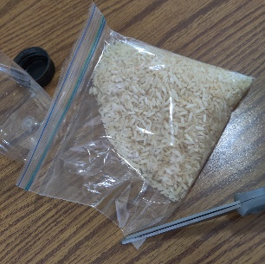
HOW TO MAKE YOUR “I SPY LOST THINGS” BOTTLE:
1. First, cut the corner off of your rice bag provided.

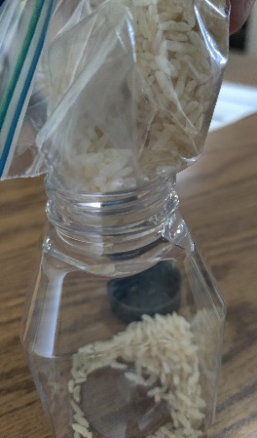
2. Next, push the cut part of the bag into the bottle and begin to pour the rice into the bottle. If it gets stuck, take the bag back out and widen the opening a little more and re-insert.
3. About halfway through filling up the bottle, push in the tiny, laminated lost things printouts found in the small envelope. If you have to add them in at the end, you’ll just need to shake the bottle up a little more at the very end.

4. When you are finished, DO NOT SHAKE YET. Tape the top of the bottle securely before shaking the bottle and trying to “find” your lost sheep, coin and prodigal son.

HOW TO MAKE YOUR “I SPY LOST THINGS” BOTTLE:
1. First, cut the corner off of your rice bag provided.

2. Next, push the cut part of the bag into the bottle and begin to pour the rice into the bottle. If it gets stuck, take the bag back out and widen the opening a little more and re-insert.
3. About halfway through filling up the bottle, push in the tiny, laminated lost things printouts found in the small envelope. If you have to add them in at the end, you’ll just need to shake the bottle up a little more at the very end.

4. When you are finished, DO NOT SHAKE YET. Tape the top of the bottle securely before shaking the bottle and trying to “find” your lost sheep, coin and prodigal son.

