1. Use a piece of construction paper and measure in 2 inches along the length of the paper and draw a guide line. This was a great opportunity to teach kids how to measure and draw straight lines using a ruler. Cut out the strip of paper that will be used for the arms of the prodigal son.
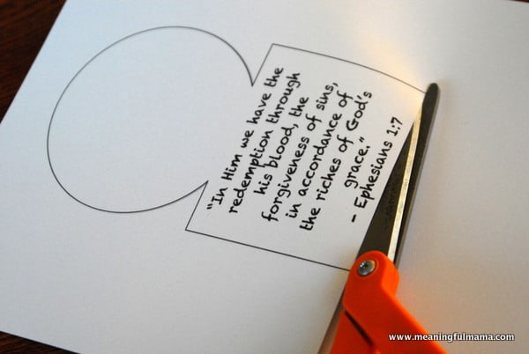

2. Cut out the printable of the prodigal son that was made for you as shown in the picture

“You are forgiving and good, O Lord, abounding in love to all who call to You.”~ Psalm 86:5

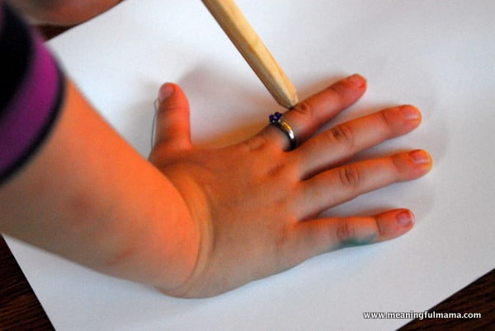

3. Have kids trace their hands on another piece of construction paper and cut them out.

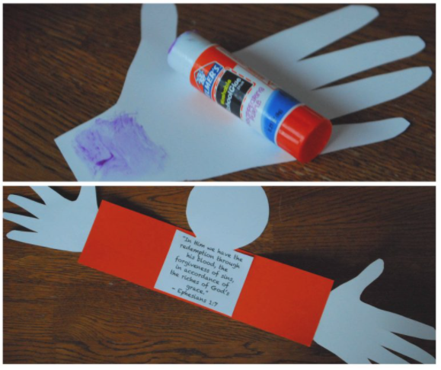
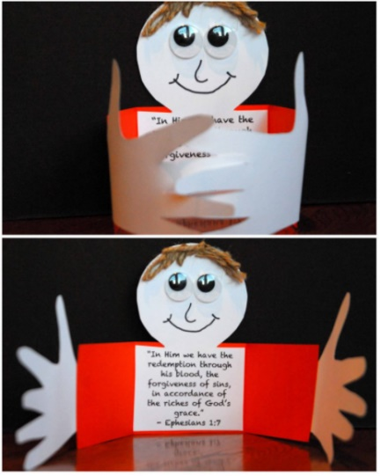
4. Lastly, glue down the verse/head and hands. Color in the face, or add whatever you have on hand as desired. I love how the arms open wide with the willingness to forgive and the hands interlock to show a big embrace as the son returns to the father.

