CHILDREN’S BULLETIN
FIRST PARISH CONGREGATIONAL CHURCH
MARCH 14TH, 2021
HAPPY SAINT PATRICK’S DAY!

Enjoy some of these fun Saint Patrick’s Day Party Game suggestions : https://www.thespruce.com/st-patricks-day-party-games-2104721

My favorite is this Leprechaun Freeze Dance Game:
https://www.youtube.com/watch?v=jmkewjN7yno

When you see this symbol | Let’s do this together
 | = Sing, Sway, Clap Along, Dance or Shake your Egg Shakers to the Music
 | = Let’s Bow Our heads and Pray Together as a Church Family (Listen to the words OR Read along if you can)
 | = Let’s Say The Lord’s Prayer Together
 | = Listen closely to the Children’s Message
 | During this time, as you listen to the stories from the bible and the sermon, please enjoy the activities found on the last pages of the Children’s Bulletin or other coloring activities throughout the bulletin.

CALL TO WORSHIP (Led by the Lay Reader) (based on Psalm 122: 1-4)
One: Happy are those who consider the poor; the Lord delivers them in the day of trouble.
Many: The Lord protects them and keeps them alive; they are called happy
in the land. You do not give them up to the will of their enemies.
One: The Lord sustains them on their sickbed; in their illness you heal all their infirmities.
Many: Blessed be the Lord, the God of Israel, from everlasting to everlasting.
HYMN: #319 Sing Them Over Again to Me (Vs 1, 3)
Sing them over again to me, wonderful words of life;
Let me more of their beauty see, wonderful words of life;
Words of life and beauty teach me faith and duty.
Beautiful words, wonderful words, wonderful words of life,
Beautiful words, wonderful words, wonderful words of life.
Sweetly echo the gospel call, wonderful words of life;
Offer pardon and peace to all, wonderful words of life;
Jesus, only Savior, keep me with you forever.
Beautiful words, wonderful words, wonderful words of life,
Beautiful words, wonderful words, wonderful words of life.

INVOCATION (Lay Reader – join in at home.) Ever-present God, let your Spirit fill this place, for we yearn for Your Presence. Grant us each your saving, healing strength. Grant us such confidence that we may look beyond the image of the ordinary and into the extraordinary truth of Your compasion. Amen.

SONG OF PRAISE: Praise to You Lord Jesus Christ

CHILDREN’S MESSAGE:
Time Especially for Children
Let’s sing “He’s Got the Whole World In His Hands”
Come in close and bring your listening ears

THE LORD’S PRAYER:
Our Father, who art in heaven, hallowed be Thy name. Thy kingdom come; Thy will be done; on earth as it is in heaven. Give us this day our daily bread and forgive us our debts as we forgive our debtors. Lead us not into temptation but deliver us from evil; for Thine is the Kingdom, and the Power, and the Glory forever. Amen.

WE HEAR GOD’S WORD FOR US
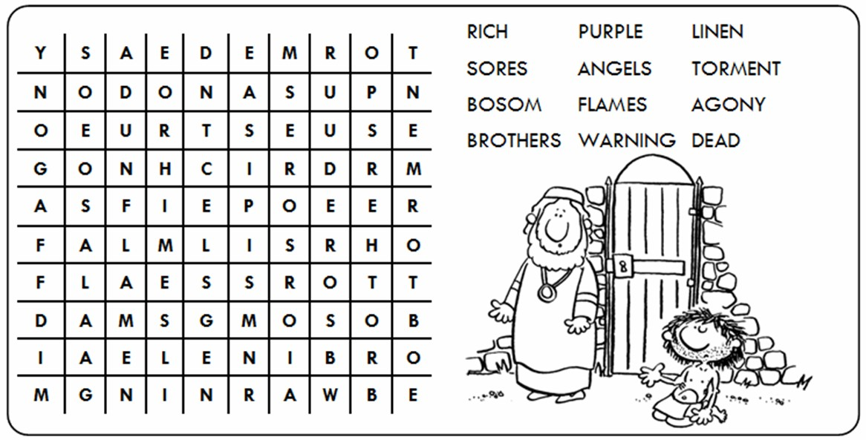
NEW TESTAMENT: Luke 16: 19-31 19 “There was a rich man who was dressed in purple and fine linen and who feasted sumptuously every day. 20 And at his gate lay a poor man named Lazarus, covered with sores, 21 who longed to satisfy his hunger with what fell from the rich man’s table; even the dogs would come and lick his sores. 22 The poor man died and was carried away by the angels to be with Abraham. The rich man also died and was buried. 23 In Hades, where he was being tormented, he looked up and saw Abraham far away with Lazarus by his side. 24 He called out, ‘Father Abraham, have mercy on me, and send Lazarus to dip the tip of his finger in water and cool my tongue; for I am in agony in these flames.’ 25 But Abraham said, ‘Child, remember that during your lifetime you received your good things, and Lazarus in like manner evil things; but now he is comforted here, and you are in agony. 26 Besides all this, between you and us a great chasm has been fixed, so that those who might want to pass from here to you cannot do so, and no one can cross from there to us.’ 27 He said, ‘Then, father, I beg you to send him to my father’s house— 28 for I have five brothers—that he may warn them, so that they will not also come into this place of torment.’ 29 Abraham replied, ‘They have Moses and the prophets; they should listen to them.’ 30 He said, ‘No, father Abraham; but if someone goes to them from the dead, they will repent.’ 31 He said to him, ‘If they do not listen to Moses and the prophets, neither will they be convinced even if someone rises from the dead.’”

Sermon: When Truth Stares Us In The Face
During this time, as you listen to the sermon, please enjoy the activities found on the last pages of the Children’s Bulletin.

HYMN: #292 Breathe on Me, Breath of God
Breathe on me, Breath of God, fill me with life anew
That I may love the way you love and do what you would do.

Breathe on me, Breath of God, until my heart is pure,
Until with you I will one will, to do and to endure.

Breathe on me, Breath of God, sire in me one desire;
That every earthly part of me may glow with holy fire.

Breathe on me, Breath of God, so shall I never die,
But live with you the perfect life of your eternity.

Invitation to Generosity: Think about how you would like show LOVE to God, others and yourself this week

GETTING TO KNOW ANOTHER CHILD OF GOD – Sue & Randy Brown

DOXOLOGY: Masithi
(Masithi) Amen, si ya ku du mi sa, (masithi) (Repeat)
Amen, Bawo, Amen, Bawo ; Amen, si ya ku du mi sa.
(sing amen) Amen, we praise your name, O God. (Sing amen)
Amen, amen, amen, amen; Amen, we praise your name, O God.
PRAYER OF DEDICATION: (Led by Lay Reader, please join at home.)
What a joy to have something to give! That you, God, for granting us choices in the use of the great gifts you’ve bestowed upon us. We dedicate the gifts that come out of your Spirit among us that they might accomplish even more than we can imagine. Amen.

Sharing Joys and Concerns: Do you have a Joy or Concern you’d like to share with the congregation?

Thank you God For: ____________________________________________________________________________________________________________________________________________________________________________________________________________________________________________________________________
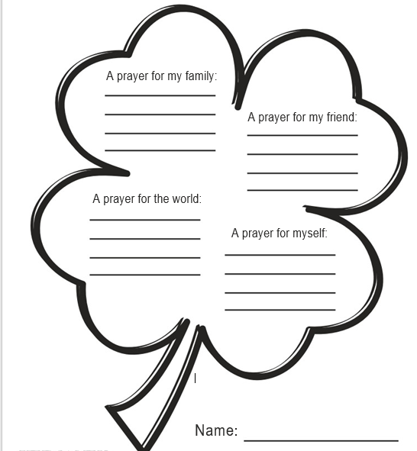

WE GO OUT TO LOVE AND SERVE A LOVING, SERVING GOD

HYMN: #52 There Is a Name I Love to Hear (Vs. 1,2)
There is a name I love to hear, I love to sing its worth;
It sounds like music to my ear, the sweetest name on earth.

O how I love Jesus, O how I love Jesus,
O how I love Jesus, whose love has first found me.

It tells my Savior’s love for all; Christ died to set us free;
Whatever problems may befall, we’ll live in dignity.

O how I love Jesus, O how I love Jesus,
O how I love Jesus, whose love has first found me.
BENEDICTION: The Pastor often will give a benediction at the end of service. This is like a special prayer asking for God’s help, guidance and blessing over everyone before the end of service.

POSTLUDE : “Go now in peace. Go now in peace. May the love of God surround you everywhere, everywhere you may go.” Words & Music: Natalie Sleeth, © 1976 Hinshaw Music, Inc.; All rights reserved. Reprinted under ONE LICENSE #A-708716

MINISTERS OF THE CHURCH - Members of the Congregation
SENIOR PASTOR AND TEACHER - The Rev. Dr. Deborah Roof
LAY READER – Jo Worthen
GREETERS – Rachel Cobban, Katie Cobban
CHOIR DIRECTOR/ ORGANIST - Joan Virga
CHRISTIAN EDUCATION DIRECTOR - Christine Lehoullier
ADMINISTRATIVE ASSISTANT - Michelle Guerrin
AV/ TECHNICAL – Paul Lindemann

