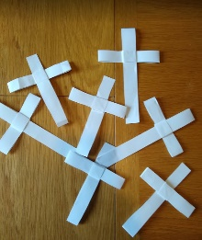
How to make a Palm Cross

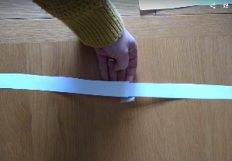
- Cut two strips about 1cm in width from the length of an A4 piece of paper. Sellotape them together to make one long strip (or use an A3 sheet if you have it).
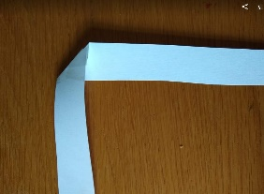
- Take the strip and fold it in the middle to form an inverted right angle/ an upside down L.
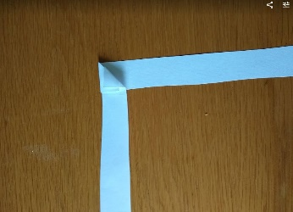

- Now take the vertical strip and fold that up (behind).
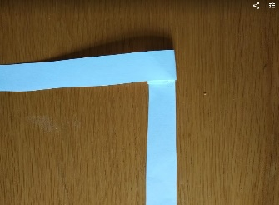
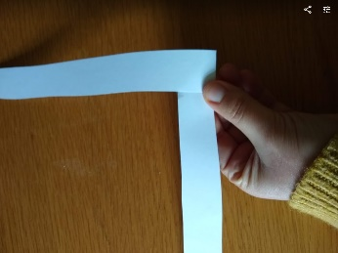
- Turn the whole thing over to form a number 7 and then fold the vertical end up again (behind).

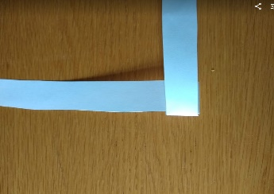
- Then take the horizontal end and fold it over (in front). Now when you look in the back you will notice you have made a small square pocket.
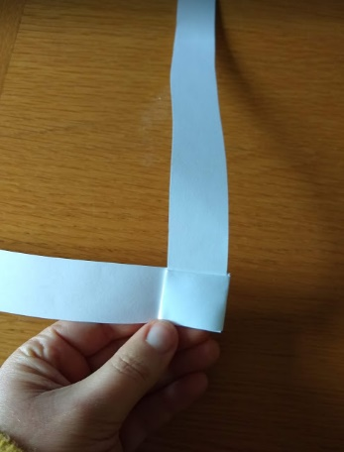
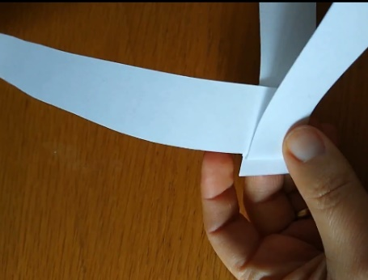
- Take the horizontal arm and slide it through the pocket from the back, all the way to the end and gently tug at it to ensure it’s firm.

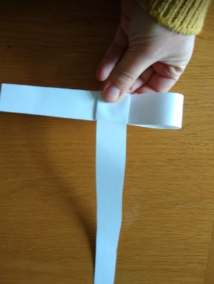
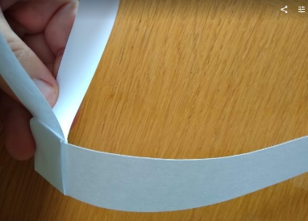

- Now slide the horizontal arm through the back of the pocket to make about a third of the length into a loop to form the left arm of the cross.
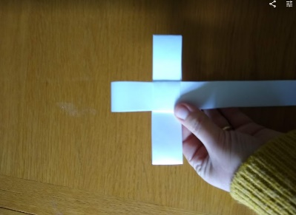
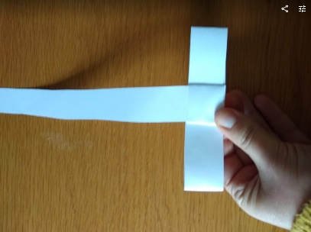

- Then tuck the end of the right arm back into the middle to form the right arm, then fold the top vertical bit down through the pocket to make the vertical part of the cross.

