MARCH 21ST - ZACCHEUS IN THE TREE AND JESUS CRAFT
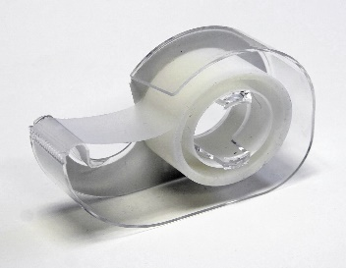
1. Tape your popsicle stick “tree trunk” to the back of the green paper plate “tree top.”

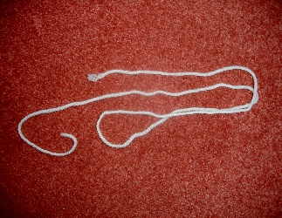
2. Take your piece of yarn that was provided and tape your little Zacchaeus to it, then loop the string through one hole in the tree top then the other so you can pull Zacchaeus up into the tree so he can look for Jesus just like in the story and pull him down out of the tree when Jesus calls him down, also, just like in the story!
3. Next, cut out and tape your Jesus to your other popsicle stick so he can call Zacchaeus out of the tree and they can have dinner together!

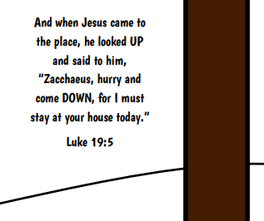
4. Finally, you can cut out the bible scripture and tape or glue that to your tree top. If you’d like you can cut out the tree trunk and add that on top of your popsicle stick tree trunk to make it look more like a tree.

